

**Electrical & Computer Engineering Department**

**Electronics Lab ENEE3102**

**Prelab for Experiment :**

### Oscillators

**Prepared for:**

**Dr.Mohammed Al-Ju'ba**

**Student name:Dalal bawatneh**

**NO:1170329**

**Procedure :**

Part one :

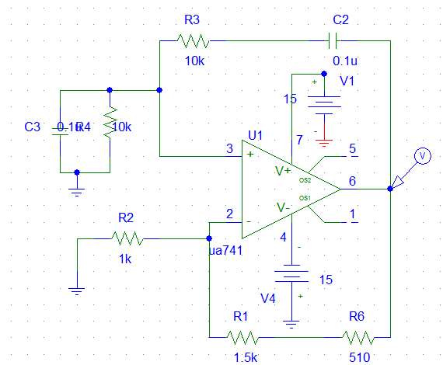

The output voltage:



To take frequency



Then F = 144Hz

When C1 = c2 = .33u



Amp=14.6v

The freq



Freq= 47 hz

* R1 = R2 = 1K



For amplitude



Amp=47.3mv

For frequency



Freq=480 hz

**Part two**

**When c=0.33u**

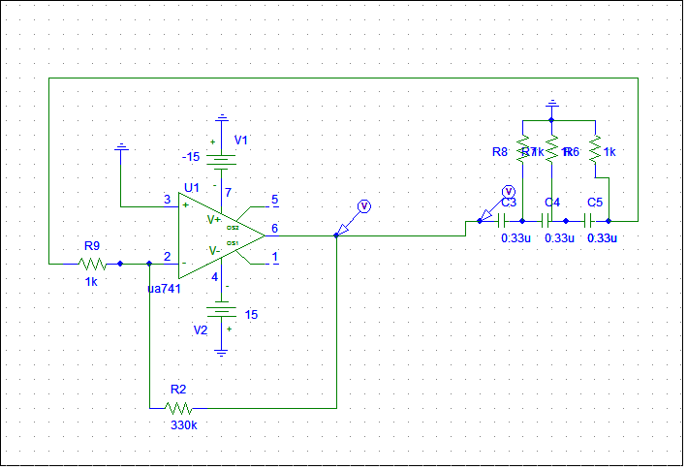



**Amp=14.6v**



**Freq=145.08hz**

**When c=0.47u**

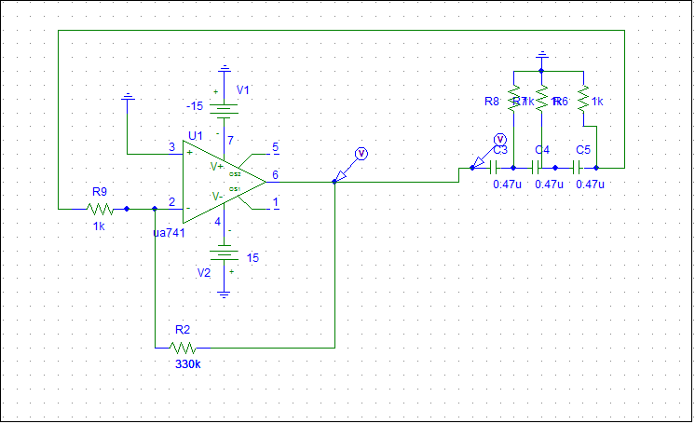

The output voltage





Amp=14.6v



Freq=102hz

* When R1 = R2 = R3 = 470
* 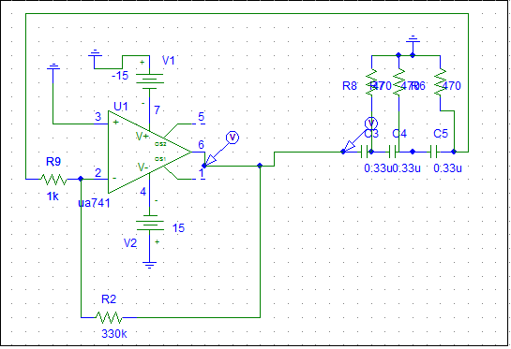



Amp=14.6v



Freq=275.055hz

**Part three :**

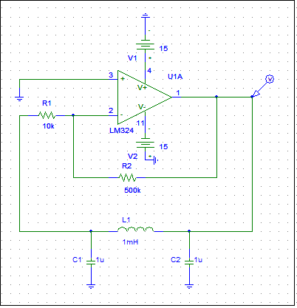



The amp=1.8 v



freq=6.801khz

when output signal disappear (no oscillations).R=2K

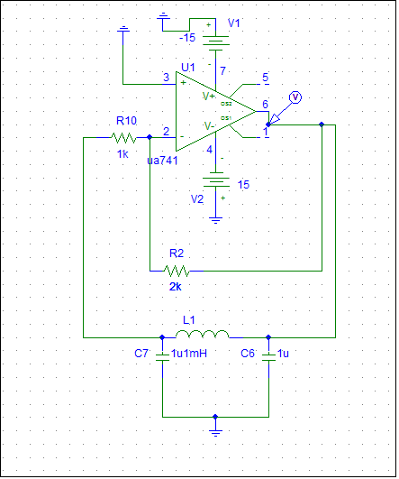

the output



When L=10mh,R=500k





Freq=2.2khz

When L=10mh ,R=5k



Part 4:

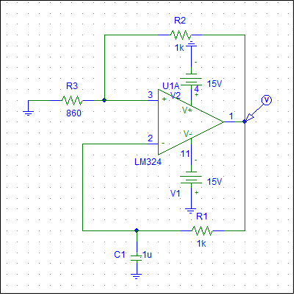



Amp=14.5v



Freq=480 hz

When c=0.1u



Amp=14.5v



Freq=3.428khz

Part 5

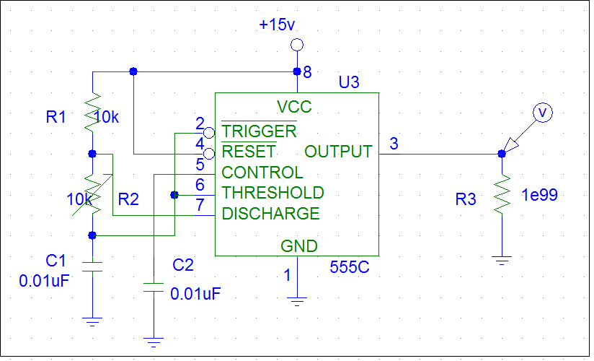

When R2=10K



Vc



Duty cycle = (1.617m- 1.4676m)/( 1.617m- 1.3844m)=0.643



Freq=4.5khz

At R =20k



vc



Duty cycle = (1.4717m- 1.2488m)/( 1.4717m- 1.0922m)=0.58



Freq=2.8k

R = 30K



vc



Duty cycle = (1.4926m- 1.2001m)/( 1.4926m- 970.947u)=0.56



Freq=2.04khz

R = 40K



Vc



Duty cycle = (1.892m- 1.5218m)/( 1.892m- 1.2278m)=0.55



Freq=1.47khz

R = 50k



Vc



Duty cycle = (2.2887m- 1.8505m)/( 2.2887m- 1.4818m)=0.543



Freq=1.25khz