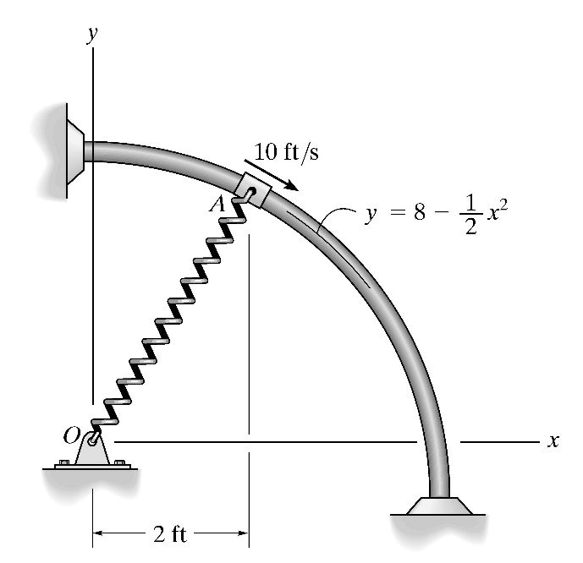Question 1:

The 5-lb collar slides on the smooth rod, so that when it is at *A* it has a speed of 10 ft/s. If the spring to which it is attached has an unstretched length of 3 ft and a stiffness of *k* = 10 lb/ft, determine the normal force on the collar by the rod and the acceleration of the collar at this instant.