- The dynamic response of the sensor
This analyzed with the Laplace transform

- Zero-order is the desirable response of a sensor:
- Inputs and outputs related by a first-order differential equation
- Stress_Strain Relation : Strain Gage:
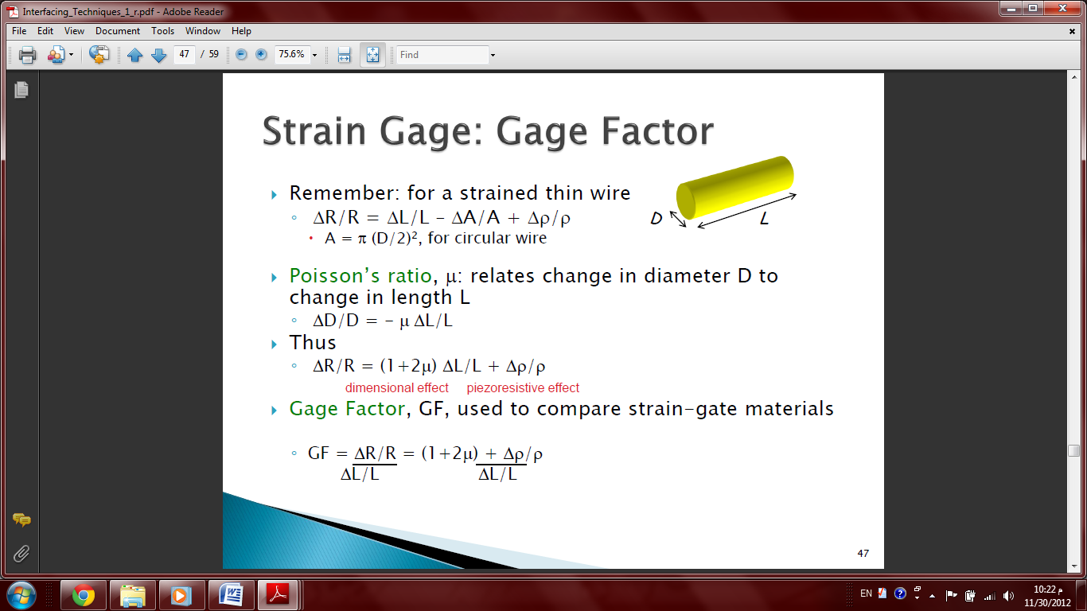
Passion Ration μ :

Gage Factor:
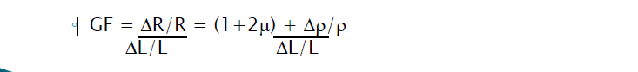
- Resistance Temperature Detectors (RTDs)
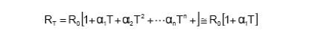
- Thermistors :
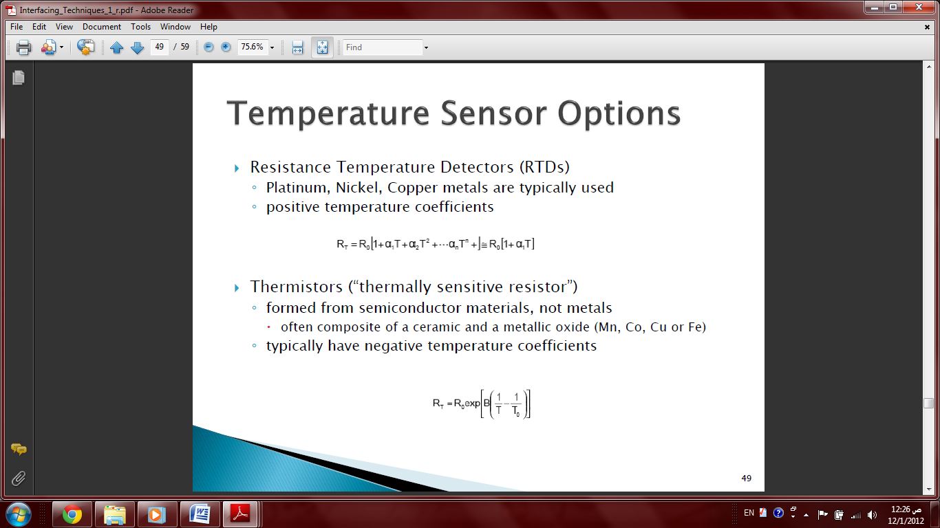
- High Pass Filter:

- Voltage Divider:
Sensitivity: (Max when RL=Rs)
- Wheatstone bridge:
- NULL Mode: 2) Deflection Mode :

Sensitivity:
Voltage follower:
Non-inverting Amplifier:
Inverting amplifier:
Integrating Amplifier:
Differentiating Amplifier:
Current to Voltage :
Summing amplifier :

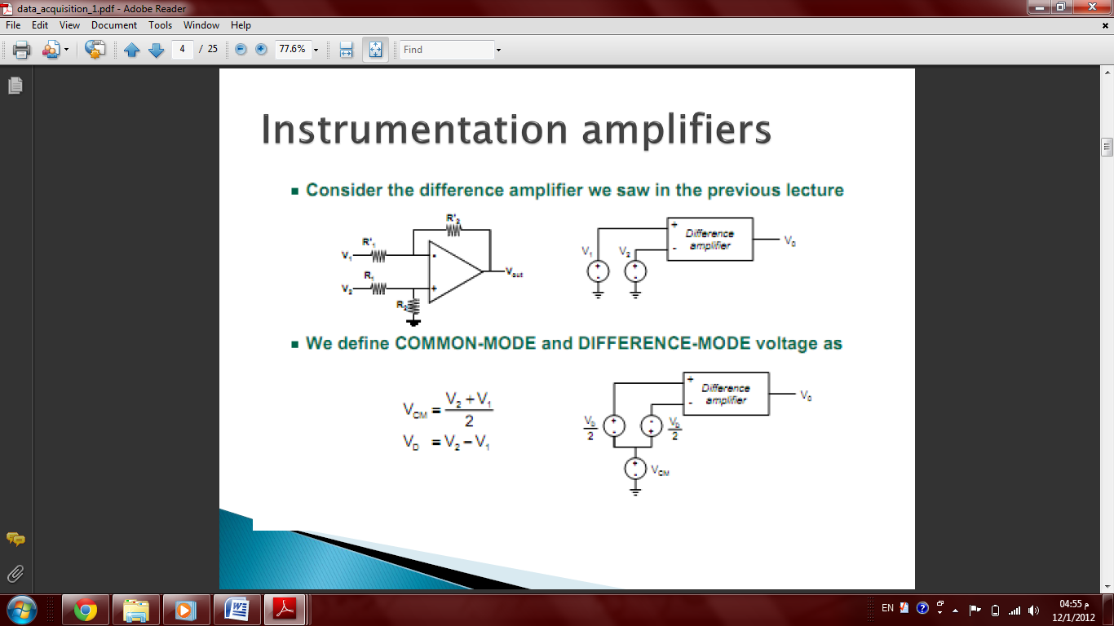
INA ..
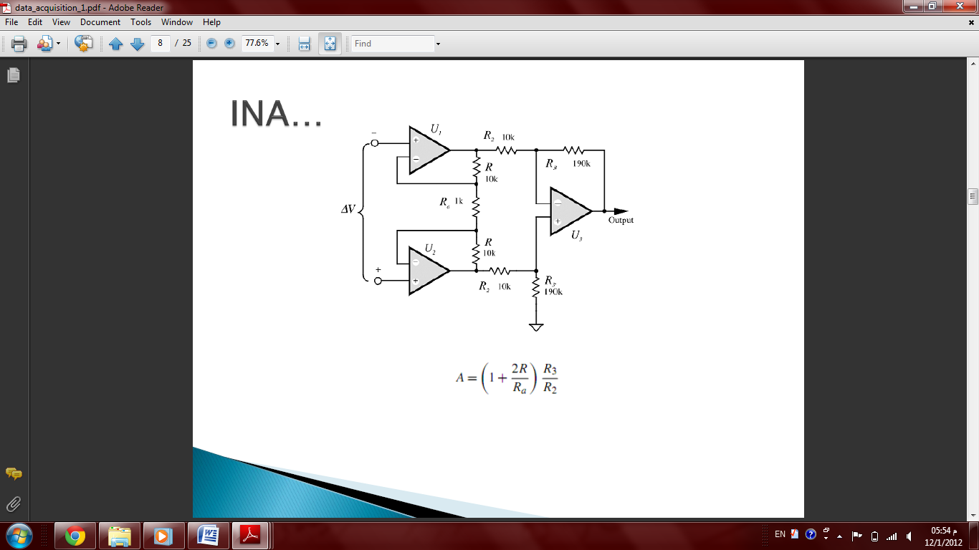
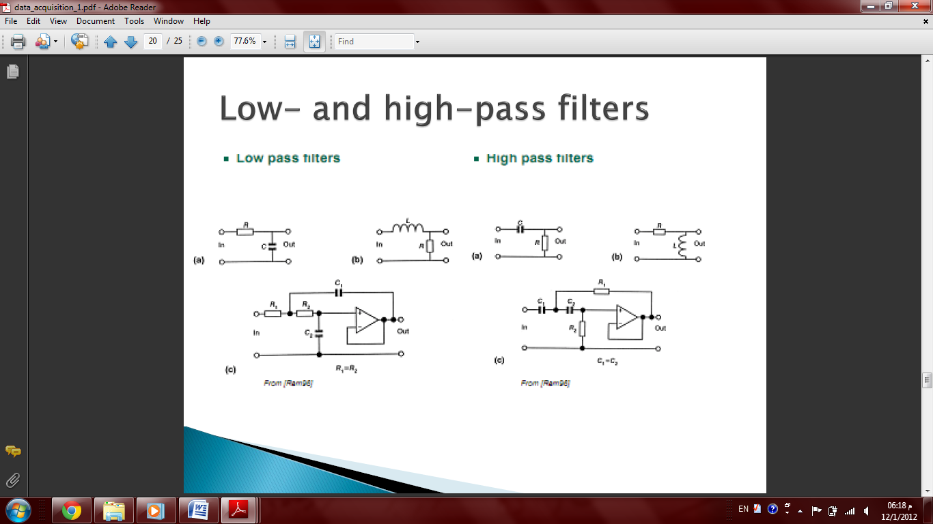
ADC:
