

Faculty of Engineering and Technology
Electrical and Computer Engineering Department
ENEE3102
Electronics Lab
Experiment # 3
Pre lab

Student’s name : Anas Joudeh
Student’s number : 1142570
Instructor : Dr.Mohammad AL-Jubeh
DATE : 3/7/2018

1. The Transistor Biasing:
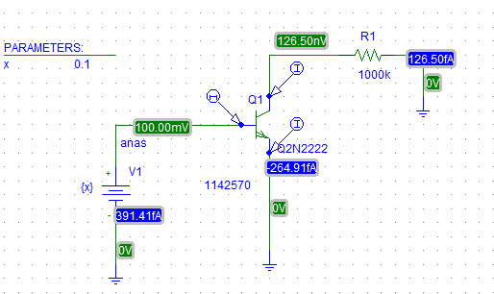
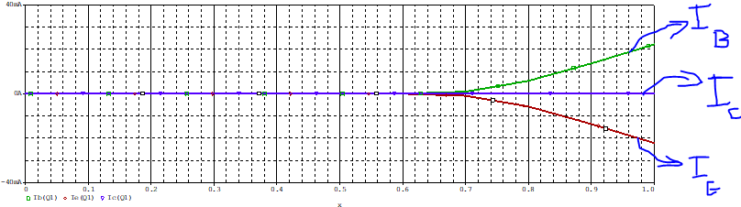
2. Reverse the supply connections :
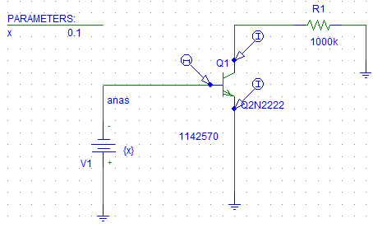
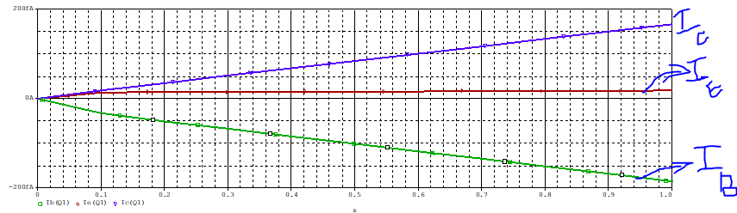
4.
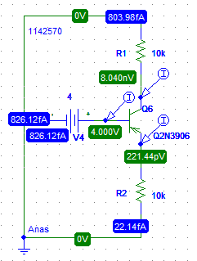
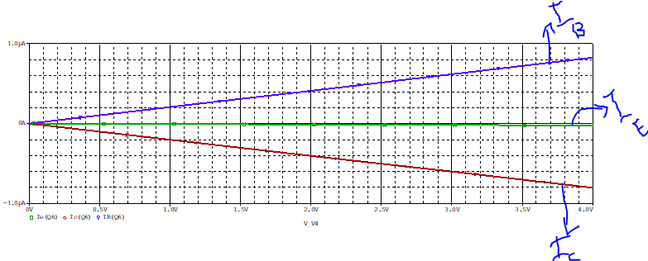

b.
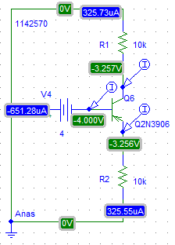
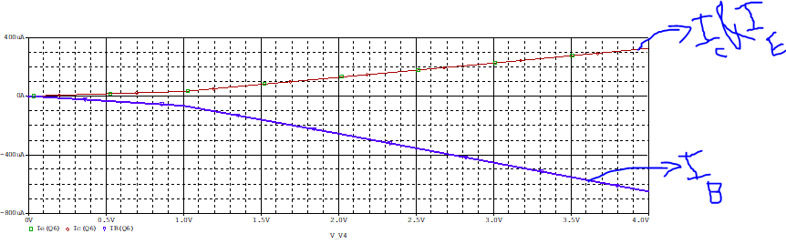

6.
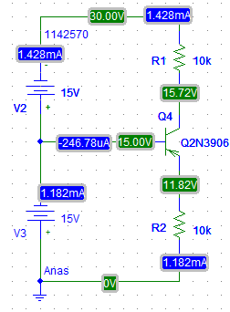
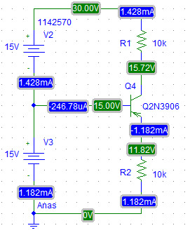

7. npn
a.
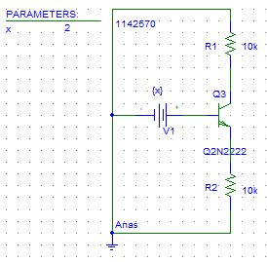

b.
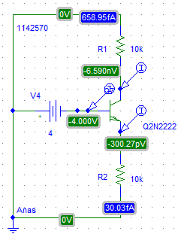
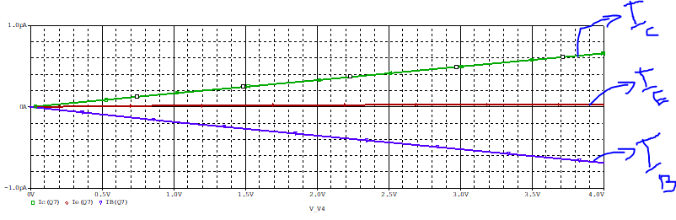

c.
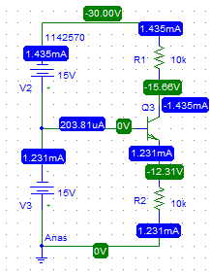

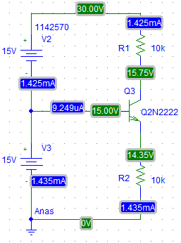

II. The Transistor DC Parameters:
A : Input Characteristic :
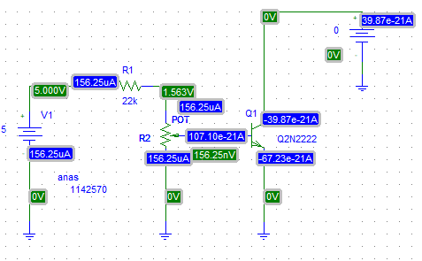

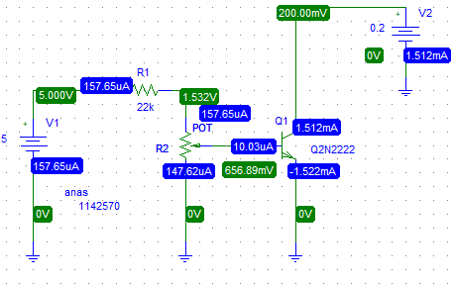

V_{CE} | I_{CE}[uA] | V_{BE}[V] measure
0 | 0 | 156.25nV
0 | 5 | 516.26mV
0 | 10 | 539.65mV
0 | 15 | 549.2mV
0.2 | 0 | 227.26nV
0.2 | 5 | 654.65mV
0.2 | 10 | 656.89mV
0.2 | 15 | 668.37mV
0.4 | 0 | 227.27nV
0.4 | 5 | 654.65mV
0.4 | 10 | 657.08mV
0.4 | 15 | 668.61mV

