

**Faculty of Engineering and Technology**

**Mechanical Engineering Department**

**Fluid Mechanics laboratory**

**ENME312**

**Experiment #2**

**The Stability of a Floating Body**

**Instructors:**

**Dr. Adel Dweik**

**Eng. Alanood Moudai**

**Done by group 3:**

Khaled Wahdan 1191584

**Ahmad Sabobeh 1191922**

Aws Daraghmeh 1191856

**Date of performing the experiment: 23.5.2022**

**Date of submitting the experiment: 28.5.2022**

**Abstract**

Boats and ships have served human beings since long ago, and the stability of those travelling modes is a very important thing to consider. Hence, the stability of bodies and what affects it needed to be studied and this exactly what we are doing in this experiment.

The aim of the experiment is to determine the distances between key points on a pontoon using different set-ups. So, a pontoon, a jockey weight, and a water container were used to simulate the real-life case. The Figure below demonstrates the key points mentioned before which are:

* G, the Center of Gravity point.
* B, the point where the Buoyancy force acts.
* M: the point where the extension of the line connecting B and C intersects with the new points of buoyancy action B1.
* C, the point representing the water table.
* Y1 and Y ’bar’ which will be introduced later.

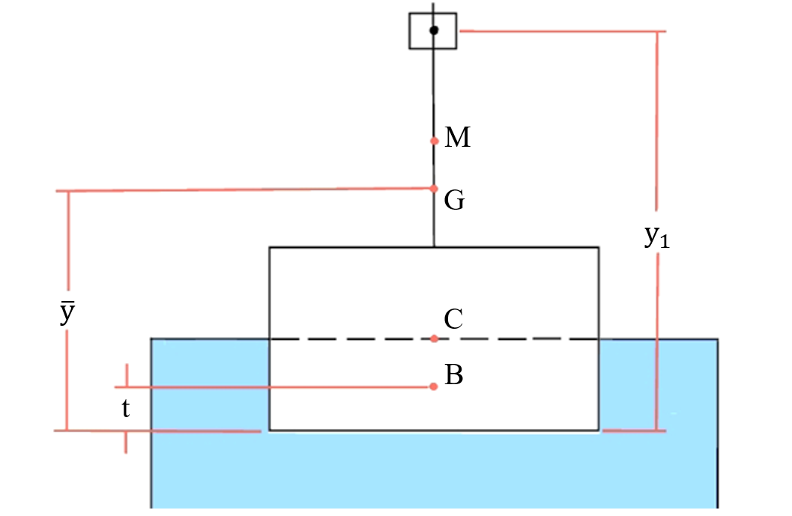

*Figure (1): Key points of the set-up for a floating body.*

Those points should be located in order to determine the stability of the floating body. These cases can be divided to three parts. The first, the floating body can be considered **stable** if the forces acting through G and B1 provide a restoring couple on the system. However, we classify the body as **unstable** if those forces provide a couple that acts on the same direction of the tilt angle which will increase the angular displacement. Lastly, the bode is to be called **Neutral** if M and G lie on the same line (coincide). These three cases can be better understood by inspecting Figure (2) and noticing how in this case the weight (acting downwards) at G and the Buoyancy force (acting upwards) at B1 provide a restoring body.



*Figure (2): Sketch showing how key points re-locate as the body tilts.*

The pontoon’s dimensions were provided by the manual and the tilt angle and jockey weight distances measured are tabulated to get our final results experimentally. As a result, we calculated the Theoretical CM distance (0.06) and the Experimental CM distance values for each run (0.02 to 0.05) which is very close and reason will be discussed later on.

**Objectives**

To Measure:

* (y1) height of the weight above the pontoon surface.
* (x) the displacement of the jockey weight away from the vertical center line.
* (ϴ) tilt angle in degrees.

To Analyze:

* Height of the center of gravity at each set-up.
* Distances between the Meta-center and Gravity center, and between the water surface and the Gravity center.
* The Stability case of the set-up.

To Measure:

* Dimensions of the pontoon.
* Weight of the Jockey weight and the total set-up weight.

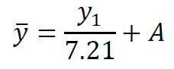**Sample Calculations**

* The relation between y and $\overline{y}$: --(1)
* The constant A: $A= \overline{y}- \frac{y1}{7.21}=44.15$
* The immersed Volume: $V=\frac{Mass}{Density of water (\frac{kg}{m3})}=0.00282 m^{3}$--(2)

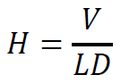

* The Height of Immersion: **= 0.03883 m** --(3)



* The distance Between G and C: --(4)
* The rate of change in angle: $\left(\frac{dϴ}{dx}\right)=slope of the curve x vs ϴ$--(5)

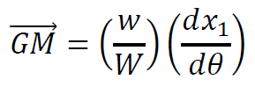

* The distance between G and M: --(6)



* Experimental Distance between C and M: --(7)

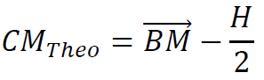

* Theoretical Distance between C and M: --(8)

**Results**

*Table (1): Given Dimensions from the manual.*

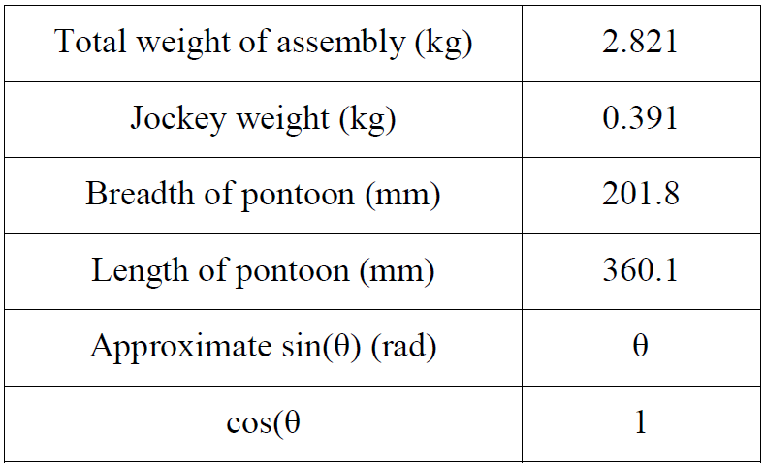

*Table (2): Measurements done in the lab, where the horizontal row represents the Jockey Weight position (x) in mm. And the vertical for the height of the jockey weight (y1) in mm. The data represent the tilt angles (ϴ) in degrees.*

|  |  |  |  |  |  |  |  |  |  |  |  |
| --- | --- | --- | --- | --- | --- | --- | --- | --- | --- | --- | --- |
|  | **-75** | **-60** | **-45** | **-30** | **-15** | **0** | **15** | **30** | **45** | **60** | **75** |
| **105** |  |  | -6.75 | -4.5 | -2.25 | 0.25 | 2.5 | 5 | 7 |  |  |
| **165** |  |  | -8 | -5.25 | -2.5 | 0.25 | 2.75 | 5.5 |  |  |  |
| **225** |  |  |  | -6.25 | -3.5 | 0.25 | 3.5 | 6.5 |  |  |  |
| **285** |  |  |  | -7.75 | -4 | 0 | 4.5 | 8 |  |  |  |
| **345** |  |  |  |  | -5 | 0 | 5.5 |  |  |  |  |

*Table (3): Calculations for Theoretical distance between C and M. (Body volume, Moment of Inertia, and distance BM)*

|  |  |  |  |
| --- | --- | --- | --- |
| **V' = V**  **(m3)** | **I**  **(m4)** | **BM**  **(m)** | **CMth**  **(m)** |
| 0.002821 | 0.000247 | 0.0874 | 0.067978 |

*Figure (3): Jockey position (x) vs tilt angle in degrees (ϴ) at the same graph for different jockey heights (y1).*

*Table (4): Calculations for experimental distances between centers.*

|  |  |  |  |  |  |  |  |
| --- | --- | --- | --- | --- | --- | --- | --- |
|  | **y bar**  **(mm)** | **CG**  **(mm)** | **dx/dΘ**  **(degrees)** | **dx/dΘ (radians)** | **GM**  **(mm)** | **CMexp**  **(mm)** | **CMexp**  **(m)** |
| **105** | 58.71 | 19.88 | 0.1548 | 8.87 | 1.23 | 21.11 | 0.0211 |
| **165** | 67.03 | 28.20 | 0.1795 | 10.28 | 1.43 | 29.63 | 0.0296 |
| **225** | 75.36 | 36.53 | 0.2167 | 12.42 | 1.72 | 38.25 | 0.0382 |
| **285** | 83.68 | 44.85 | 0.2667 | 15.28 | 2.12 | 46.97 | 0.0470 |
| **345** | 92.00 | 53.17 | 0.35 | 20.05 | 2.78 | 55.95 | 0.0559 |

**Discussion of Results**

As mentioned in the Abstract, the aim of the experiment was to measure the distances between key points and compare them with the theoretical values. In our experiment, we conducted the experiment on different jockey weight heights to see how the elevation and change of location of G affects stability. Angle Readings corresponding to those elevations are measured and recorded in table (2).

Those values we got helps us to determine the rate of change in angle with respect to the Jockey weight position (x), this is done by plotting the (x) vs. (ϴ) curves for the 5 different elevations (y) we used at one graph. Relations among the same (y) were found to be linear and the equations of them were determined using MS Excel, equations give us the slope of each line or in other words (dϴ/dx). All of that can be observed at Figure (3).

Table (4) shows our calculations for the 5 different Jockey heights (y) for all of key points distances, including the goal which are CM experimental values. Those values need to be compared against the theoretical value of CM distance, which was calculated in Table (2) using equations provided in the Sample Calculations section.

It can be noticed that experimental values are less than the theoretical one, this result was not surprising at all since there are various sources of error such as incorrect angle readings, operating errors, approximation in equations, loss of significant figures, or finding the slope of the best fitting line in Excel.

A thing that needs to be considered is what will happen if another liquid was used instead of water? To answer it we need to detect the effect of density in our experiment. It can be found that the density affects the Immersed Volume of Water (V) and change it based on the liquid’s density through ***Eq. (2)***, thus all of other distances based on this parameter will change including the theoretical and experimental values of CM.

**Conclusion**

Our result is considered acceptable since we obtained a range of values experimentally for CM close to that one calculated theoretically. This result was expected since there are multiple sources of error in this experiment. However, the results varied because of the change of the jockey height which is logical and can be used to predict the stability of the system.

**Applications**

Determine the stability of different set-ups and know how to distribute the weights of a floating body to place the Center of Gravity at a place where it doesn’t exert a rotating couple that would flip the body.

**References**

1. Fluid Lab Manual.
2. Attached Data Sheets.