Grammar
Sentence > clause (the physical representation of a sentence) > phrase > words > sounds
*what distinguish a clause from a non-clause is having the verb in the clause
*syntax (the position of words in a clause /phrase) is the godfather of grammar, they both a system of organization of words and what goes with what
*lexical words are those words that have meaning on their own, the difference between grammatical words (prepositions, pronouns…) and lexical words (nouns, verbs, adj. adv.…) is that the grammatical words are used as tools in sentence while lexical words are words who have a meaning of its own but it needs to be activated.
*the lexical category:
*nouns:
1. Morphology: They all accept the plural (s) and possessive(s), and (99%) of nouns accept prefixes.

*Verbs
In terms of: actions: eat, play…… (Physical verbs)
1. Semantics (the meaning of the word): events:
States: love, feel….. (Mental or heart feelings)
2. Morphology (the shape of the word): all verbs (99%) accept the (Ed) the past simple form and (singular subject s) ex: she eats, he needs.
3. Syntax (position of word): follows a noun (most verbs have a specific position in a sentence always after a subject)
*Adjective
In terms of:
- Semantics: adj. describes or means nationality, size, and qualities, colors… so any words give those things is an adj.
- Morphology: all adj. accept (superlative form: est, comparative form: er).
- Syntax: more, most, less, verb to be, Adj. usually comes after these words.
*هاي الاشياء الي كتبتها اللي هي سينتاكس و سيمانتكس ومورفولوجي هي عبارة عن امور عاساسها بشوف شو الكلمة اللي قبالي حسب موقعها وشو المعنى الللي بتعطيه وشو الاحرف المضافة الها , فبتطلع يا اما فعل او اسم او صفة.....
*Adj can be:
Predicative (after verb to be): that kid is nice (adj used to provide information about the subject)هاي اهم من التانية
Attributive (before a noun): that nice kid is sick (nice: just describe the noun not very important, so it’s attributive), (sick: gives information so it’s predicative)
*Adverbs
In term of:
Semantics:
- Adverbs of manner: slowly…
- Intensifiers or degree adverbs : really, more , very, so …
- Adverbs of time: today,
- Adverbs of place: here, there
- Adverbs of directions: straight, left, right..
- Adverbs of frequency: sometimes, every…
- Sentence adverbs\ attitude adverbs: actually, sadly, obviously (we start the sentence with them; they describe the general attitude of the sentence).
Morphology:
Not all of them end in (ly) how do we know if the word is an adverb, we look to the behavior of the word, and its position. Ex:
Today is Tuesday: noun اجت باول الجملة وما في قبلها فعل))
I will see you today: adverb (اجت بعد فعل ووصفت ايمتا الفعل صار)
Syntax:
The position:
Ex: The fast (adj.) girl recovered fast (adv.) from her fast (n.)
Ex: that man looked hard. * In this case it can be adv. Or adj. we either describe that he looked in a hard way (so intensely), or he seems hard (anxious).
Ex: my dog is so friendly. Here it’s an adj. cause normally after verb to be we have adj. and also if we change this word to an adv. it wouldn’t work. So (ly) here is not an indicator of an adv.
Grammatical Words
In terms of semantics and morphology and syntax:
Don’t talk to me in this way. It doesn’t give a positional meaning here so it’s not lexical
I’m in the garden. Here it’s a preposition, because it gives the spatial (prepositional) meaning
His appearance draws people around him. Preposition, cause usually prep. Have a word (usually noun) after it.
I sat and looked around. Adverb, cause it’s describe the verb look.
The computer is on. Here it’s an adj.
The teacher told me to come in. it’s a preposition.
*If there is a noun after a preposition, we consider it lexical preposition.
*Grammatical words:
*Determiners: always found next to a noun (the noun can be one word or two or more but still it’s a noun like: book, red book, big red book) if not next to a noun (before or after) then it’s not a determiner,
- Articles: an , a, the
- Demonstratives : this , that
- Possessives: my , your, his, her
- Quantifiers: any, some, all, many

Ex: all (d.quantifier) the (d.article) books are good, * the (d.) is for determiner
Ex: I don’t have any book (d.) I don’t have any (not a d. cause there isn’t a noun after it)
*auxiliaries: (helping verb) : we find them next to verbs, it helps us to know the number of the subject (singular, plural ), also it shows us the time(present, past…..), also the aux. gives us sth the main verb can’t give which is (negative, positive) the (not) written with the aux.
*coordinators: and, or, but, they connect lexical words (nouns, verbs, clauses, propositional items)
*complementizers: if, because, since, after, as (these complementizers introduce a subordinate (not main) clause (focus on the word clause),
Ex: I didn’t go to school because -it was raining (subordinate clause)-
Ex: after (preposition) the game, we went to eat pizza. (It didn’t introduce a sub clause just a noun)
Ex: after (complementizers) we watched the game, we went to eat pizza. (It came before a sub clause)

Unit 2:
Phrases
NP: noun phrase that might be made of just a noun
Ex: students (NP) are smart. The np here made of one noun which is students.
Ex: the students (NP) are smart. The np here made of one noun which (students) and a determiner which is (the). Note: the adj. usually written next to the noun because it’s more related to the noun and more closer to it than the determiner.
Ex: the nice students (NP) are smart. The np here made of one noun which (students) and a determiner which is (the) and an adj. which is (nice), why do we call it noun phrase? Because it’s the captain here, the main word, the rest of the words in the np are modifiers.
NP

D N` ركزي على الشحطة هاي اللي بتخليني اضيف افرع تانية للاشي

Adj. N

*A phrase means: a head (captain) + assistants (potential modifiers, ممكن يكونو موجودين او لا زي ال the, nice….) or I can only have the head which is here the noun and the noun is a type of word that stands alone and it’s the nominal unit that the phrase here.

The students of physics:
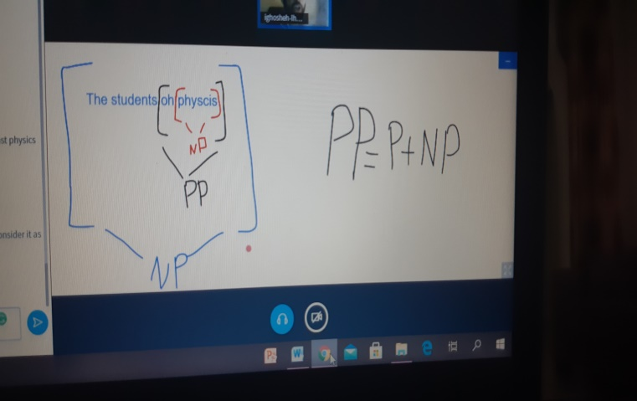

*a phrase can be a word or more, that’s why we have a noun phrase made of a noun only, How can I know that a phrase is a one unit when I do a tree for the whole sent. ? When I can replace it with a pronoun.
Ex: (the new house) is beautiful.
It
Ex: (I) (found) (the ball) (in the garden).
It there
Functions in the sentences:
What the function of the different phrases in a sent. :
- Subject : is realized by a np(generally speaking)
- Predicate: the verb, Usually answer the what, where, when questions about the subject
- Complement: usually the object
- Adverbial: optional in a sent.
*subject:
(SAI) (SV) (TAG QUESTION):
- SAI:
Subject auxiliary inversion (when I switch the place of the subject with the aux. then it’s (SAI)
-SV: the unit that cause a change in the verb form, is the subject
*note: he, she, and it: 3rd person singular pronouns
I, you: 2nd, 1st, person singular pronouns
You, they, we 2nd, 1st, person plural pronouns
*grammatically I can know what type of pronoun I have based on the form of the verb (whether I has an (s) or not, if it has an (s) then the pronoun should be singular (he, she, it, I, you) if the verb doesn’t have an (s) then the pronoun might one of those (the, we, you) and this called (SV) subject, verb agreement.
-tag question:
Ex: There are 5 villages around me, aren’t they? *(they) here refers to (5 villages) there is nothing refers to (there)
In this sentence we have real subject: 5 villages
And a grammatical subject: there (semantically its empty doesn’t mean anything) (also called dummy subject), but I need it to start the Sen. It does fill the grammatical position of a subject until the real subject shows up.

Predicate (usually the VP): everything in a sentence but the subject, its job is to say sth about the subject.
Ex: s

Np p (predicate)
The predicate is usually the verb and its compliment (the object) we use to make the sentence grammatical
Ex: the students eat lunch

Subject predicate
Usually the predicate answer the what, where, when questions about the subject

Complement:
- Direct Object: (answers the what\who Q about the verb)
Ex: I know you
- indirect object: usually came after these verbs (give, buy, make, offer)
Ex: I gave my friend a gift

Indirect o direct o
*In another way and to know which one is the direct or the indirect: I gave a gift to my friend (I added a preposition to the weaker object, the indirect object)
*If I wanted to know if the compliment that I have is an object, I change the sent. Into a passive and make the object as the subject if it can be a subject then it’s an object whether it was direct or indirect.

Note:
- Verb that doesn’t need an object: intransitive
- Verb that can have an object: transitive
- Verb that can just have one object: monotransitive
- Verb that can have two objects: di-transitive

EX:
1. I made Amanda a cup of tea
2. I made a cup of tea for Amanda
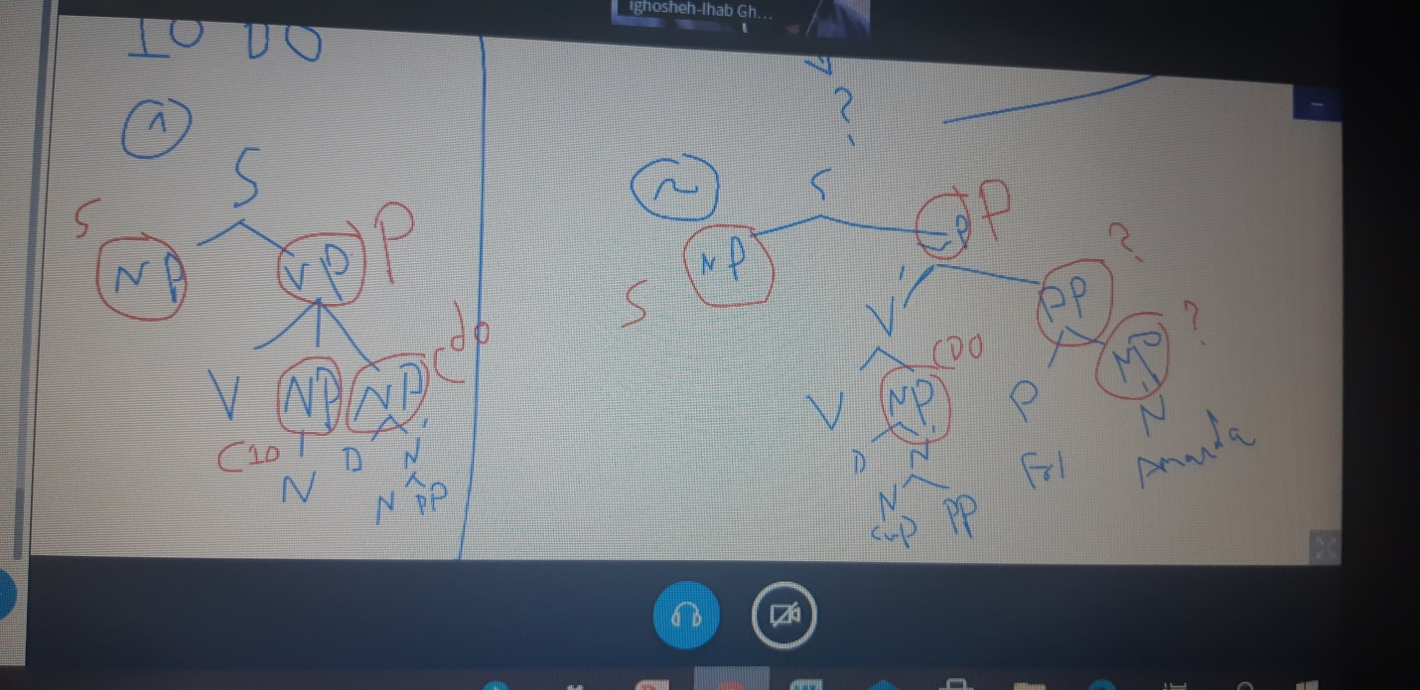
- Subject predicate : when I have a verb to be(copula verbs) or these verbs (seem, look, appear, sound, become, or any verb that give us the sense of a verb to be) and doesn’t have an object but I have a compliment that tells sth about the subject
Ex:
- I am an instructor.
- I grew tired.(I am tired) this verb gave us the same meaning as a verb to be

- Object predicate: tells me sth. About the object.( usually come with the verbs (consider, found and these verbs named as complex transitive verbs)
Ex: the judge found the man guilty.
Np object predicate.
The tree diagram for the sentence: the judge found the man guilty.
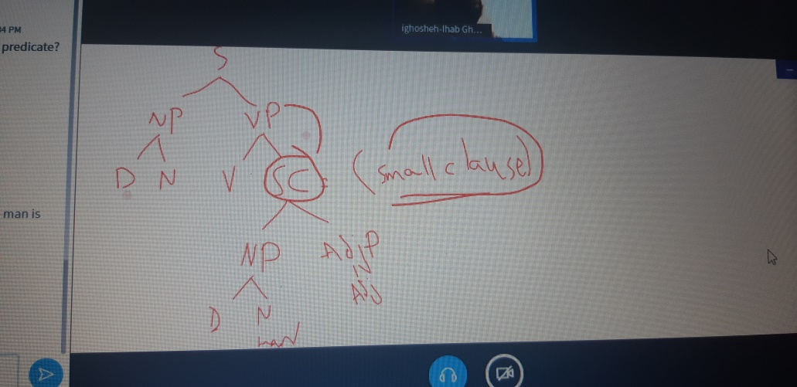

Ex: they found the king a good chef. (found: complex transitive verb cause it has an object predicate)
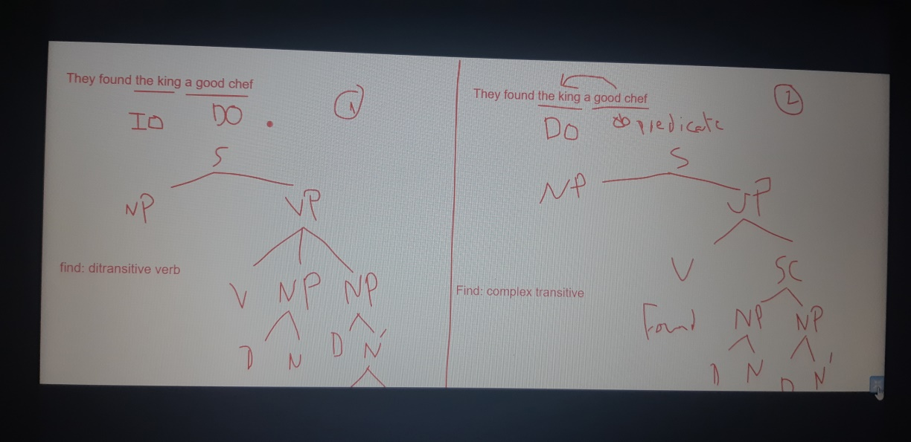

*Note: there is a different between a (di transitive verb) and a (complex transitive verb)
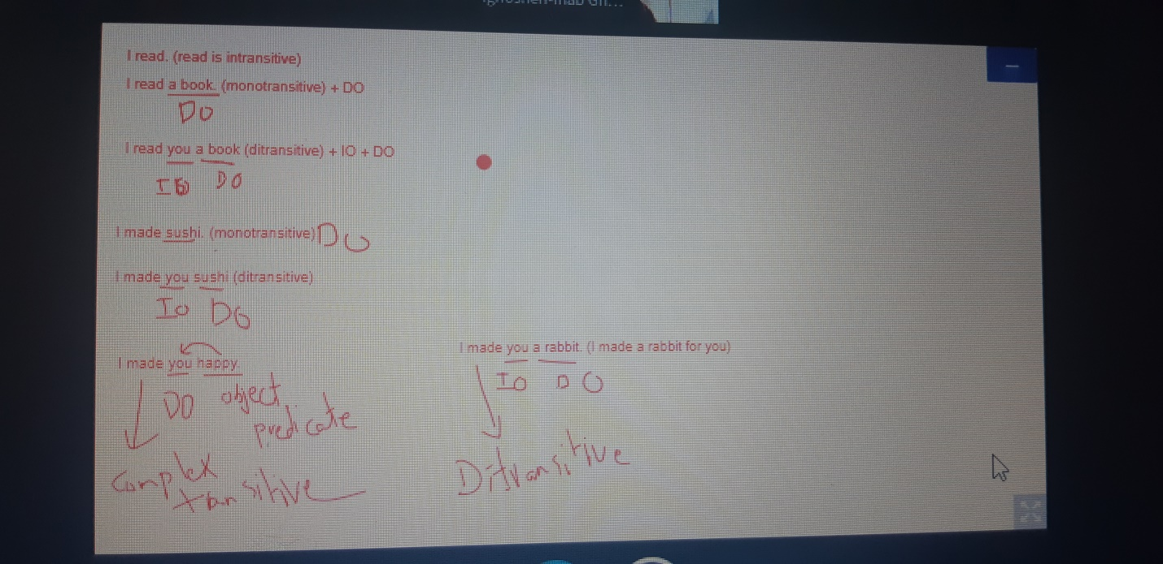

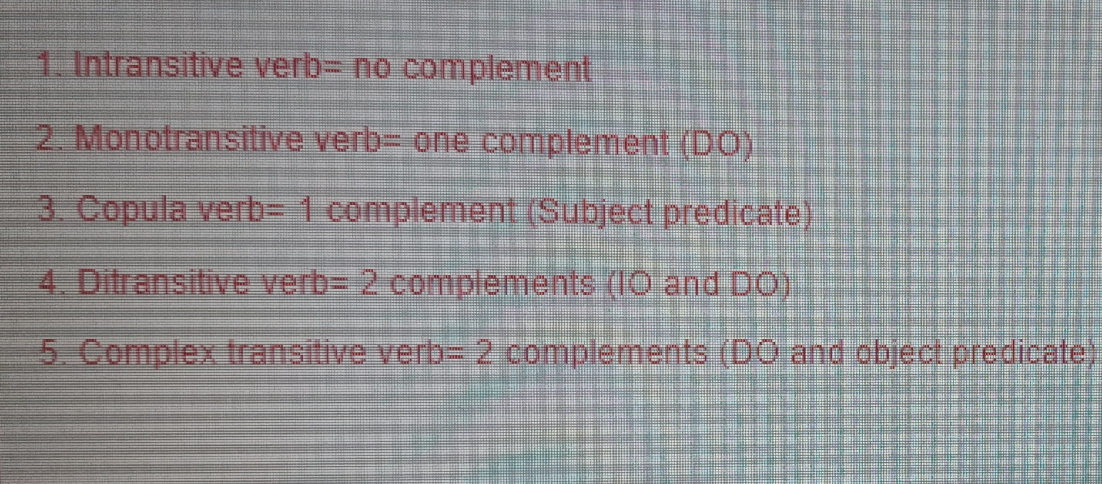
*Note: the test that I do to see if there is an object in a sent. Is to turn the sent. Into a passive and this test is only for direct object and indirect object.
*The other tests is to ask the what and the who questions.
* Copular verb is a special kind of verb used to join an adjective or noun complement to a subject. Common examples are: be (is, am, are, was, and were), appear, seem, look, sound, smell, taste, feel, become and get

*note: DE lexicalized verbs: doesn’t have a meaning
Ex: I take (have) a look = I look (in the 1st one I emphasize the np, in the other I emphasize the v.

Np (DO) verb
*I use it (DE lexicalized verbs, to emphasize the np, and to add modification to the np, because only these verbs allows modification to the np) ex: I take a quick look. Cause if I say (I look a quick look) I repeat the words it’s not a natural sent.

Prepositional verbs: (verbs that associated with prepositions, always occur with each other)
Believe in, refer to, and listen to
Ex: the kid listens to music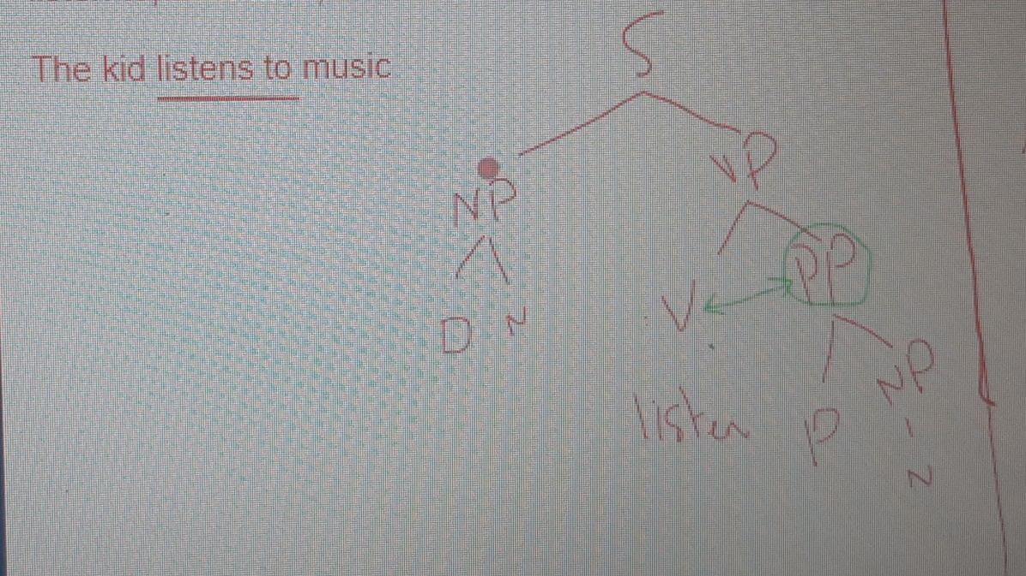

After the mid:
Quick revision:
1. Intransitive verbs (no complement)
2. Monotransitive (1 complement=direct object)
3. Copula verbs (1 complement=subject predicate)
4. Ditransitive (2 complements; the first is an indirect object, the second is direct)
5. Complex transitive: 2 complements; the first is a DO and the second is an object predicate
Ex: I consider Romeo and Juliet a tragedy\The politician considered that argument invalid
6. Light verb (de lexicalized verbs): direct object
Ex: I took a hot refreshing shower.
7. Prepositional verbs: we called them as so cause they are associated with a preposition, ex: listen to, believe in, and refer to (these verbs always require an object which we called a prepositional object), Ex: The kid listens to music prepositional object
8. Phrasal verbs: turn down, put on, and take off,( we called them phrasal not prepositional cause they don’t mean literally of what they consist of, they have another meaning and the preposition here called particle not prep.) ex:
take off your shoes, The plane took off.( it doesn’t require always an object)
* The difference between the prepositional verbs and the phrasal is that the object in the phrasal can be moved without the preposition (take your shoes off), but the prepositional one can’t (listen music to)
- Prepositional verb: requires an object, It takes a prepositional object (PP), the verb and the prepositions are inseparable (The kid listens music to), can take an adverb
- Phrasal verb: may/may not take an object, It takes a noun phrase as an object. (NP), the verb and the particle can be separated (The kid took his jacket off), can’t take an adverb
8. Phrasal prepositional verb: verb+particle+preposition, ex: get along with, cut down on, run out of, put up with, come up with, ex: My friend gets along with his pets.

*So a clause contains:
The np in the sent.
*1. Subject: must have in a sent.
The vp of the sent.

*2. Predicate: (verb+complement), a verb is a must but complement is not
3. Complement: tells me who and what about the verb (not always necessary in a sent.)
4. Adverbial: give me information about time and place in the sent and tell me the manner of the verb.*also not necessary in a sent. , ex: (in the garden): I saw a cat in the garden
Adverbial: 
Adverbial: 1. time/place/manner of the verb, it can be :
- Pp :[in the garden]

- Np: all the time
Last Tuesday
This evening

- Adv. P:
I called you repeatedly.

*The adverbial is flexible part of a sent. I can move it anywhere, it’s also optional I can delete it from the sentence and also it will still a grammatical one.
* The difference between the adverbial and the other parts (subject, predicate..) is that I can put as much adverbials in one sent. As I want, I can stack them,
*ex: I saw a cat yesterday in the morning at 8.
I saw a cat at 8 in the morning yesterday.
*I can change their positions and still it will be grammatical

*there is sth called a function in the sent. (Subject, predicate, complement, the main NP, the main VP: these have clausal function because they serve the clause, but the pp that came within an np or a VP is has a phrasal function but if it was alone not within anything so it would have a clausal function)
*in general the direct object and the indirect object are the only things that can be passivized.

VP:
In a VP I have two types of verbs:
Lexical \ auxiliary ex:
The student writes. (Lexical)
The student is writing (aux+lexical)
*so in a tree diagram I just simply put (vgp: verbal group phrase) instead of a (v) when I have it within the VP.
Verbal group: Aux + verb
*Lexical:
- Mandatory (must have in a sent.)
- Meaningful (carries the meaning semantically )
- I can have only one lexical verb in a clause.

*aux:
- Optional (we don’t necessarily need in a sent.)
- Carries a grammatical meaning (if it was 3rd person…\ and whether it was singular or plural)
- Tell me the tense (time) of the verb (present, past….)
- I use it to ask and to make a verb negative
- I can’t have more than 4 aux. verbs in a clause.
*modals are considers as a aux. verb

The student is writing. Progressive (continuous)
The student has been writing perfect Progressive
The student may have been writing modal perfect Progressive
The paper may have been being written modal perfect Progressive passive
*there sth called (Affix hops: the suffix of the tense(ing, ed…) jump to the lexical verb to the right of the aux.): when the auxiliary doesn’t carry its marker (ex: the (is) doesn’t carry the (ing) but we need the lexical verb to carry it).
* Progressive: be+ing
Perfect: have+ed/en (participle)
Passive: be+participle (ed/en)
* modal perfect Progressive passive (this is the grammatical position of them)

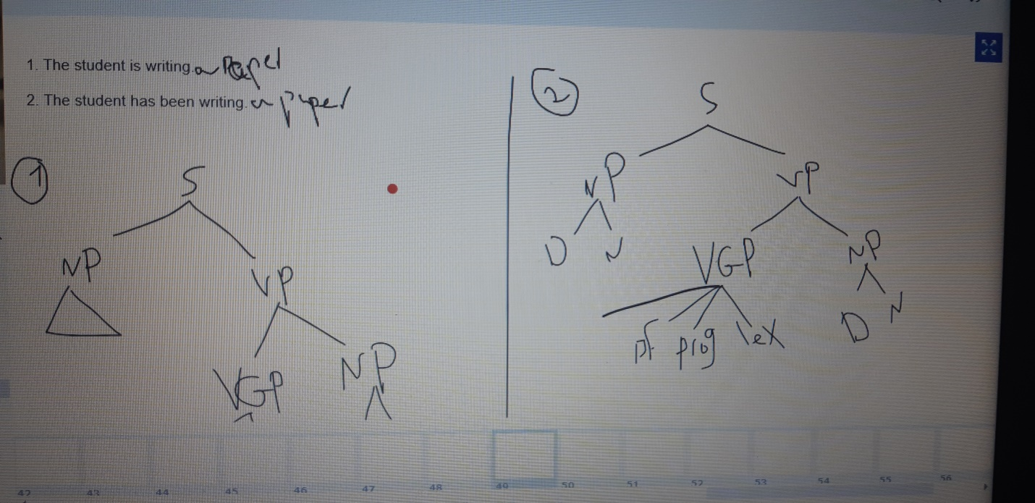
This picture is ex. On the (vgp)
*not every word with (ing) is progressive verb it might be an adj.p
*The window is broken:
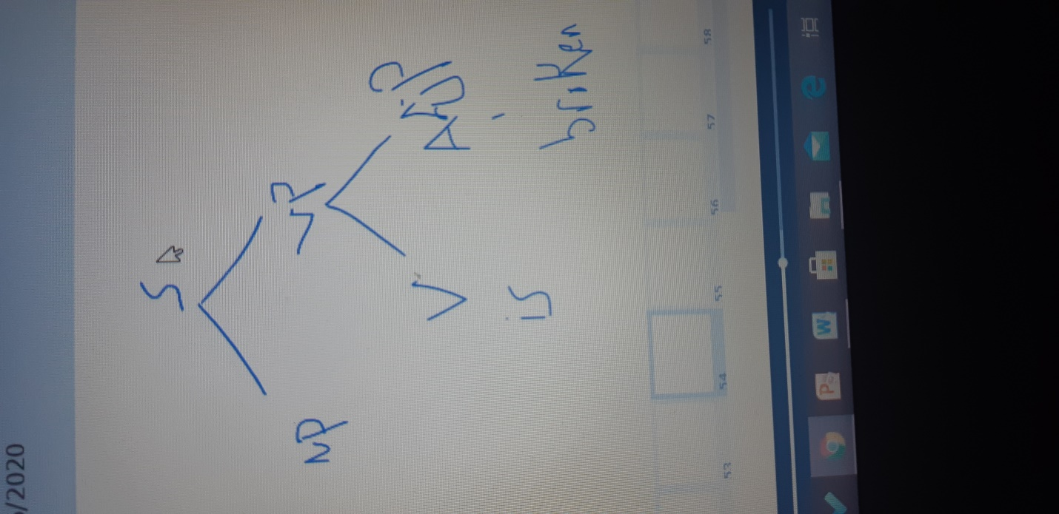

* A verb phrase can be finite if it give us information like time (tense) and number (singular, plural). As the verb (want) here in the Ex: I want to go. , but (go) here is not finite its tens less, its infinitive doesn’t have a subject and doesn’t show us the time and the number

*independent: when the clause can stand alone, have full thought, ex: The students write poetry. , The students have been writing poetry

*there is a different in grammar between:
1. The students are nice: are here is the lexical main verb, and it’s a copula verb
2. The students are being nice: are here is an aux. and its present progressive one
*also there is a different in the meaning, the 1st one means they always nice, the 2nd one is that they just being nice at the moment.

*finite, finiteness: when there is an agreement between any verb in the (VP) or (vgp), and the subject, if in a VGP there is an aux. that agree with the subject then the whole VP is finite . there is a test to do to know if the verb is finite , which is changing the subject from singular to plural and see if at least one verb change, or change the tense of the verb, if anything change then its finite and the whole clause is finite.

*The student may have written poetry: this clause might seem tricky to know if it’s finite or not because the (have) doesn’t show an agreement with the sub. But this happened because there is (May) which is a modal v., now whenever there is a modal in the (VGP) in a sent. Then it’s always finite but they fail to show the finiteness because they don’t change in form, so they finite but don’t show their finiteness

I know what you did. This is one sent. But there are 2 clauses; every lexical main verb is supposed to be in a clause, so the number of the clauses determined as the number of the lexical verbs. So in term of finiteness and independent we do the test to all the clauses in the sent. :
Clause1: I know: it’s independent, it can stand alone and it’s fully grammatical clause. And its finite cause there is an agreement between the verb and the sub. cause if I change the sub. to another one like (he) then the verb will turn into (knows) and any change in the sub. That led to a change in the verb then that mean that the VP is finite.

*Note: (that, what, which, because, if, for) when I have these words in a sent. And I want to draw a tree diagram then I put them as a (complementizers or CP and it can’t stand alone) because they introduce the clause.
*clause 2: what you did: it’s dependent clause, it can’t stand alone. But its finite cause if I change the tense of the phrase the verb (did) will change into (do) and then if I change the sub. To (he) then the (do) will become (does), so it’s finite.
*Conclusion: because C2 is dependent, it has to have a particular grammatical function to serve C1. , In this example, the entire C2 functions as a complement for C1.
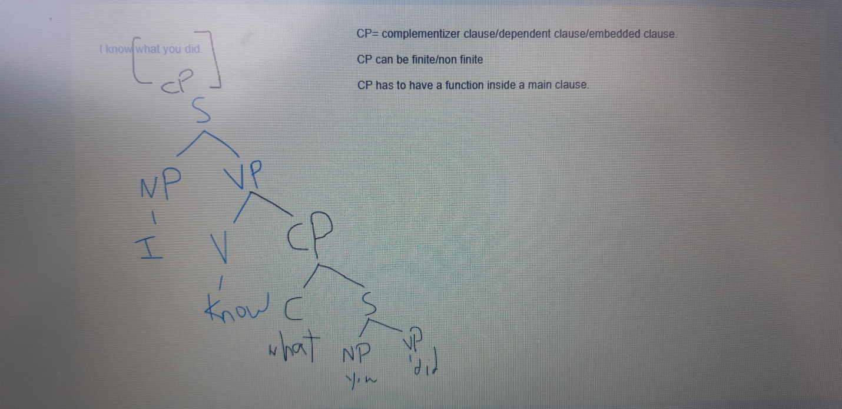
*The function of the embedded\complementizer clause here is a direct object (cdo)

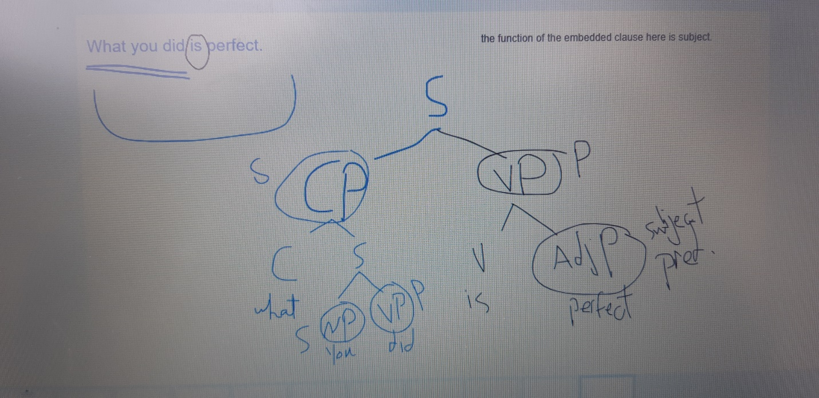
the function of the embed clause here is subject.

CP \complementizer phrase\embedded clause: its dependent clause can’t stand by its own.
CP must have a function to the main sent. Ex: I know that Mary loves John. Here the CP functions as a direct object.
Sometimes we can have a CP without the complementizer itself,
For ex: I believe you should see a doctor soon.
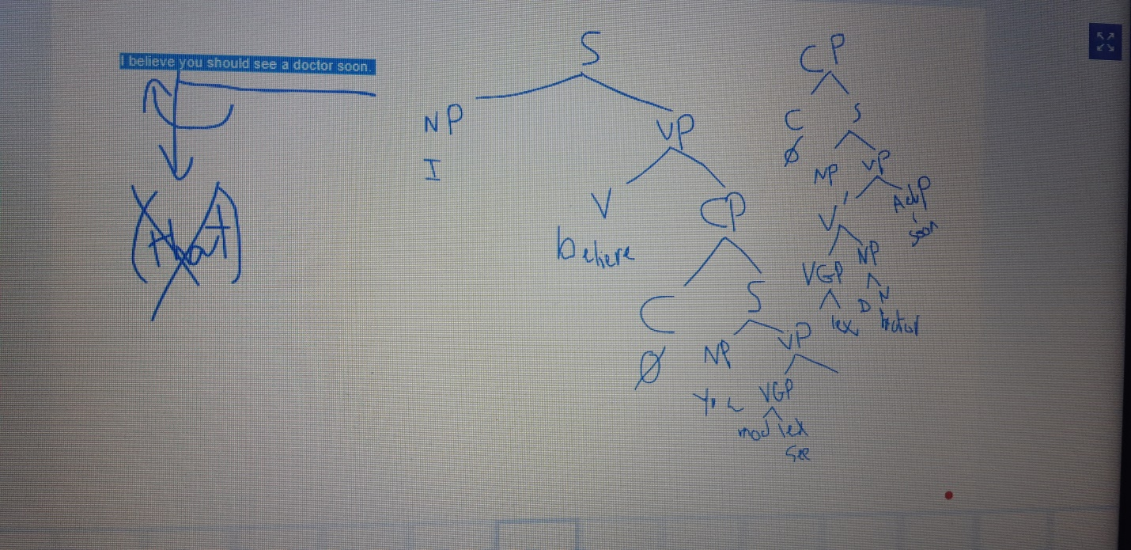

*note: with copula verb (verb to be or the verbs that is not an action verb), the complement that we have is usually (subject predicate)
*note: when the dr ask me for the functions in the sent. Then I mark the phrases in the sent. As the main VP, NP, the embedded CP, NP, VP

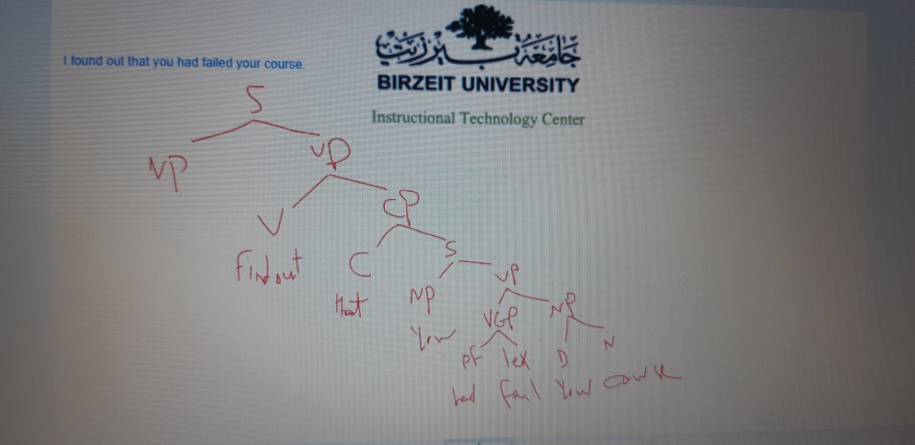
*Tree diagram for this ex:
I found out that you had failed your course. The CP here function as a phrasal object cause (find out) is a phrasal verb, and here find out is a finite, cause I can change its tense and so it can show me time

CP\Finite clauses\ embedded can be:
1. DO, ex: I know that Mary loves John
2. Subject predicate, ex: you are what you eat.
3. Phrasal object, ex: I found out that you had failed your course.
- Subject, ex: That you smoke annoys me.
- Adverbial, ex: You study grammar because it's a requirement.

*It annoys me that you smoke: (it) here called a dummy subject (it replaced the CP), and this replacing called extra position. It’s when I dont want for the CP to be the subject.

*tree diagram for: You study grammar because it's a requirement.
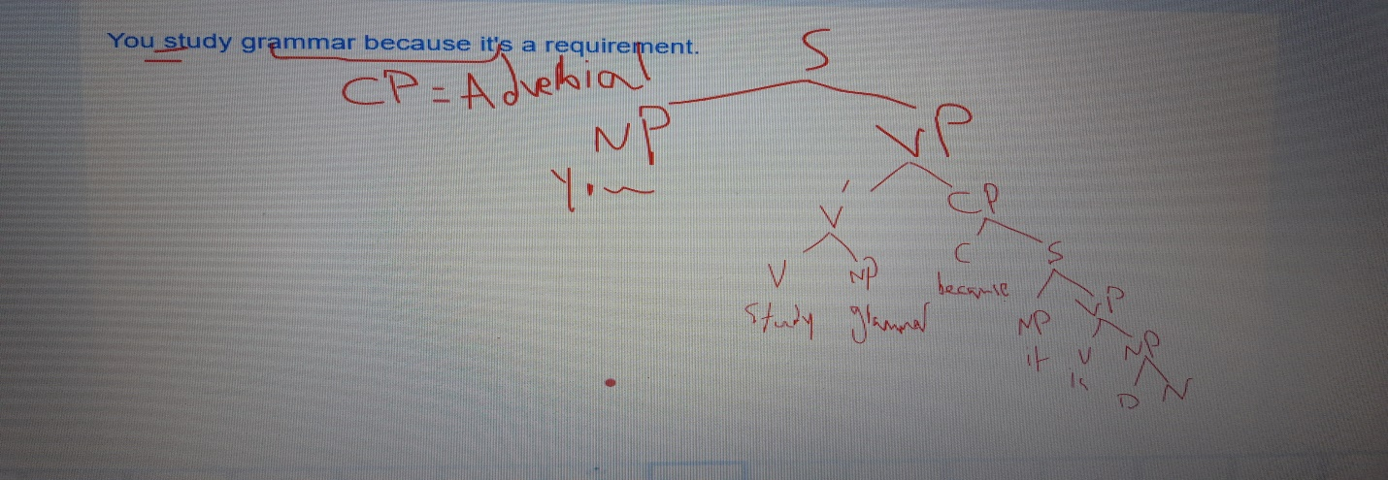
The CP here is an adverbial cause it’s optional (I can delete it), and flexible, I can change its position.

V.I: Tree diagram for this sent. :
They suggested that the sketch was done by the daughters of the architect.
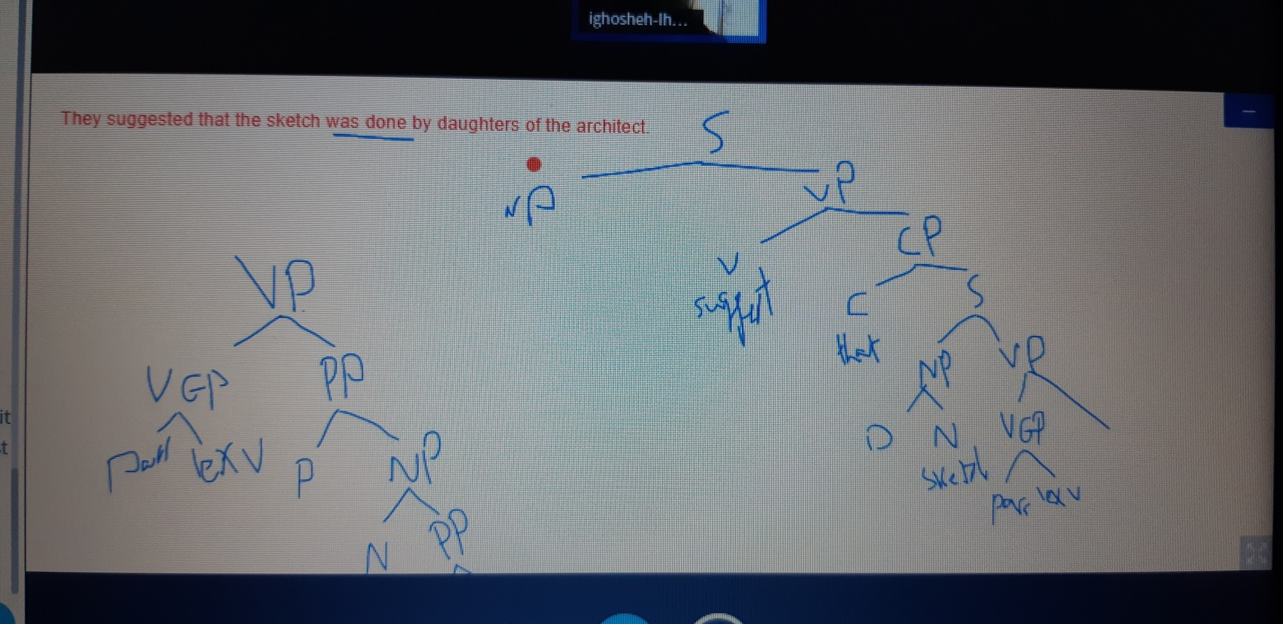

Tree diagram for this sent:
Fortunately, Zelda discovered that Zoltan missed her
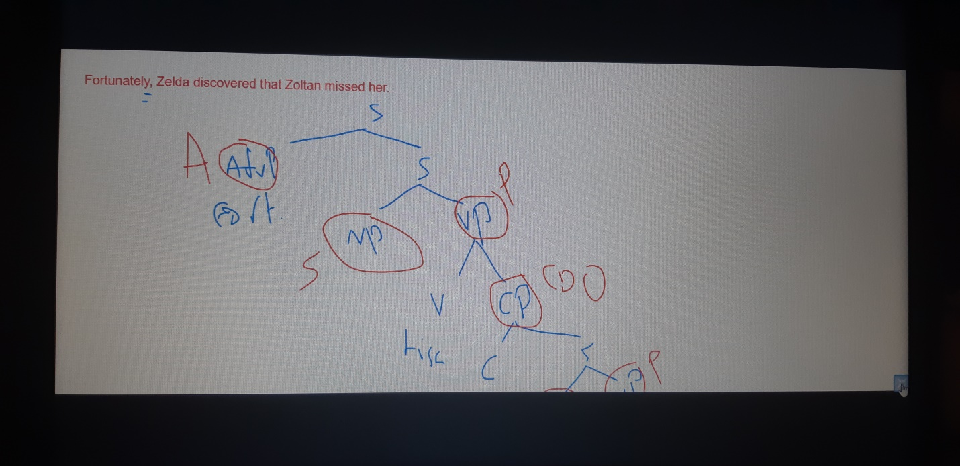

*note: (your) consider as a determiner
*when I have a clause: there will be in it:
- Words: adj., n., v., determiner, complementizer…., but those words has no function we label them as if it is their identities but not their function
- Phrases: np, vp, cp, pp, adv. p, Adj. p, and their function can be either sub predicate, object predicate, adverbial, sub, predicate, cdo, cio
*usually when I have a phrase that started with the prep. (By) then the phrase is an adverbial cause the (by) thing is usually optional and flexible.
*when I have a verb that can show me the past tense of it then finite.
*nominative: means that the pronoun is in the subject form (I ate)
Accusative: means that the pronoun is in the object form (you saw me)
*bare infinitive: there is no infinitive in the sent.

*nonfinite verb:
- tens less
- doesn’t show agreement with the sub
- its subject usually come in the accusative form
*what makes a clause in English is: subject, verb. These two are more important than a compliment (object or sth else….)

*Imbedded clauses: the one can’t stand alone (cp) ,sometime can be in a sent without the complementizer( cause its understood that it’s there) so in a tree diagram we put this shape in the place of it Ø, or whenever sth is understood that it’s there but not written
*anything that introduces an imbedded clause (dependent clause) is a complementizer
Ex: I know when(C) you were born (cp, here it’s a cdo)

Ex: While I was eating breakfast.my friend called (this is an adverbial) *(I have 2 clauses cause I have 2 finite lexical verbs)
Finiteness: identifying tense and agreement with the subject

Nonfinite: lacks verb tense and lacks sub. + A non-finite verb means a non-finite clause
Ex: While having (this verb doesn’t have a sub and doesn’t show a tense, so it’s a nonfinite clause) breakfast. My friend called (this verb is finite and show tense and agreement with the subject, so it’s a finite clause)
Non-finite verbs/clauses:
1. infinitive (to+base form of v.), ex: To open the window (this is a tens less clause, and there is no sub), you need a ladder (this one had tense and agreement with the sub).
2. Present participle (v+ing), ex: Being (tens less, we don’t know when this verb is taking place) a qualified teacher, I could (has a module, and module always indicate f) easily find a job.

- Past participle (v+ed/en), ex: done last minute, the report was ready for submission.

A clause needs a subject, and a predicate (verb)
1 lexical verb= 1 clause
2 lexical verbs= 2clauses

Infinitive:
a. to+verb I need to go(c2) to the doctor(c1)

B. bare infitive: infinitive but without to
Ex: I helped you pass (non f). (There is no to, but the verb is inf.)
VI: Ex: I wanted you to pass (you here is the subject of pass not the object of wanted, but it’s in the accusative form, cause nonfinite verbs shows no agreement with the sub so mostly their subjects come on the object form) *(the subject in this sent. Is the whole clause (you to pass)

2. Present participle
finding (subject less, tens less) a job has become really hard.*(if I want to make sure that this verb is nonfinite I put a subject in the accusative form: me finding a job has become really hard. (And we know finding here is a verb cause it have an object and if we remove it the sent. Wouldn’t work)
These words are present participle but not verbs except for smoking
This movie is boring. (Adj.)
Smoking cigars is bad. (Verb cause it has an obj.)
Swimming is awesome. (This here is a noun and this n. is the sub. Of this sent.)
Past participle:
Killed (it’s a v. cause of the by, only verbs accepts the by) by his illusions, the poet never understood a thing!
Watching movies is fun / To watch movies is fun
In these sent. The complementizer and the np when I draw a tree are presented like this Ø because they are not there, it’s understood that they there but not written as:
For(C) him (NP) watching (non f) movies is fun\ for him to watch movies is fun
The only different between these 2 sent. Is that in the inf. One when we write the VP in a tree instead of V we put a VGP the inf. And the main v
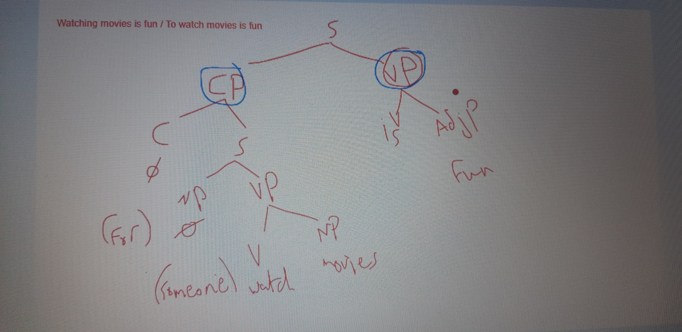

To be or not to be is the question *(or here is a coordinator)
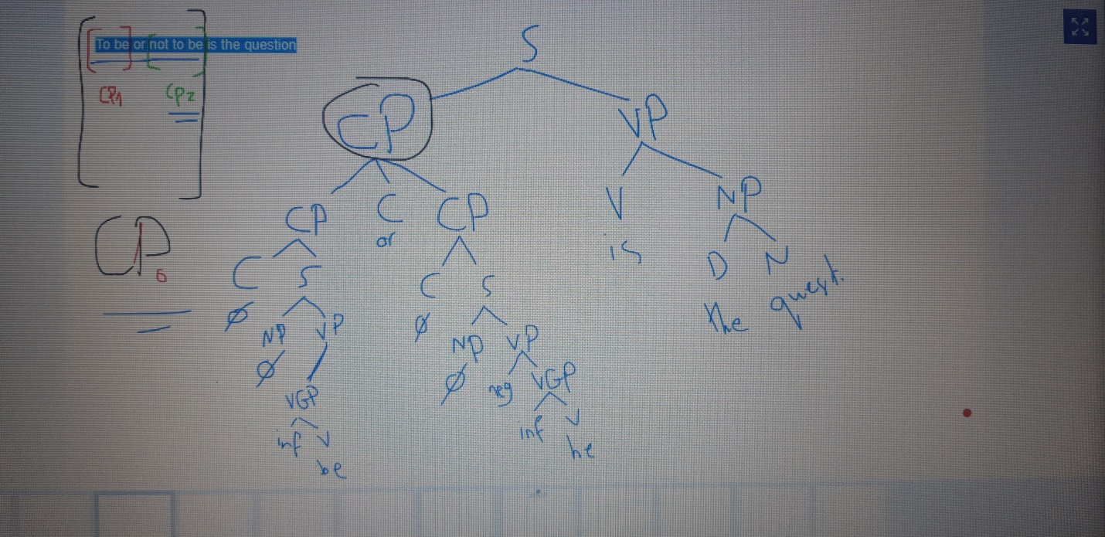

The possible functions of non-finite embedded clauses:
1. Subject
2. CDO
3. Subject predicate
4. Adverbial

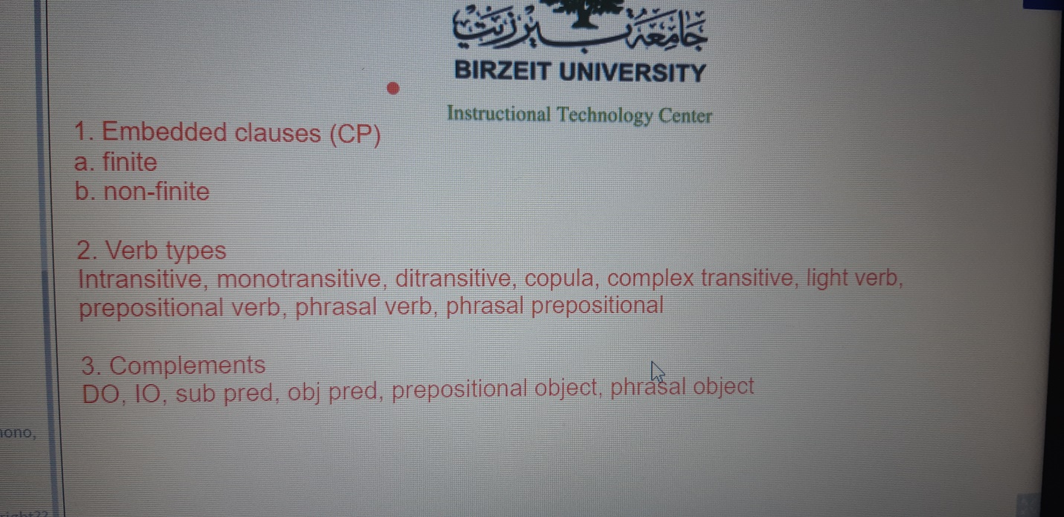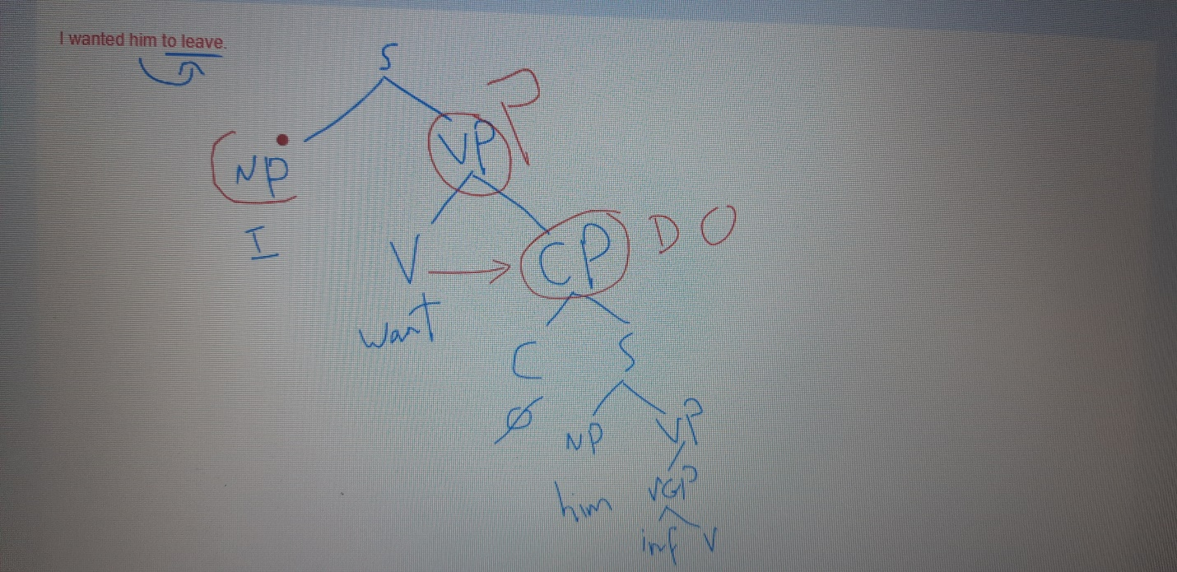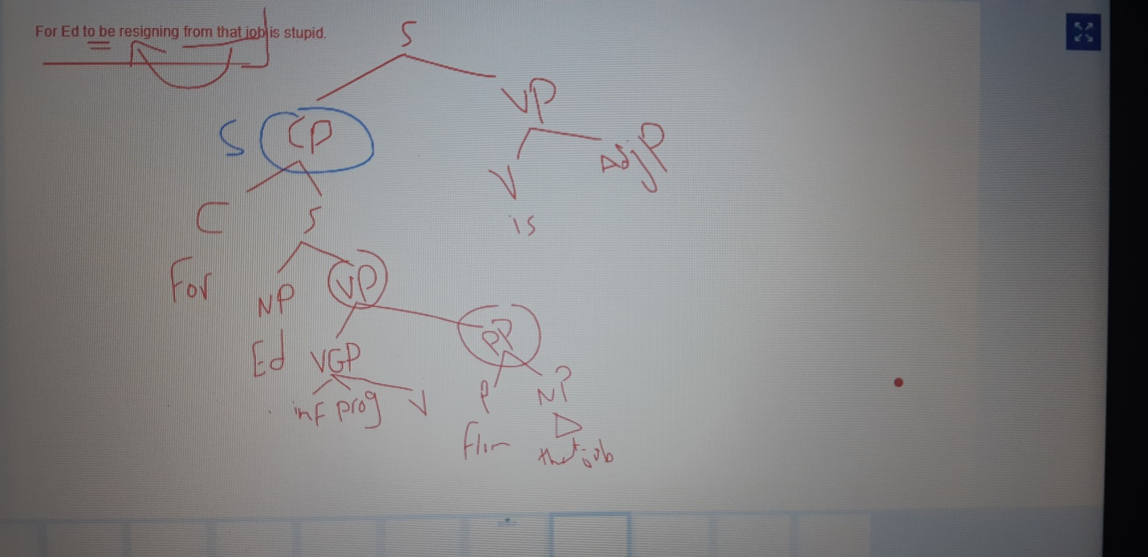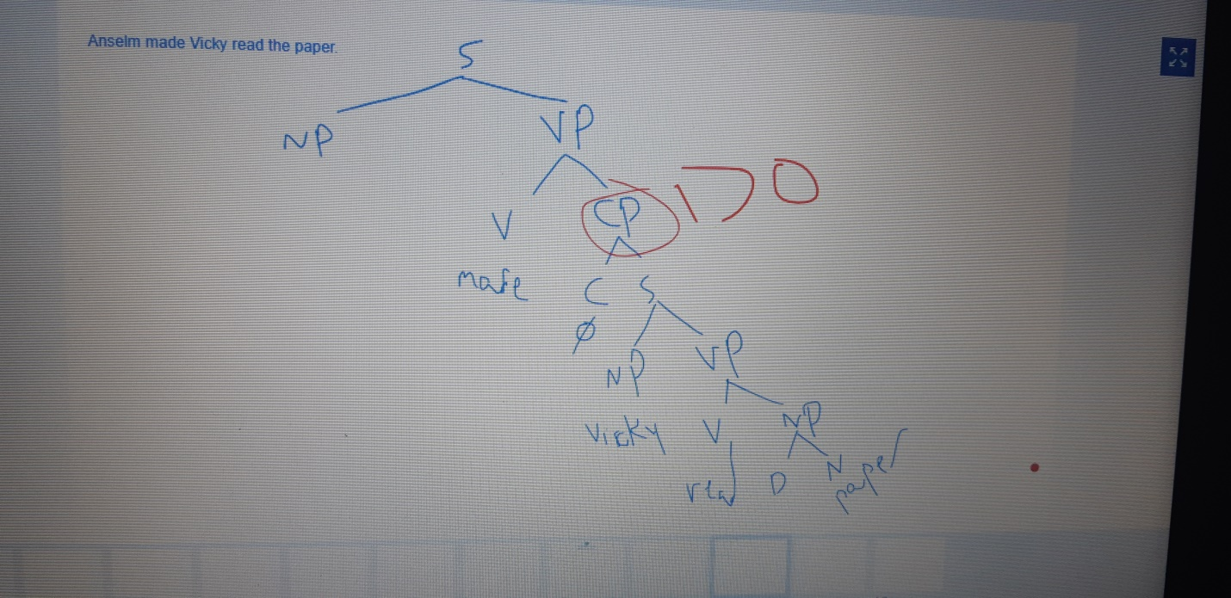

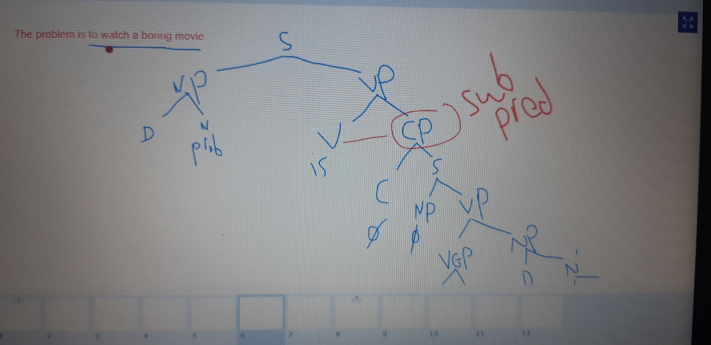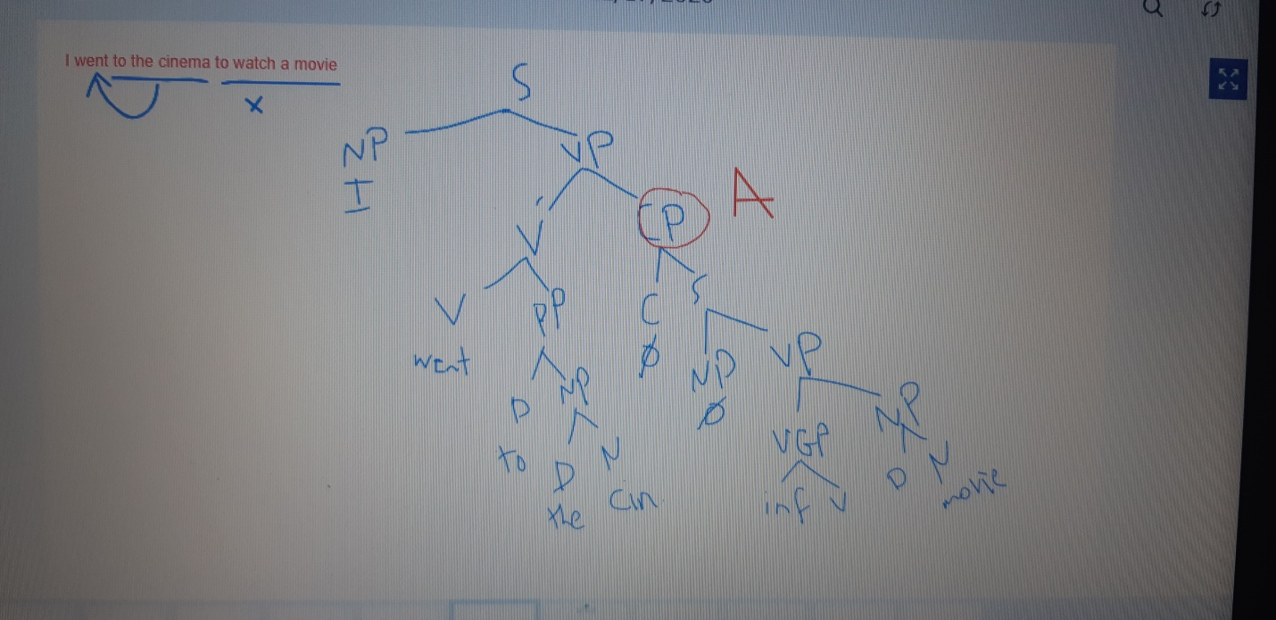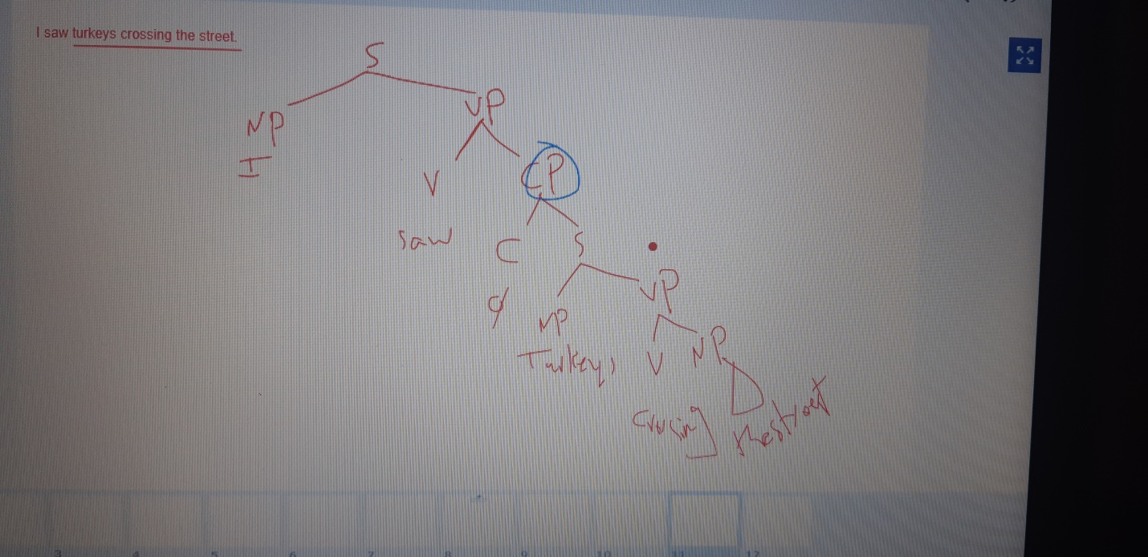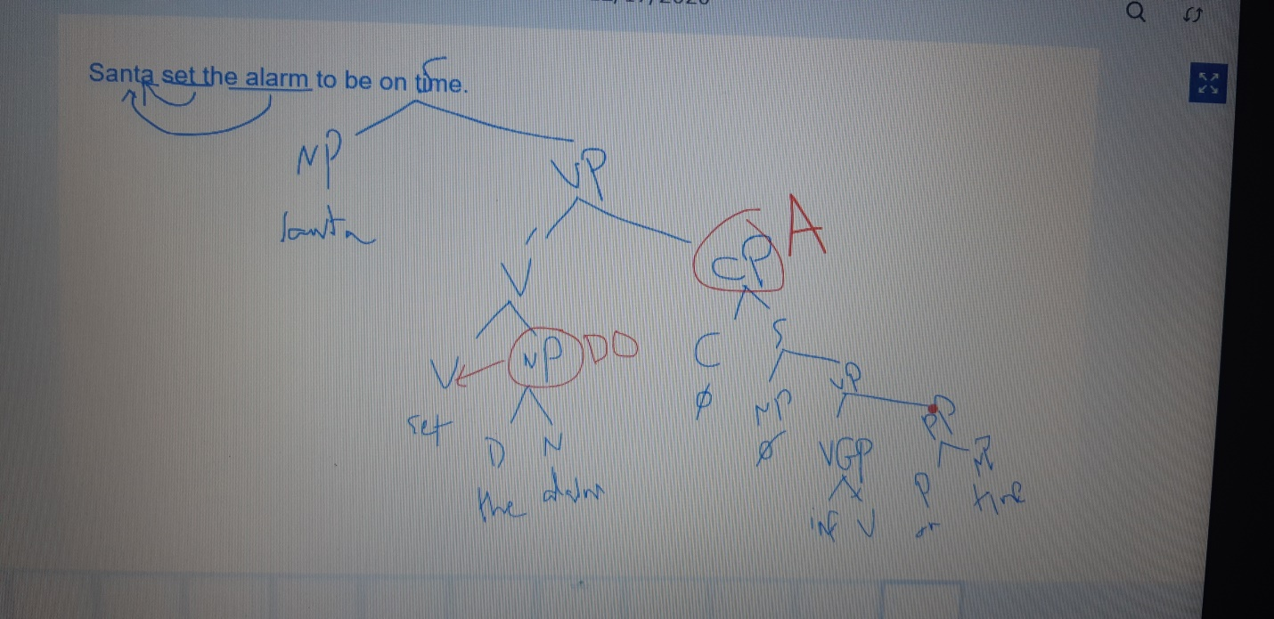

Note:
Clausal functions:
1. Subject not optional in a clause (can’t have more than 1 in a clause)
2. Predicate not optional in a clause (can’t have more than 1 in a clause))
3. Complement optional in a clause (can have as many as I want in a clause)
4. Adverbial optional in a clause (can have as many as I want in a clause)
Note:3, 4 are included In 2
Phrases:
Clause: made of number of phrases (np, vp, pp...), sentences: made of number of clauses (finite, nonfinite….)
About the phases:
There are inside functions for phrases
Ex: ... In the garden ... (this is a phrase that has a head which is the P, it’s not a sent. and the head of the phrase is the function of it)
*Note: there is no pp without an np in it, I can’t have (in) alone as a pp it should be (in the garden) to be a pp(in here is the head of the pp, and the garden is the complement\oblique (oblique means the object of sth) of the head
*Note: the PP is not usually modified, they’re too weak to be modified can’t accept modification)
Phrasal function:
- The head (the word that I can’t have the phrase without, for ex I can’t have a pp without the preposition)
- Complement (essential for the head, like the np (the garden) in the pp (in the garden))
- modifier(s): (they can an article, adverb, adjective…., and their function is modifying, I can have multiple modifiers)
(They’re not essential for the head) ex: in the garden (the NP (not the whole PP) the garden have a head (garden) and a modifier (the) I have a mod. For the np but not for the pp

.. On the roof of the big house..

PP (On the roof of the big house) the main phrase
Np (the roof of the big house) embedded phrase
Pp (of the big house) embedded phrase
Np (the big house) embedded phrase
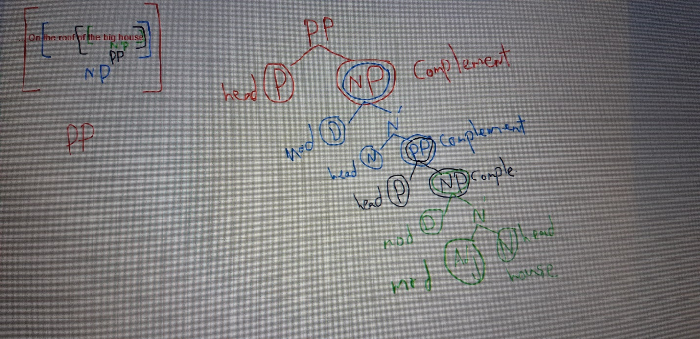

Ex: on clausal and phrasal functions in one sent. : I’m happy that you passed the exam.
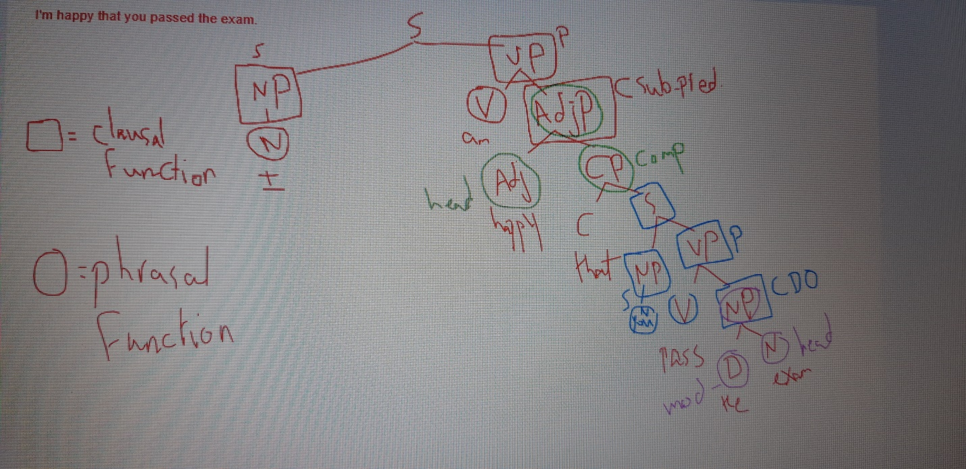
*Can I put a modifier for the head of the adj. phrase?
Yes I can, but it is essential it is optional, ex: I am very happy that you passed the exam.
*note: the pp and the adv.p in a sent. Is the least significant thing in a sent.

A student of English with red hair.
In this sentence I have the head with the modifier (a student)
I have a complement (of English) the what part, it is important and I can’t change its position, it should be closer to the head)
I have another modifier (with red hair) *not another complement
Functions inside a phrase:
1. Head
2. Modifier (s) , they can be multiple one is: pre modifier before the head, the other post modifier after the head
3. Complement
*in a sentence beside the main np and the vp, I have compliments, these comp. either central ((اساسي (answers the who and the what) or peripheral ((جانبي \ثانوي answers (the when and the where and the how) the compliment that answer central information is more important the peripheral.
*A teacher of English with red hair (grammatical) why: cause the what part here is more important so I put it near the head
*A teacher with red hair of English (non-grammatical) cause the important information is not near the head
*A teacher with red hair of English from France (non-grammatical) cause the important information is not near the head
No matter what I tried to put PPs in this sentence the most important one of them that likes to stick with the head is (of English) that’s why it’s a complement not a modifier.
*I can have as many modifiers as I can and I can switch their position as I want, but only one compliment and should be next to the head
*Inside a NP, determining if a PP is a complement OR a post modifier:
1. A Complement carries more important info for the head. (the what part is more important than the other parts)
2. A complement to a head must be adjacent (next to) to it. (And that’s when I have a sent. With both a complement and a post modifier but if I had only a post modifier, then it can be next to the head
3. You can have more than one modifier to a head and their position isn’t fixed, but only one complement and that complement should be next to the head
4. If you can put a PP in relative clause with be /have, then the pp is a modifier.(Relative clauses: if I can replace a pp with a relative clause then it’s a modifier if I can’t then it’s a complement : A teacher from France A teacher who is from France , it worked then it’s a modifier.

5. Convert the head to a verb if the pp turns into a direct object then it’s a comp., if it turned to a complement then it’s a modifier.
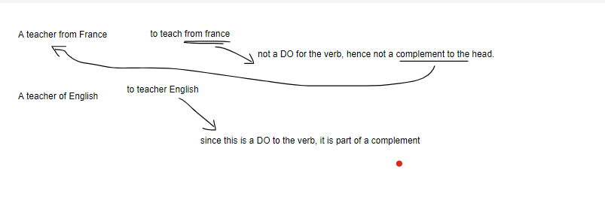
6. 5. When you have two PPs on a tree diagram, the one next to N is a complement, and the one next tor N bar is a modifier.
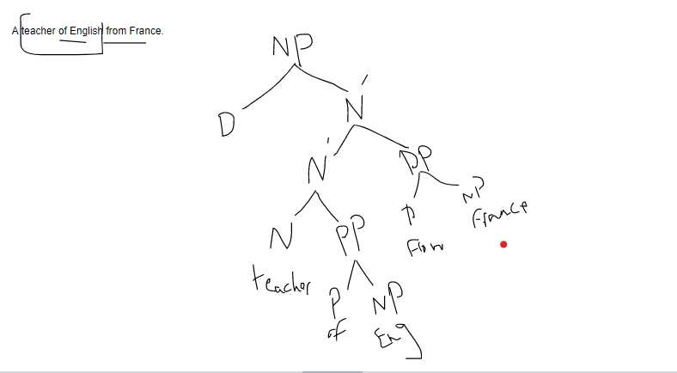

Ex on point 6: A nice teacher of English from France.
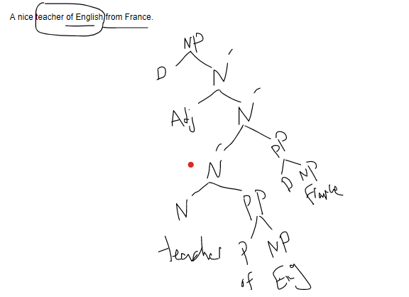

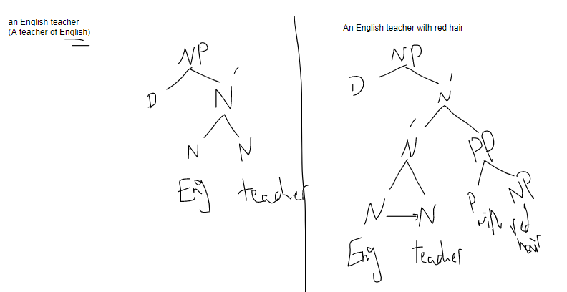
Ex on point 6

Functions inside phrases:
- Head
- (Compliment) you can choose not to have it (we use it cause we can only use one) in a phrase.
- (Modifiers) (s) You can choose not to have them (we use them cause we can use as much as I want) in a phrase.
Relative clauses:
The student who gave a presentation has a nice accent.
Who gave a presentation (this is an embedded clause CP, can’t stand alone) who here is a complementizer cause it introduces a clause. And this cp is a part of the noun phrase (The student who gave a presentation) it’s a one unit I can replace it with a (he), and the CP is a RC (relative clause) and this RC is a modifier cause if I added another unit like: (The student of English who gave a presentation has a nice accent.) so the RC didn’t stick to the head once we added (of English) and we can delete it.
*relative clauses that came as embedded clauses inside a noun phrases is always a modifier to the head

Who: subject
These are a clausal function
Gave: predicate
Presentation: direct object
Ex on when I have a CP (RC) within the noun phrase:
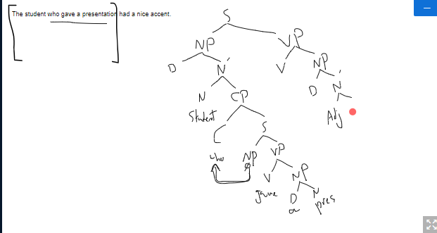

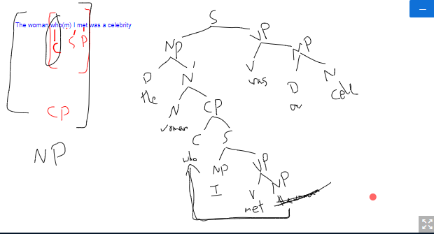
*Note: focus on what he did with (the women)
I have two kinds of RC, but they both considered modifiers to the head, and the different isn’t in their modification, it’s about how restrictive is specific and non-restrictive are more like (by the way kind of information), and they both give attention to the head but the restrictive gives it more attention like (a spotlight focus), and they both can be omitted considering they both are modifiers but the one that are more likely to be omitted is the non-restrictive one, Again, there isn’t a massive different between them it’s a subtle ((غير ملحوظ different, it’s just about the focus on the head, and subtle different in meaning.
Restrictive RC:
- Can use (that) in it instead of the complementizer (note: that is more important and gives more info. To the head , And it make the whole RC more solid than other complementizers, and doesn’t need a comma before it)
- Don’t have commas, or just have 1(either before it or after it, and its optional)
- Shows back ground information but an essential info)
- This RC is important for the head, the head can’t survive without it
Ex: children who eat vegetables are healthy: all the information here is essential, both the RC (who eat vegetables) which is a modifier, and the complement (are healthy)

Non-restrictive RC: بتشبه الجملة المعترضة في العربي, يعني بقدر استغني عنها
- Have 2 commas (one before it, another after it)
- Can’t use (that) in it instead of the complementizer
- Shows back ground information (by the way information, which is not that necessary)
- The RC isn’t that important for the head, the head can survive without it
Ex: children, who eat vegetables, are healthy: here we mean that all children are healthy (this is the necessary info.) and by the way the one who eat vegetables are healthy too

Examples on restrictive and non-restrictive:
- The participants who were invited volunteered for the study (restrictive)
*not all the participants volunteered for the study, just the ones who were invited
- The participants, who were invited, volunteered for the study (non-restrictive)
*all the participants volunteered for the study and also by the way they were invited.

*The point that you are trying to make is not valid: (if I want to make sure that this is a RC I replace (that) with (which\who) :
The point which you are trying to make is not valid. (This sent. Sounds as likely as when it was with that, so it is a RC, and because it’s a RC then it’s a modifier. Cause relative clauses are always modifiers.
* The fact that you are a good athlete makes me happy.
The fact which you are a good athlete makes me happy. (When I replaced (that) with (which) the sent. Didn’t seem right so (that you are a good athlete) isn’t a RC. It’s a complement.
*Note: the two sent. Are a CP
Note: not every (that) in a sent. Is a relative that, the relative one can be replaced with (which\who) or deleted, and there is a complement that which I can’t delete, but I can delete the head within the same sent.
The test that I do to know if a clause is a complement or a relative clause is to delete the head if it works then the CP a complement, if it didn’t then it a relative clause. Ex:
That you are a good athlete makes me happy. (It worked) (Complement to the head)
That you are trying to make is valid. (It didn’t work) (Relative clause=modifier).
*there is another test which is removing the complementizer, if it worked then it’s a relative clause if not then it’s a compliment cause the (that) in the compliments can’t be deleted t5he complement can’t survive without the (that).
The fact you are a good athlete makes me happy. Didn’t work (compliment)
The point you are trying to make is valid. Worked (relative clause)
*Note: not all (that) we see in a sent. Is a relative that, it might be:
- Demonstrative: that boy
- Noun: I don’t like that
- A complement (that)
- A relative (that)
The news that she was dead shocked us all.
The CP here is a complement clause not a relative clause.

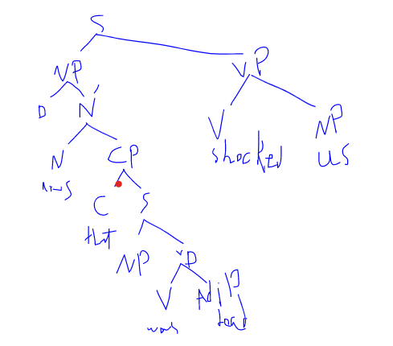
The CP (I always write it as a CP) whether it was RC or CC, and is always a part of the NP when it’s there to emphasize the head, and usually there is no difference between a relative clause and a complement clause in a tree diagram
Other Examples on how to know if the clause was a RC or CC:
- Reports that the country will go into another lockdown are lies. This is a complement clause, because I can’t delete the (that) as the tests we did, and deleting the (that) is the most powerful test.
- The javelina that I saw next door was unafraid of coyotes. This is a RC cause I can delete (that) or replace it with (which) and still be true.
- The report that javelinas are dangerous is exaggerated. This is a complement clause, because I can’t delete the (that).
- Gerald, who lives next door, will be leaving soon. This one is a non-restrictive relative clause because it’s between two commas. Also we can’t delete the head

*In a RC the relative pronoun (that\who\which) has a particular function in the clause (subject\complement) but in a complement (that) doesn’t have a function.
- The president [that founded this organization] was arrested. (That here has a function; it’s a (subject) so it’s a RC.
- I am the man [to fix this]. This is a reduced non-finite relative clause (i am the man who is needed to fix this), and because I can delete (who).
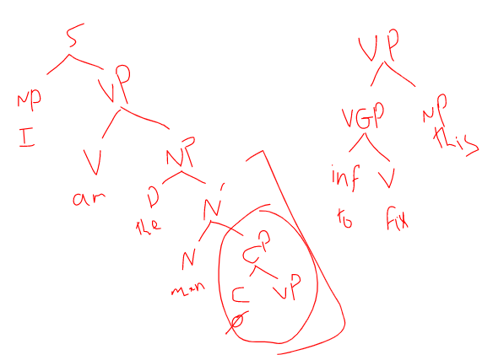

- The story [that the minister went to France] seems true. This is a complement clause cause (that) doesn’t have a function.

Ex: that you are a doctor and she is a doctor is known for us.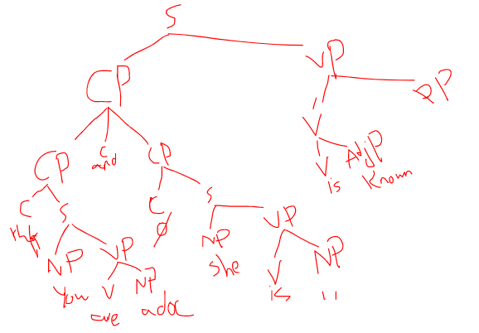

I am here to inform you. (I am here for me to inform you)
