**Formula sheet Exam 2**

**Constants**

Water γ =9790 N/m3 =62.4 lbf/ft3

g=9.8 m/s2 = 32.2 ft/s2

Atmosphere= 101.3kPa = 14.7 psi

**Mass conservation**

ρ = P/ (TR)



$\dot{m}=ρVA=ρQ$

$$\frac{dmcv}{dt}=\sum_{in}{\dot{\dot{m}i-\sum_{out}{\dot{me}}}}$$

∑ m`in  = ∑ m`out

**The Linear Momentum Equation**



$$\sum{F=\sum_{out}{\dot{m}V-\sum_{in}{\dot{m}V}}}$$

**Angular momentum**





**Energy equation**



$$\dot{W}pump=\dot{m}ghp=ρgQhp=γQhp$$

HGL=z + p/ϒ

EGL = HGL + *V*2/(2*g*)

**Bernoulli’s equation**

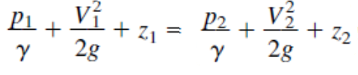

**Dimensions**

