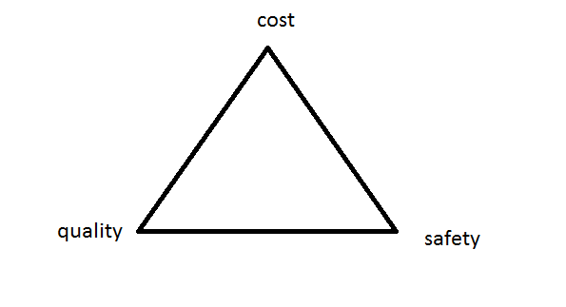

Properties are the way the material responds to the

environment and external forces.

**Stress vs strain curve**

