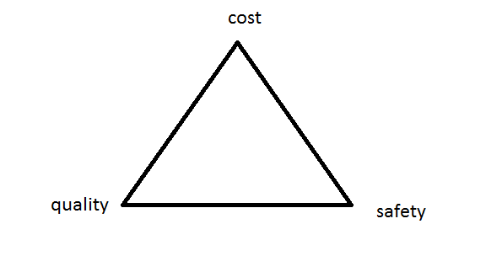

Properties are the way the material responds to the
environment and external forces.

Stress vs strain curve

