

**Faculty of Engineering and Technology**

**Mechanical Engineering Department**

**Fluid Mechanics laboratory**

**ENME312**

**Experiment #9**

**Pressure Losses in Ductwork and Pipes**

**Instructors:**

**Dr. Adel Dweik**

**Eng. Alanood Moudai**

**Done by group 3:**

Khaled Wahdan 1191584

**Ahmad Sabobeh 1191922**

Aws Daraghmeh 1191856

**Date of performing the experiment: 9.5.2022**

**Date of submitting the experiment: 16.5.2022**

**Abstract**

When designing Systems containing fluid flows, an important factor that should be always taken into consideration is Energy Losses. Those losses can be either dynamic or frictional. Friction losses happen due to fluid viscosity, while Dynamic losses occur due to change on direction. In order to overcome those losses, a suitable pump or fan must be calibrated to deliver the required energy with taking those in consideration.

In these two experiments, losses were to be determined once for air flow inside ductworks, then for water flow in a closed pipe. So, the main **aim** is to collect data about pressure difference at certain points, in addition to flow rate values so that we can work out the head loss in the desired part.

In the first part, the fan forces the air through the ductwork set-up. Multiple obstacles were mounted on the flow channel such as a Screen, elbows, Venturi, Orifice, and a heater. Pressure difference around each component is measured separately and recorded into a table. Figure (1) below show the set-up we had at the laboratory.



*Figure (1): Ductwork Set-up to test air flow losses.*

On the other hand, part two was about determining losses in water flow through a closed pipe. The experiment was conducted at a low flow rate. Hence, another way for determining mass flow rate was required. So, we got a graduated container and measured the time needed to fill a certain quantity of water. Pressure head was found through manometer readings between two points with known in-between distance. Figure (2) shows the set-up for the low flow water rate losses experiment.

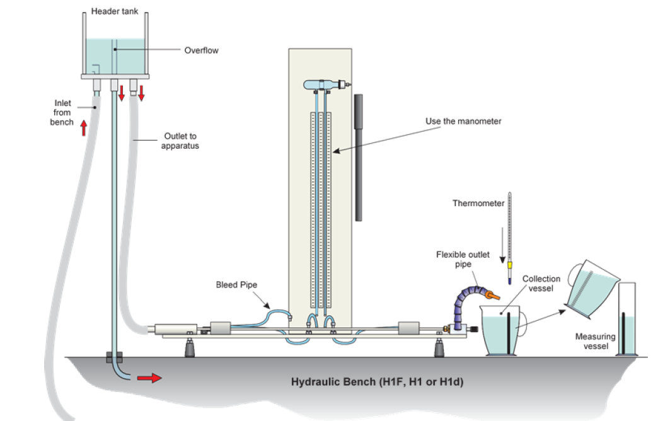

Figure (2): Set-up to test water flow losses.

**Objectives**

To Measure:

Ductwork:

* Pressure Difference between several points.
* Orifice-Meter hydraulic head.
* Venturi-Meter hydraulic head.
* Cross-sectional Area.

Water Pipe:

* Manometer Readings between two different points.
* Quantity of water needed to fill a certain level and the Time required to fill it.
* Cross-sectional Area.

To Analyze:

Ductwork:

* Main velocity in pipes.
* The Pressure Loss Factor (K).
* Friction Factor (f).
* Equivalent Length for each part.

Water Pipe:

* The velocity, gradient, and viscosity of water in each run.
* Relationship of the gradient vs velocity.
* Reynold number in each case.
* Friction in each case.
* Flow Rate vs. Velocity.

To Determine:

* Type of water flow depending in Reynolds Number.
* Flow rate values from the orifice and venturi in the ductwork part.

**Sample Calculations**

Ductwork:

* $Pipe Cross sectional Area: A= \frac{π}{4} × D^{2}$**----(1)**
* D = 0.0983 m
* Pressure Loss: $ΔP= ρg(dh)$**----(2)**

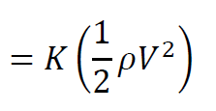

* Pressure Loss Factor **K** from: **----(3)**
* Equivalent Length: $Leq = \frac{K ×D}{ƒ}$**----(4)**

$ƒ (friction factor)=0.025$

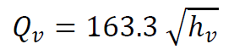

* Venturi Flow Rate: **----(5)**

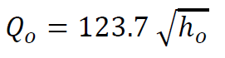

* Orifice Flow Rate:  **----(6)**
* Main Velocity: $V_{main}= \frac{\frac{Q_{v}}{A} + \frac{Q_{o}}{A}}{2}$**----(7)**

Water Pipe Flow:

* $Pipe Cross sectional Area: A= \frac{π}{4} × D^{2}$**----(8)**
* D = 0.003 m
* $Volumetric Flow Rate: Q \left(\frac{m^{3}}{s}\right)= \frac{V\left(ml\right)×{10}^{-6}}{Time (s)}$**---- (9)**
* $Velocity: u \left(\frac{m}{s}\right)=\frac{Q}{A}$**----(10)**
* $Hydraulic Gradient$: $i= \frac{Δh}{L}$**----(11)**
* 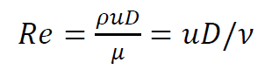L = 0.524 m
* Reynold’s Number: **----(12)**
* Dynamic Viscosity = 1.004 x 10-3
* Theoretical Friction Factor: **----(13)**

**Results**

Table (1): Data and Calculations for the Ductwork (Section, Pressure head, Pressure, Pressure Loss factor K, Equivalent Length)

|  |  |  |  |  |  |
| --- | --- | --- | --- | --- | --- |
| Section | | pressure head loss (mm) | ΔP | K | Leq |
| 1,2 | Screen | 41 | 0.482652 | 0.0075 | 2.9431 |
| 2,3 | Straight Duct | 0 | 0 | 0.0000 | 0.0000 |
| 3,5 | Orifice Meter | 12 | 0.141264 | 0.0022 | 0.8614 |
| 5,6 | Round Elbow | 2.5 | 0.02943 | 0.0005 | 0.1795 |
| 6,7 | Straight Duct | 1 | 0.011772 | 0.0002 | 0.0718 |
| 7,10 | Venturi Meter | 4.5 | 0.052974 | 0.0008 | 0.3230 |
| 10,11 | Round Elbow | 2.5 | 0.02943 | 0.0005 | 0.1795 |
| 11,12 | Heat Bank | 5 | 0.05886 | 0.0009 | 0.3589 |
| 12,13 | Straight Duct | 1 | 0.011772 | 0.0002 | 0.0718 |
| 13,14 | Round Elbow | 2.5 | 0.02943 | 0.0005 | 0.1795 |
| 14,15 | Straight Duct | 1.5 | 0.017658 | 0.0003 | 0.1077 |
| 15,16 | Right Angle elbow | 11 | 0.129492 | 0.0020 | 0.7896 |
| 16,18 | Straight Duct | 2 | 0.023544 | 0.0004 | 0.1436 |
| 1,18 | *Total ΔP loss* | 94 |  |  | 6.2092 |

Table (2): Required data for Ductwork Calculations (Heads, Diameter, flow rates and velocities)

|  |  |  |  |
| --- | --- | --- | --- |
| ho | 5.3 | Qo (m3/s) | 0.079105 |
| hv | 3 | Qv (m3/s) | 0.078568 |
| d | 0.0984 | Vo | 10.40747 |
| Area | 0.0076 | Vv | 10.33676 |
|  |  | V | 10.37212 |

Table (3): Data for Water flow in the pipe (Volume of water filled, Time, pressure heads).

|  |  |  |  |  |
| --- | --- | --- | --- | --- |
| **V**  **(m3)** | **Time**  **(s)** | **h1**  **(mm)** | **h2**  **(mm)** | **dh (mm)** |
| 500 | 50.17 | 480 | 70 | 410 |
| 500 | 55.13 | 465 | 90 | 375 |
| 500 | 55.9 | 450 | 110 | 340 |
| 500 | 62.4 | 415 | 155 | 260 |
| 500 | 67.84 | 380 | 192 | 188 |
| 500 | 88.97 | 360 | 230 | 130 |
| 500 | 189.7 | 330 | 265 | 65 |

Table (4): Calculations for the Water flow in the pipe (Flow Rate, velocity, hydraulic gradient, Temperature, Viscosity, Reynolds’, and Theoretical friction loss).

|  |  |  |  |  |  |  |
| --- | --- | --- | --- | --- | --- | --- |
| **Q**  **(m3/s)** | **u**  **(m/s)** | **i**  **(m.m-1)** | **Temp**  **(C0)** | **Viscosity**  **(N/m2)** | **Reynold**  **Number** | **fth** |
| 9.966E-06 | 1.411 | 0.782 | 20 | 1.004E-03 | 4215.0 | 0.0094 |
| 9.069E-06 | 1.284 | 0.716 | 20 | 1.004E-03 | 3835.8 | 0.0096 |
| 8.945E-06 | 1.266 | 0.649 | 20 | 1.004E-03 | 3783.0 | 0.0096 |
| 8.013E-06 | 1.134 | 0.496 | 20 | 1.004E-03 | 3388.9 | 0.0099 |
| 7.370E-06 | 1.043 | 0.359 | 20 | 1.004E-03 | 3117.2 | 0.0101 |
| 5.620E-06 | 0.795 | 0.248 | 20 | 1.004E-03 | 2376.9 | 0.0108 |
| 2.636E-06 | 0.373 | 0.124 | 20 | 1.004E-03 | 1114.8 | 0.0131 |

Figure (3): Hydraulic Gradient Vs. Water Velocity (m3/s) relationship.

**Discussion of Results**

The main purpose of the experiment was to study the energy losses in air and water flows by finding pressure differences between certain points. In the first part, the effect of each individual component was determined. Whereas in the second, losses were determined at various flow rates and the effect of each was demonstrated through numbers.

Table (1) shows the calculations done for the first part, and the shared values by the whole system were obtained from Table (2). It can be noticed from the fifth column that the values of pressure loss factor (k) are too small, this is because we are conducting the test on a low air flow. On the following column, the Equivalent Length values are shown, and if we summed up this column we get (6.2 m) and the actual length given from the Manual is (7.42 m).

Another thing worth mentioning in the first part, is that if we summed the values of pressure loss for all component, we get a total of (86.2 mm), and the last reading representing the whole path was (94.2 mm). This difference is considered acceptable for such experiments as we were told by the lab technician.

Table (3) and Table (4) shows the Data and Calculations of the second part, which is water flow in a closed pipe. This experiment was also conducted on a low water flow rate level, this clarifies why most of the obtained flows were classified as Laminar or Transitional based on Reynolds Number. Since only the first run with the highest flow rate exceeded the ‘4000’ mark, hence it is considered a Turbulent Flow.

Figure (3) represents a very important relation in this part which is the Hydraulic Gradient versus the Water Velocity. It’s clear that the two parameters are directly proportional with a close to linear relationship. This curve is usually used to determine the Laminar, Transitional, and Turbulent regions. Figure (4) below shows the classification of zones based on this curve; hence we can notice from our curve that most of our values are in the Transient zone.

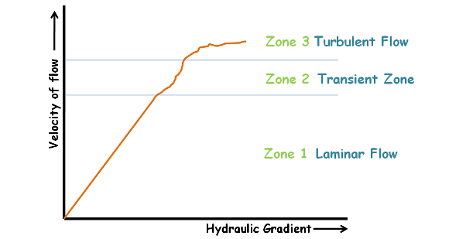

*Figure (4): Flow Types based on the (Hydraulic Gradient vs. Velocity graph).*

**Conclusions**

As a result, we can use the values we obtained to design against those losses in order to deliver the desired flow values for our destination. The numbers we have gotten are considered acceptable for low flow rates, since performing the test on a higher flow rate will give very different values. But for us, we got the expected values and the relations we looked for.

**Applications**

Determining the losses that might happen in systems of water/air flow, in order to design against them. Also testing different parts and materials to minimize the energy losses.

**References**

1. Fluid Lab Manual.
2. Attached Data Sheets.