Birzeit university– faculty of engineering and technology

Department of mechanical engineering

Fluid Mechanic Laboratory

ENME312

Section 1

**Experiment No.6**

**“Flow measuring apparatus.”**

Instructors:

Dr. Adel Dweik

Eng. Alanoud Muadi

Group 5:

Majd Raddad 1201196

Qais Samara 1202956

Mohammad Abu Ayyash 1182690

**Prepared by: Majd Raddad - 1201196**

Date of performance: 11/03/2024

Date of performance: 18/03/2024

Table of Contents

Abstract3

Objectives3

Sample calculation.4

Results6

Discussion of Results 8

Conclusion 9

References 9

Appendices 10

**Abstract**

During the previous experiments, several flow-measuring devices were observed and examined. To understand the operation of each device separately as well as to analyze the results for each device, the venturi meter and the orifice meter were among those devices that were examined and analyzed experimentally. Both of these devices are differential pressure apparatuses that compute flow using the Bernoulli principle and the continuity equation. Another device to be introduced is the rotameter, which is a flow-measuring device based on Bernoulli's principle. The rotameter is made up of a tube with a float that responds to the water flow rate. A reading can be taken directly from the glass tube's scale, which corresponds to the float's position within the tube, and the reading can then be converted into a mass flow rate.

The experiment was carried out using a hydraulic bench and apparatus which includes the three mentioned devices. The main aim of the experiment is to compare and analyze the flow-measuring devices efficiently by calculating the discharge coefficient, which indicates the number of losses through the water flow in the device. The theoretical mass flow rate was determined by taking head readings at the critical venture and orifice locations. For the rotameter, the mass flow rate was determined by taking the apparatus scale reading and directly converting it to a mass flow rate. The discharge coefficient was calculated using the actual and theoretical mass flow rates, and the actual mass flow rate was determined using the weights and the stopwatch.

The resulted mean values of the discharge coefficient were **1.080, 0.718, 1.191** for the venturi-meter, orifice, and the rotameter respectively.

**Objectives**

1. Determining the discharge coefficient for the venturi meter, Orifice meter, and Rotameter at different flow rates and choosing the most effective device used in the piping system.
2. Obtaining the flow rate measurement with a comparison of pressure drop by utilizing three basic types of flow measuring technique.

**Sample calculation.**

The experiment consists of three devices, so the calculation should include all of these devices. Run No. 1 was taken, the calculation as follows:

* The ideal mass flow rate:

$ṁ=\frac{m}{t}$ kg/s (1)

$ṁ=\frac{12}{24.15}$ = 0.497 kg/s

Where:

ṁ: Mass flow rate

m: mass of water (12kg).

t: time in seconds.

**Venturi meter:**

$ṁ_{ Venturi exp}=ρa_{B}\sqrt{\frac{2*g}{1-({\frac{a_{B}}{a_{A}})}^{2}}×\left(h_{A}-h_{B}\right)}$ kg/s (2)

$ṁ_{exp.}=998*0.000201$ (($\frac{2*9.81}{1-({\frac{0.000201}{0.000531})}^{2}}$) * (0.297 – 0.076)) ^1/2

$$=0.45 \frac{kg}{s}$$

Where:

Ƿ: the density of water in kg/ $m^{3}$.

$a_{B}$: Cross- sectional area at section B in m^2.

$a_{A}$: Cross- sectional area at section A in m^2.

g: acceleration due to gravity (9.81 m/ $s^{2})$.

$h_{A}$: the height of water at section A (m).

$h_{B}$: the height of water at section B (m).

**Orifice meter:**

$ṁ_{Orifice exp}=ρa_{F}\sqrt{\frac{2*g}{1-({\frac{a_{F}}{a_{E}})}^{2}}×\left(h_{E}-h_{F}\right)}$ kg/s (3)

$ṁ_{Orifice exp}=1000*0.000314\sqrt{\frac{2*9.81}{1-({\frac{0.000314}{0.000204})}^{2}}×\left(0.283-0.045\right)}$ = 0.69 kg/s

Where:

Ƿ: the density of water in kg/ $m^{3}$.

$a_{F}$: Cross- sectional area at section F in m^2.

$a_{E}$: Cross- sectional area at section E in m^2.

g: acceleration due to gravity (9.81 m/ $s^{2})$.

$h_{F}$: the height of water at section F (m).

$h_{E}$: the height of water at section E (m).

**Rotameter:**

ṁ= 0.43 kg/s

by using Rotameter calibration curve.

**Discharge coefficient:**

$C_{d}$ = $\frac{ṁ act }{ṁ exp}$

$C_{d}$ venturi = $\frac{0.497}{0.45}$ = 1.106

$C_{d}$ orifice = $\frac{0.497}{0.69}$ = 0.724

$C_{d}$ Rotameter = $\frac{0.497}{0.43}$ = 1.16

Were:

$C_{d}$: discharge coefficient.

m act: Actual mass flow.

m exp: Experimental mass flow.

**From the plotted graphs**

Values of the Discharge coefficient = the slope of the best fit line trend

Cd venturi = 1.136

Cd orifice = 0.722

Cd rotameter = 0.992

**Results**

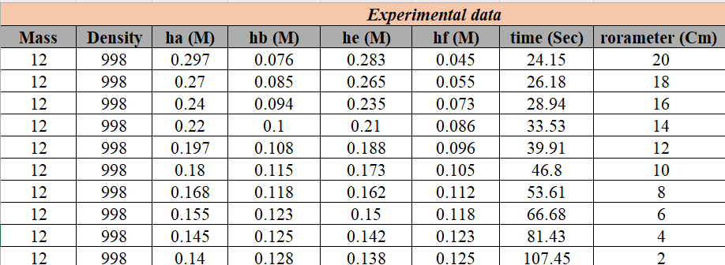Table (1): Experimental data

.

Table (2): Calculated data

* **Cd**: coefficient of discharge for Venturi, Orifice and Rotameter,.
* **m**: mass flow rate for Rotameter, Venturi, and Orifice. (Kg/sec) for rotameter and (m3/sec) for venturi and orifice.

Figure (1): Actual mass flow rate (Kg/s) vs Theoretical mass flow rate (Kg/s) for the flow measuring apparatus.

Figure (2): Rotameter calibration (Actual mass flow rate vs readings in cm)

**Discussion of Results**

The experiment's goal was to compare and analyse the effectiveness of several tested flow measurement devices by determining each device's discharge coefficient. the aim was accomplished through understanding the working methodology of each device and reach to the results regarding each device efficiency and which have less energy losses.

Table (1) presents the experimental results for the venturi meter and orifice. It is shown that the pressure head was recorded at two locations, while the rotameter's reading was taken by rotameter recorder.

Table (2) shows the results of the calculations performed, including the discharge coefficient value and the real and theoretical mass flow rates.

Figure (1) plots the relationship between the theoretical and actual mass flow rates; the discharge coefficient was calculated by finding the slope of this graph and drawing a best-fit line through the data. Figure (2) plots the relationship between the rotameter reading and the actual mass flow rate.

The discharge coefficients for the venturi meter, orifice, and rotameter, respectively, have mean values of **1.080, 0.718, and 1.191** for the manual calculation. Since the discharge coefficient is expected to be less than 1, the results seem to indicate a clear error in the experiment's conduct because losses will always occur in such devices. What was noticed the most is the orifice meter's discharge coefficient of 0.722, which indicates a large head loss due to the sudden change in the cross-section along with other factors related to the device's design.

However, it was found that a rotameter has a larger discharge coefficient than a venturi based on this value, which is predicted to be less than one. so, no conclusions can be drawn from knowing that it exceeded one and the error in taking rotameter readings, which it should give a clear liner relationship.

**Conclusion**

Flow measuring devices and each device's parameters have been tested. such as the discharge coefficient that indicates the measuring device's accuracy. The experiment's errors in the study, taking readings, and other factors resulted in illogical values such as Cd exceeding 1 for the rotameter and venturi, which indicates that the experimental flow is larger than the actual one. As a result, the experiment was unable to provide a very accurate comparison between the tested devices.

For the previously mentioned values in the experiment, the errors that could’ve been the reason behind these values, as usually readings were taken by naked eyes from all the measuring devices (piezometer, rotameter scale (cm) were all these values could’ve been miss-read, the time using stopwatch at the same time of observing the hydraulic bench lever could be not accurate. All these errors might be the reason of reaching to these values.

**References**

* Fluid mechanics laboratory manual (2022, march).
* White, F. M. (1999, January 1). Fluid Mechanics.
* CHE241 - Lab Report Flowmeter Measuremen. (2017). <https://www.studocu.com/my/document/inti-international-university/fluid-mechanics/che241-lab-report-flowmeter-measuremen/4227296>
* Lee, R. C., & Silverman, L. (1943). An apparatus for measuring air flow during inspiration. Review of Scientific Instruments, 14(6), 174-181.

**Appendices**

