

**Birzeit University**

**Faculty of Engineering & Techonology**

**Department of Electrical & Computer Engineering**

**ENEE211**

**“Prelab Exp#3”**

**Student :Mohamad Bornat #1130842**

**Instructor:Dr.Jasser Sa’ed**

**Date: 27\6\2016**

|  |  |  |
| --- | --- | --- |
|  |  |  |
| **Proportionality** |  |  |

**1**- The line below has a slope (proportionality) k=0.651/10.012=0.0651 (points are labeled on the plot)

Or give any value for Vi and find the corresponding value of Vo, and take the ratio.

**2-**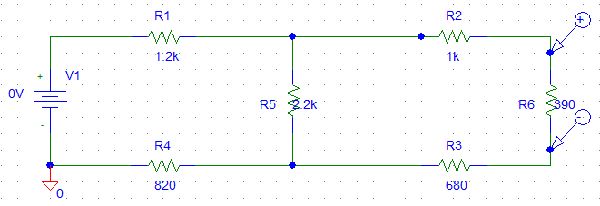

**Plot of the response Vo Versus Vin**



|  |  |  |
| --- | --- | --- |
|  |  |  |
| **Superposition** |  |  |

1- calculations:- To solve for R=680ohm :-

Turn off the 20V source (short) :

Req= $\left(1200+820\right)*\left(\frac{2200}{2200+2020} \right)+ \left(390+680\right)=2.123KΩ$

I1= $\frac{Vdc}{Req}=\frac{15}{2123}=7mA$ (upward)(Current from source of 15 V)

V1=7mA*680=4.76V (Voltage from source 15 Volts)

Turn off the 15 V source :

Req=($390+680)*\left(\frac{2200}{2200+390+680}\right)+\left(1200+820\right)=2.734KΩ$

I(main current ) = $\frac{20}{2.734K}=7.3mA$

Current divider :

I2(through 680Ω)= $\frac{2.2*7.3}{390+680+2200}=4.9mA$ (downward )

V2=4.9mA*680=3.34V (polarity is reverse the first case)

*Results*

V=V1+V2=4.76-3.34=1.42V

I=I1+I2 = 7mA-4.9mA=2.1

(2&3)-

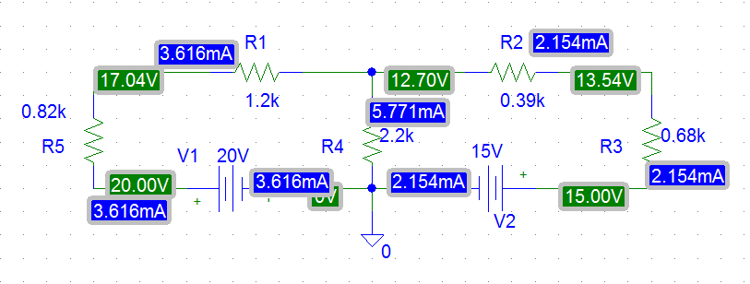

|  |  |  |
| --- | --- | --- |
|  |  |  |
| **Thevenin’s and Norton’s Theorems:** |  |  |

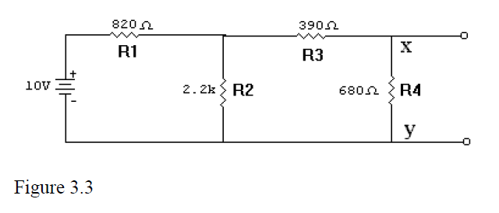

1-To find Vth , remove R4

I= $\frac{10}{2200+820}=3.3mA$ → Vth = 2.2K*3.3m=7.2V

To Rth (seen from X,Y) ,set 10V to short circuit:

Rth= $390+\frac{820*2200}{2200+820}=987Ω$

Thevenin’s Equivalent circuit becomes :-

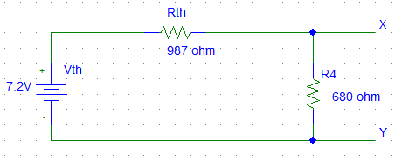

2-To simulate the circuit and find Vth ,set R4 to very large value with respect to the circuit to behave like an open circuit ,so Vth=7.284V

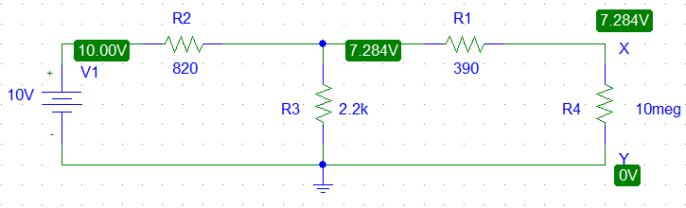

To find Rth ,set R4 equal to zero to find short circuit current (Norton’s current )→Rth=Vth/Isc = 7.284/7.378m=982Ω

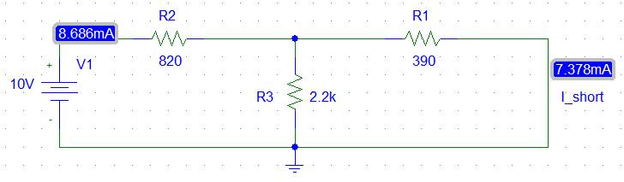

3-I(through 680Ω) = $\frac{7.2}{680+987}=4.3mA$ → Vxy=4.3m * 680=2.93V

4-To find Norton’s equivalent circuit:-

Rth=RN  =987Ω calculated above .

To find IN , make R4 short circuit :

Req= 2200//390+820=1.1kΩ

I(main current) =10/1.1k = 8.6mA

Current divider:

IN = (8.6)(2.2)/(2200+390)=7.3mA

I(through 680Ω)=7.4*987/(987+680)=4.3mA→ Vxy=4.3m*680=2.92V

Norton’s Equivalent circuit becomes:-

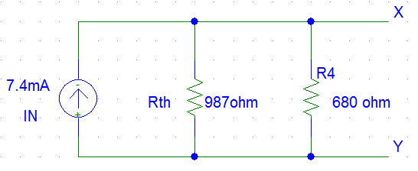

5-I solved implicitly above ,Isc=IN , and RN the same procedure as Rth.

|  |  |  |
| --- | --- | --- |
|  |  |  |
| **Delta-Y- Transformations** |  |  |

1-Vab=7.918-7.456=0.462V from circuit below

RY=R_delta/3 = 3.3k/3=1.1kΩ each resistor in Y connection .

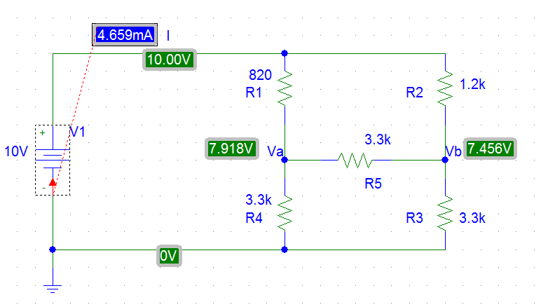

|  |  |  |
| --- | --- | --- |
|  |  |  |
| **Reciprocity Theorem** |  |  |
|  |  |  |

