Chapter 17 Auditing and Evaluating the AIS

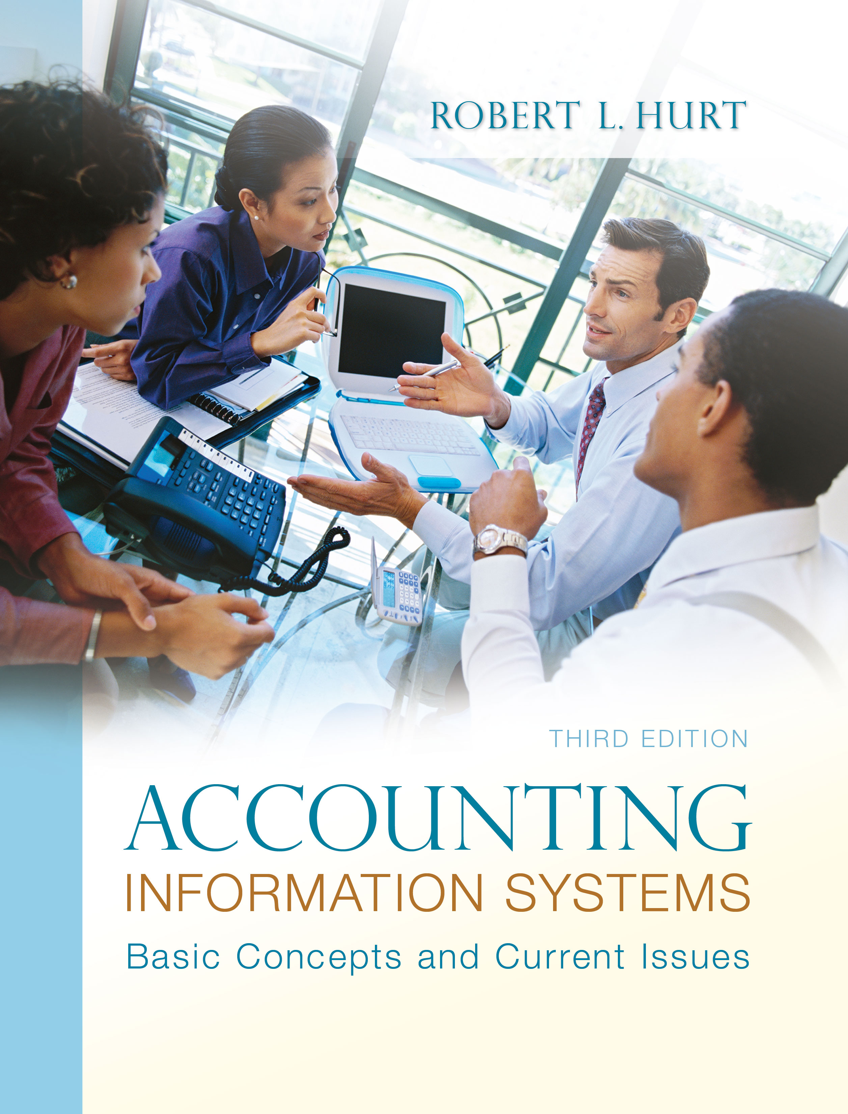
1. Reading review questions
a. List and discuss the seven types of audits described in the chapter. A financial audit involves the examination of a company’s accounting information system and financial statements. In an operational audit, auditors examine a company’s rules and procedures for conducting business. A systems audit determines whether the various forms of information technology in an AIS are producing expected results. A compliance audit determines whether or not a GNFP is following the rules and regulations in the Yellow Book. A management audit determines the degree to which the assumptions underlying decisions are valid; it also examines the ways in which management decisions are supported. An investigative audit, which may be conducted by a Certified Fraud Examiner, may be triggered by observation of unusual behavior or discrepancies in the accounting information system. An international audit is really a “basket” of the other types; it can be conducted in a US-based firm with international operations or a non-US based firm.
b. Explain the ten generally accepted auditing standards that guide financial audits. First and foremost, an auditor must be well-trained in auditing before an engagement commences. Independence speaks to the auditor’s mental attitude; that is, the auditor must always remain independent from the client. The auditor must exercise due professional care in preparing for and completing the audit. The audit is to be properly planned, and all staff members must be adequately supervised. A thorough assessment of internal controls is a critical step early in the audit process. The evidence standard speaks to the importance of having an objective, reasonable basis for expressing an opinion on the company’s financial statements. The audit opinion must state whether or not the statements are presented in accordance with generally accepted accounting principles. Full disclosure is a commonality between GAAS and the conceptual framework. Consistency is one of the qualitative characteristics of accounting information in the conceptual framework; it is also one of the reporting standards.
c. Describe the common steps associated with an audit. The five steps are: (1) Assess management’s integrity. (2) Evaluate management’s credentials. (3) Review the internal control system. (4) Perform compliance testing. (5) Issue the audit report.
d. Respond to the questions for this chapter’s “AIS in the Business World.” I was very fortunate to have three assistants available to prepare responses to the AIS in the Business World vignettes for the third edition; I’ve posted their responses on my AIS blog: www.bobhurtais.blogspot.com.

2. Reading review problem

a. In addition to internal audits, what other kinds of audits do accounting professionals commonly perform? Other kinds of audits include: financial, investigative, systems, compliance, management, operations, and international.

b. How are the various types of audits similar to one another? How are they different? All audits are similar in that they should be conducted professionally and with integrity. They are different in their specific goals and the specific standards that guide them (e.g. Yellow Book for compliance audits and GAAS for financial audits).

c. What concepts and standards guide financial statement audits? The AICPA’s statements of auditing standards provide broad guidance for financial statement audits. See the response to (b) in Problem One for an overview of them.

d. How is auditing related to your study of AIS? The accounting information system provides information for many types of audits. In addition, internal control is an important element of many types of audits. A fundamental understanding of business processes is also essential.

3. Multiple choice review questions. Answers to all of these questions appear at the end of the textbook itself.

4. Making choices and exercising judgment
The point of these exercises, which appear in every chapter throughout the third edition, is to encourage students to think critically and “outside the box.” Thus, I am not providing solutions to them, as doing so would likely discourage the purpose of these exercises.

5. Field exercises
Answers to these exercises will vary significantly; thus, like the previous set, I am not preparing published solutions for them.

6. Audit types

a. financial

b. investigative

c. operational

d. financial

e. financial
f. systems

g. operational

h. international

i. systems

j. management

7. Generally accepted auditing standards

Responses will vary significantly.

8. Violations of GAAS

a. Supervision, training
b. Disclosure
c. Independence, professional care
d. Independence, professional care
e. Independence, internal controls
f. Training

9. Investigative audit
a. An investigative auditor would: (1) Examine the relevant documents (checks and deposit slips). (2) Interview employees in the travel department to verify that the executives actually did not travel. (3) Interview the auditors or whomever told the company to stop the practice. (4) Interview the executives and the controller. Recommended internal controls in this situation would include: separation of duties (the controller should not be signing checks or making bank deposits) and adequate documentation (the company should develop a specific policy prohibiting the conduct).

b. The investigative auditor has already examined some relevant documents (purchase orders, invoices); additional documents might include the company’s conflict of interest policy (if such a policy exists). Physical observation of the widgets would be essential to determine if there was some legitimate reason for the high prices; interviews with production personnel would provide additional evidence in that area. Other people to interview here would include shipping and receiving personnel (to verify that the widgets were actually received) and, ultimately, purchasing personnel. Internal controls should include a conflict of interest policy, independent authorization / verification of purchase orders and an independent vendor approval process.

10. Terminology

1. E
2. I
3. F
4. H
5. G
6. C
7. B
8. D
9. J
10. A

11. Multiple choice questions
1. D
2. C
3. D
4. A
5. C

12. Statement evaluation
a. Never true.
b. Sometimes true. Financial audits focus on statements; other kinds of audits examine other aspects of an organization.
c. Always true.
d. Sometimes true. Unqualified opinions are appropriate most of the time, but not always.
e. Never true.
f. Never true.
g. Never true.
h. Never true.
i. Sometimes true. Publicly traded companies need to have audits.
j. Sometimes true. The audit opinion talks about the financial statements; a company may have a weak internal control system but (through happy accident) still have fair statements.

13. Prior material application
a. Processes would be examined through observation; they would also likely be compared to standard business processes and the company’s own descriptions. The general purpose financial statements are the primary (but not only) output examined in a financial audit; they would be examined throughout the audit. For internal controls, the auditor might talk to employees, observe them and read written accounts of how internal controls should (and do) function. Finally, regarding storage, an auditor would examine account balances by verifying the transactions recorded in them.

b. An investigative auditor would use professional judgment and other clues to determine which transactions to investigate. For example, if investigating a case of suspected fraud involving fixed assets, those transactions would be scrutinized more carefully than others.

c. Since the chief internal auditor has not shared the plan with anyone else, it is most likely at the “chaotic” stage of the CMM. To be considered “repeatable,” each operational audit would need specific goals. A “defined” operational audit would draw its standards and procedures from broader policies of the organization. When the process becomes “measured,” actual results are compared to expected results in key areas, such as cost and time. Finally, an “optimized” operational audit would be considered a way of improving quality throughout the organization.

d. The use of XBRL might not impact a financial statement audit at all; when auditors come in to examine the AIS and financial statements, the statements may not have been converted to XBRL. In a systems audit, though, the system and software used to prepare instance documents would be examined closely.

e. Answers will vary considerably.

