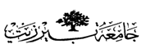

Organic –Chem. 221 Lab

Instructor name: Dr. Adi Qamhieh Exp. date: 26.3.2018

Experiment title
Perfume- The Synthesis Of Nerolin

Student Name
Muhammad Ibrahim Musleh
Student No
1162595
Partner Name
Fairouz Zayed
Partner No
1160750

Experiment No
6

Submission date: 16.4.2018

