BERZIET UNIVERSITY FACULTY OF ENGINEERING AND TECHNOLOGY DEPARTMENT OF ELECTRICAL AND COMPUTER ENGINEERING

ENEE 2102

Circuits Laboratory

Experiment.4 Prelab

**Newtork Theorems**

Prepared by:

Omar Nazzal 1200629

Supervised by

Dr. Jaser Sa'ed

Teacher assistance:

Eng.Shadi Bannoura

April 2022

**Part A: Proportionality**

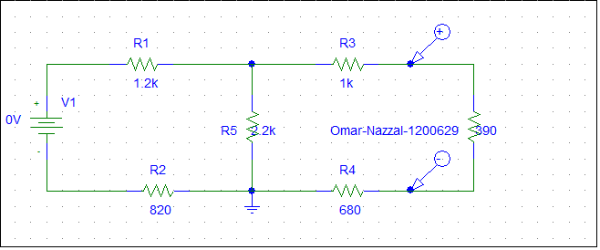

**Cursors at vin =**5,10

.

Part B: Superposition

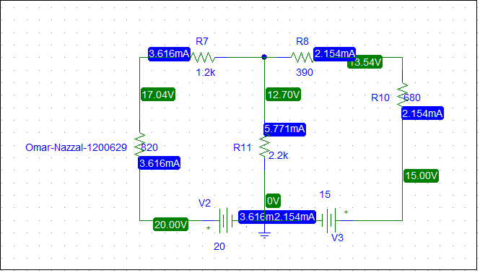figure 4.2 in manual

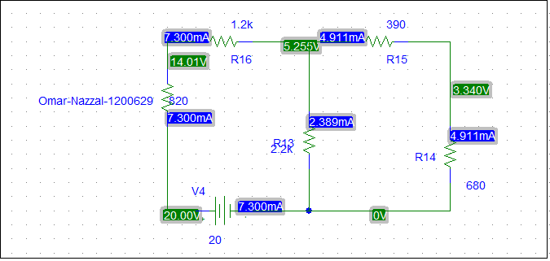figure 4.3 in manual

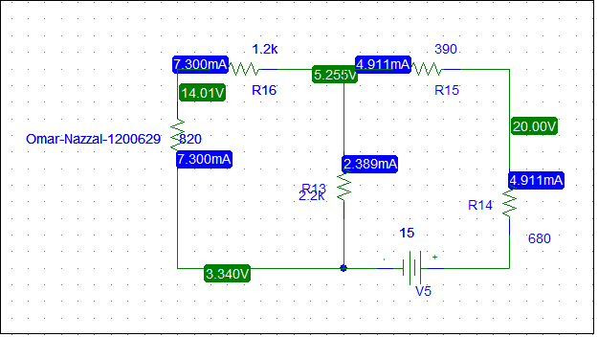figure 4.4 in manual

**Part c : Thevenin's theorem**

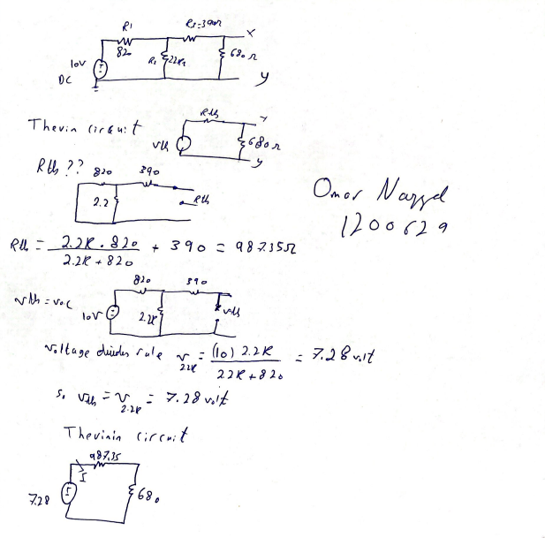

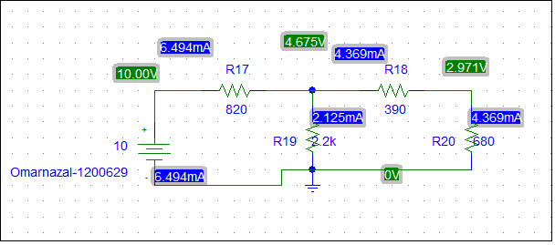

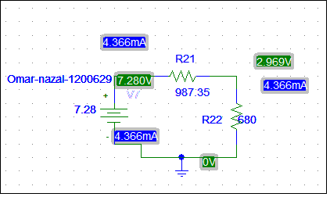

**Part D : ∆-Y Transformation**

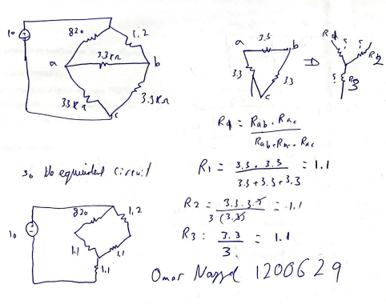

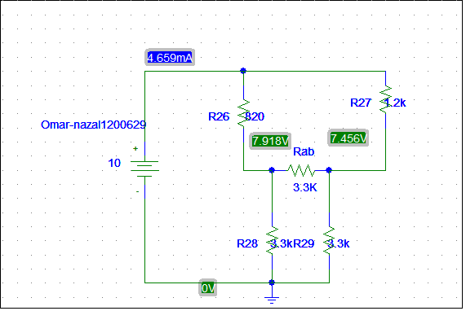Vacroos a-b = 7.918-7.456=0.462 volt

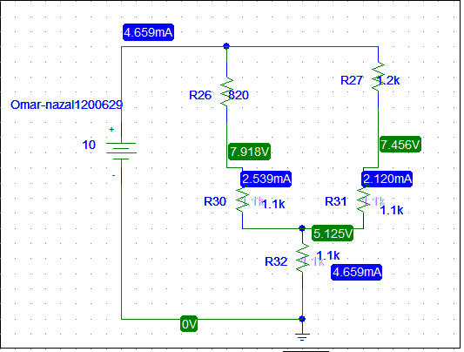

**Part E: Reciprocity Theorem**

