

**Faculty of Engineering & Technology – Electrical & Computer Engineering Department**

**Second Semester 2021 – 2022**

Communication Laboratory ENEE4113

***Experiment 1 - Prelab***

**Name: Ahmaide Al-Awawdah.**

**ID: 1190823**

**Section: 9**

**Instructor: Dr. Ashraf Al-Rimawi**

**Date: 25th March 2022**

SAM (t) = Ac [1 + µ cos(ωmt)] cos(ωct)

The mathematical expression of the demodulated signal = Ac` [1 + µ cos(ωmt)]

The figure below shows the demodulated signal for all three cases (µ=0.22, µ=1, µ=1.85), with fm = 800hz, fc= 8000hz, Ac = 16v.

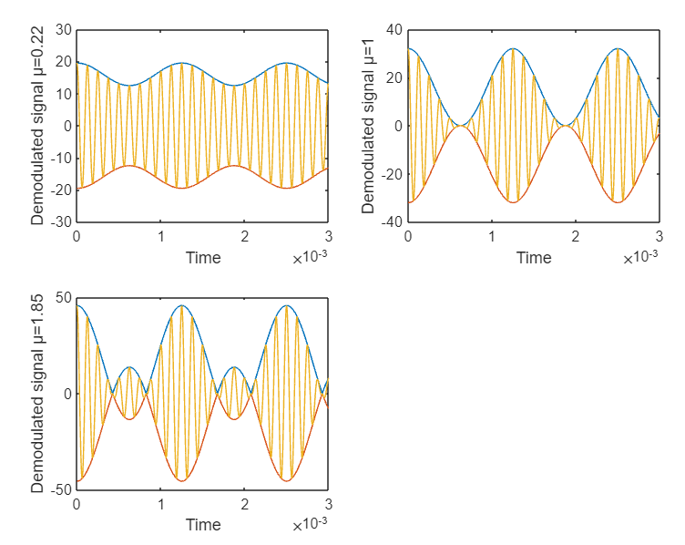

As shown in the figure for each signal the demodulated signal is in blue and its reflective value is in orange, while the modulated signal is in yellow.

when µ<1 the demodulated signal never reaches 0, when µ=1 its minimum value is 0, if µ>1 then the demodulated signal will go make a smaller wave signal as shown in the 3rd figure.

The code:

fm=800;

fc=8000;

u1=0.22;

u2=1;

u3=1.85;

Ac=16;

t=0:0.000000001:0.003;

D1= Ac.*(1 + u1.*cos(2*pi*fm*t));

De1= abs(D1);

D2= Ac.*(1 + u2.*cos(2*pi*fm*t));

De2= abs(D2);

D3= Ac.*(1 + u3.*cos(2*pi*fm*t));

De3= abs(D3);

s1= De1.*cos(2*pi*fc*t);

s2= De2.*cos(2*pi*fc*t);

s3= De3.*cos(2*pi*fc*t);

title("Normal Am Modulation");

subplot(2,2,1), plot(t,De1,'-', t,-De1,'-', t,s1,'-');

axis([0, 0.003, -30, 30]);

xlabel("Time"), ylabel("Demodulated signal µ=0.22");

subplot(2,2,2), plot(t,De2,'-', t,-De2,'-', t,s2,'-');

axis([0, 0.003, -40, 40]);

xlabel("Time"), ylabel("Demodulated signal µ=1");

subplot(2,2,3), plot(t,De3,'-', t,-De3,'-', t,s3,'-');

axis([0, 0.003, -50, 50]);

xlabel("Time"), ylabel("Demodulated signal µ=1.85");