

**Faculty of Engineering and Technology**

**Machine Design 2- ENME436**

**Project**

**Water Wheel Generator Gear-Box**

**Prepared by:**

**Bader Abu Jaghab 1170401**

**Instructor:**

**Dr. Allan Tubaileh**

**Submitted on: May 20, 2021**

Table of Contents

Case Study 2

Geometry Calculations 2

Stages One & Two 3

Number of Teeth 3

Center Distance 3

Pitch Diameters 3

Base Diameters 4

Addendum Radius 4

Dedendum Radius 4

Contact Ratio 4

Stage Three 5

Force Analysis 5

Power Calculations 5

Stage One 6

Pinion 2 6

Gear 3 7

Stage Two 7

Pinion 4 8

Gear 5 8

Stage Three 9

Pinion 6 9

Gear 7 10

Stress Calculations 10

Contact Stress 10

Contact Stress Factors 10

Contact Strength 12

Bearings 13

Bearing Reactions 15

Bearings A & B 15

Bearing C & D 16

Bearings E & F 17

Bearing G 19

Bearing Selection 19

For bearing A 20

For bearing B 20

For bearing C 20

For bearing D 20

For bearing E 21

For bearing F 21

For bearing G 21

Figure 1 Gear Box. 4

Figure 2 Pinion 2 Force Analysis. 8

Figure 3 Gear 3 Force Analysis. 9

Figure 4 Direction of pinion 4. 10

Figure 5 Direction of Gear 5. 10

Figure 6 Force directions of pinion 6 11

Figure 7 Force direction of gear 7 12

Figure 8 Bearings positions 16

Figure 9 Reactions on bearing A & B 17

Figure 10 Reactions on bearing C & D 18

Figure 11 Reactions on bearing E & F 19

Figure 12 Reactions on bearing G. 21

Figure 13 Bearing A 22

Figure 14 Bearing B 22

Figure 15 Bearing C. 22

Figure 16 Bearing D 23

Figure 17 Bearing E 23

Figure 18 Bearing F. 23

Figure 19 Bearing G. 24

Table 1 Stages 1 & 2 Geometry Calculations. 7

Table 2 Contact Stress Results 14

Table 3 Strength & Factor of Safety Calculations. 15

# Case Study

This report studies the required gears that are needed to operate a three phase 415/240 V generator that required a speed of 1500 RPM, and an input power that ranges from 1 KW to 1.1 KW.

This generator is assumed to run on the power of a waterfall that is about 10 meters in height, and Stjórnarfoss waterfall was taken as a reference for the needed calculations.

# Geometry Calculations

The water flow will rotate a water wheel that is 4 meters in diameter, such that the minimum water speed is 10 m/s.

Hence the angular velocity of the water wheel is given as follow,

$$ω=\frac{V}{r}=\frac{10}{2}=5 rpm$$

This means that an angular velocity change from 5 RPM to 1500 RPM is required, which needs a total velocity ratio of 300, therefore, the gearbox was assumed to consist of three stages, the first two stages are identical and each of them has a velocity ratio of 7, and the third stage has a velocity ratio of 6.13.

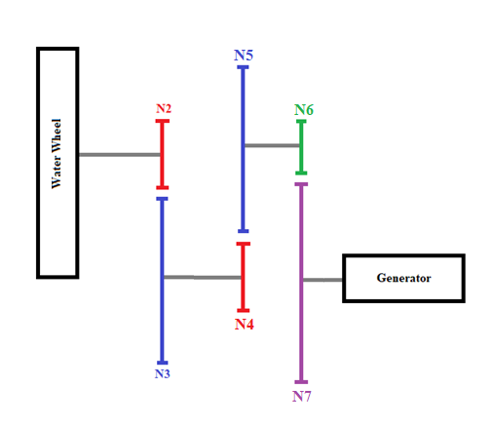

Figure Gear Box.

## Stages One & Two

### Number of Teeth

This stage has a velocity ratio of 7, a pressure angle of 20 °, a module of 6, and full depth cut gears (K =1). The minimum number of pinion teeth to avoid interference is given by,

$$Np min=\frac{2K}{\left(1+2VR\right)\sin^{2}∅} ×( VR+\sqrt{{VR}^{2}+\left(1+2VR\right)\sin^{2}∅} )$$

$$=\frac{2×1}{\left(1+2×7\right)\sin^{2}20} ×\left( 7+\sqrt{7^{2}+\left(1+2×7\right)\sin^{2}20} \right)=16.09 teeth$$

Then N2 = 17 > NP minimum.

As for the gear 3, the number of gear teeth is given by,

$$N_{G} =VR*N2$$

$$N_{G}=7*17=119$$

Maximum number of teeth for the gear can be used to check this value using the following formula,

$${N_{G}}_{MAX}=\frac{N_{P}^{2}*Sin^{2}∅-4*k^{2}}{4*k-2*N_{P}*Sin^{2}∅}= \frac{{17}^{2}*Sin^{2}20-4*1^{2}}{4*1-2*17*Sin^{2}20}=1309.9 tooth$$

Since NG maximum is bigger than NG, then the calculated value above is valid.

### Center Distance

It is given by,

$$C=\frac{N_{P}+N_{G}}{2}*m$$

Such that the module is taken as m = 6.

$$C_{23}=\frac{17+119}{2}*6=408 mm$$

### Pitch Diameters

The module is given by,

$$m=\frac{d}{N}$$

Then the diameter is given by,

$$d=m*N$$

$$d_{2}=6*17=102mm$$

$$d_{3}=6*119=714mm$$

### Base Diameters

The base diameters are given by,

$$d_{b}=d_{P}*COS(PHI)$$

$$d_{b2}=102*COS\left(20\right)=95.85mm$$

$$d_{b3}=714*COS\left(20\right)=670.94mm$$

### Addendum Radius

The addendum radius is given by,

$$r_{ap}=r_{P}+m$$

Such that,

$$r_{p}=\frac{d_{p}}{2}$$

Then,

$$r_{ap2}=\frac{102}{2}+6=57 mm$$

$$r_{ap3}=\frac{714}{2}+6=363 mm$$

### Dedendum Radius

It is given by,

$$r_{dp}=r_{P}-1.25*m$$

Then,

$$r_{dp2}=\frac{102}{2}-1.25*6=43.5mm$$

$$r_{dp3}=\frac{714}{2}-1.25*6=349.5mm$$

### Contact Ratio

It is given by,

$$CR=\frac{L_{ab}}{P_{b}}$$

Such that,

$$L_{ab}= \sqrt{r_{ap}^{2}-r_{bp}^{2} }+ \sqrt{r_{ag}^{2}-r_{bg}^{2} }+C*SIN\left(PHI\right)$$

$$P_{b}=m*PI*COS(PHI)$$

Then,

$$L_{ab}= \sqrt{{57}^{2}-{\left(\frac{95.85}{2}\right)}^{2}}+ \sqrt{{363}^{2}-{\left(\frac{670.94}{2}\right)}^{2}}-408*SIN\left(20\right)=29.98mm$$

$$P_{B}=6*3.14*COS\left(20\right)=17.71$$

$$CR_{23}=\frac{29.98}{17.71}=1.6927$$

## Stage Three

This stage share the same calculations as stages one and two, such that it has a module of 6, a velocity ratio of 6.13, angle PHI of 20 degrees, and full depth cut gears (K=1).

The results for all stages can be seen in the table below.

Table Stages 1 & 2 Geometry Calculations.

|  |  |  |  |  |  |  |  |  |
| --- | --- | --- | --- | --- | --- | --- | --- | --- |
| Parameters | | Number Of Teeth | Center Distance | Pitch Diameters | Base Diameters | Addendum Radius | Dedendum Radius | Contact Ratio |
|
| Stage 1 | Pinion 2 | 17 | 408 | 102 | 95.84 | 57 | 43.5 | 1.6927 |
| Gear 3 | 119 | 714 | 670.94 | 363 | 349.5 |
| Stage 2 | Pinion 4 | 17 | 408 | 102 | 95.84 | 57 | 43.5 | 1.6927 |
| Gear 5 | 119 | 714 | 670.94 | 363 | 349.5 |
| Stage 3 | Pinion 6 | 16 | 345 | 96 | 90.211 | 54 | 40.5 | 1.6751 |
| Gear 7 | 99 | 594 | 558.1774 | 303 | 289.5 |

# Force Analysis

## Power Calculations

The force that is produced by the waterfall is given by the following formula,

$$F=\frac{ALC}{T}$$

Such that,

* F is the produced force in newtons.
* A is the area that the water flows throw in m2.
* L is the length of the waterfall in meters.
* C is a coefficient of roughness, and it equals 0.8 for a rock bottom.
* T is the time in seconds.

To calculate the time, newton’s law is used,

$$∆y=V_{1}t+0.5at^{2}$$

$$10=10*t+0.5*9.81*t^{2}$$

By solving this quadric equation, the time is obtained to be 2.77 seconds.

And for the reference waterfall, L is given as 10 meters, and the area is given as 36 m2.

Then,

$$F=\frac{36*10*0.8}{2.77}=104 N$$

Which is the tangential force on the wheel. As for the power, it is given by the following formula,

$$H=F_{t}*V=104*10=1040 watts$$

This answer is in the required input power range that the generator needs, which is 1000 – 1100 watts, and this verifies the force calculations.

## Stage One

### Pinion 2

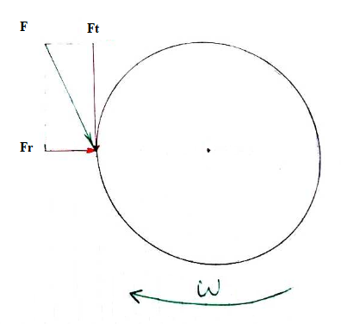

Figure Pinion 2 Force Analysis.

Since the gear rotates in a clockwise motion, the total force F will oppose this motion, hence the force will be in the drawn direction at an angle of 20 degrees. This force is analyzed into two components, tangential and radial components.

The tangential force is calculated from the power on the gear and it speed, such that the tangential force is given by the following formula,

$$F_{t}=\frac{Power}{V}=\frac{Power}{ω×r}=\frac{1040}{5*\frac{102}{2*1000}}=4078.43 N$$

As for the radial force, it is given by the following formula,

$$F_{r}=F_{t}×tan∅=4078.43×tan20°=1484.43 N$$

### Gear 3

In the gear, the forces equal the pinion’s forces in magnitude and oppose them in direction, as can be seen in the figure below.

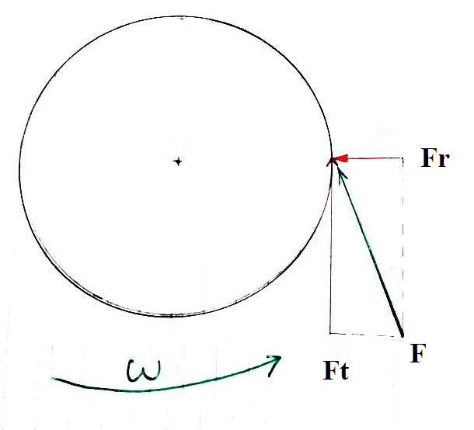

Figure Gear 3 Force Analysis.

## Stage Two

The forces for this stage are calculated in a manner similar to stage one.

Since stage one has a velocity ratio of 7, then the angular velocity of gear 3 equals 35 RPM, which is the same for pinion 4 since it is on the same shaft as gear 3.

Therefore the forces are calculated as follows.

$$F_{t}=\frac{Power}{V}=\frac{Power}{ω×r}=\frac{1040}{35*\frac{102}{2*1000}}=582.63 N$$

$$F_{r}=F_{t}×tan∅=582.63×tan20°=212.06 N$$

### Pinion 4

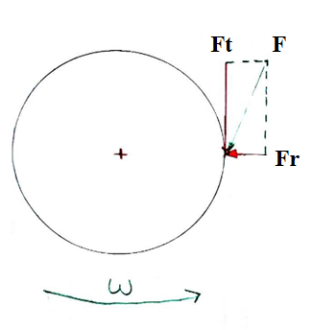

Figure Direction of pinion 4.

### Gear 5

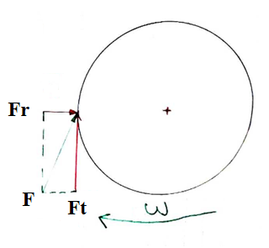

Figure Direction of Gear 5.

## Stage Three

Stage two has a velocity ratio of 7, then the angular velocity of gear 5 is 245 RPM, then the forces of pinion 6 & gear 7 will be as follows.

$$F_{t}=\frac{Power}{V}=\frac{Power}{ω×r}=\frac{1040}{245*\frac{96}{2*1000}}=88.44 N$$

$$F_{r}=F_{t}×tan∅=88.44×tan20°=32.19N$$

### Pinion 6



Figure Force directions of pinion 6

### Gear 7



Figure Force direction of gear 7

# Stress Calculations

## Contact Stress

The hardness of the surface and center of the gears were assumed to be equals, hence only the contact stress is required.

The contact stress for spur gears is given by,

$$σ=C_{P}×\frac{\sqrt{F_{t}.C_{O}.C_{m}.C_{V}}}{\sqrt{b.I.d_{P}}}$$

### Contact Stress Factors

* Cp is the elastic coefficient, it is dependent on the type of the pinion and gear materials, and for this project all gears were made from steel. For two steel mating gears, the elastic coefficient (Cp) equals 191MPa.
* Co is the overload factor, the driver was taken as a medium shock, while the driven machine was taken as uniform, hence Co = 1.5.

Further Calculations are done for stage one.

* Cm is the load distribution factor, it is calculated using the following formula,
$$C_{m}=1+C_{mc}(C_{pf}C_{pm}+C_{ma}C_{e})$$

* Cmc = 0.8 for crowned teeth.

$C_{pf}=\frac{b/25.4}{10*d_{P}}-0.025$

$=\frac{12/25.4}{10*102}-0.025=-0.0245$

* Such that b was chosen to be 12 mm.

$Cpm=1$

$C_{ma}=A+ B*b+C*b^{2}=0.127+0.0158*\left(\frac{12}{25.4}\right)-0.93*{\left(\frac{12}{25.4}\right)}^{2}=0.1345$

$C_{e}=1$

Then,

$$C_{m}=1+0.8\left(-0.0245 *1+0.3032*1\right)=1.2229$$

* $C_{V}={\left({\frac{ A+ \sqrt{200*V}}{A}}^{}\right)}^{B},$ such that A, B, & V are given by,

$$A=50+56*(1-B)$$

$$B=\frac{{\left(12-Q_{V}\right)}^{\frac{2}{3}}}{4}$$

$$V= ω×r$$

The gears were assumed to have commercial quality gears such that the quality factor equals 5, hence, the results are as follows,

$$B=\frac{{\left(12-5\right)}^{\frac{2}{3}}}{4}=0.915$$

$$A=50+56*\left(1-0.915\right)=54.77$$

$$C_{V}={\left({\frac{ 54.7697+ \sqrt{200*0.255}}{54.7697}}^{}\right)}^{0.0158}= 1.1151$$

* $I=\frac{Sin∅.Cos∅.R}{2.m_{N}.(R+1)}$, such that R is given by,

$$R=\frac{d_{g}}{d_{p}}=\frac{714}{102}=7$$

$$m_{N}=1 for spur gears, then,$$

$$I=\frac{Sin20×Cos20×7}{2×1×(7+1)}=0.1630$$

From the previous section, the tangential force equals 4078.4 N.

$$σ=C_{P}×\frac{\sqrt{F_{t}.C_{O}.C_{m}.C_{V}}}{\sqrt{b.I.d_{P}}}=191*\frac{\sqrt{4078.4*1.5*1.223*1.1151}}{\sqrt{12*0.1630*102}}=1166.8MPa$$

The calculations for Stages two & three are in the table below.

Table Contact Stress Results

|  |  |  |  |  |  |  |  |
| --- | --- | --- | --- | --- | --- | --- | --- |
| Parameters | Pitch Diameter | R | Cm | Cv | I | Ft (N) | Contact Stress |
| Pinion 2 | 102 | 7 | 1.0879 | 1.1187 | 0.163 | 4078.4 | 1166.8 |
| Gear 3 | 714 |
| Pinion 4 | 102 | 7 | 1.0879 | 1.3115 | 0.163 | 582.6 | 477.49 |
| Gear 5 | 714 |
| Pinion 6 | 96 | 6.18 | 1.088 | 1.7863 | 0.1604 | 88.4 | 225.59 |
| Gear 7 | 594 |

## Contact Strength

The contact strength is given by the following formula,

$$S_{fe}=S_{C}×\frac{C_{L}.C_{t}.C_{H}}{C_{r}}$$

The following factors don’t vary between the gears.

* Ct is a factor of temperature, and here it is assumed that the temperature doesn’t affect the gears hence it is equal to 1.
* Cr is the reliability factor, the reliability was taken to be 0.99, hence Cr =1.
* CH is the hardness factor, the factor CH equals 1 for pinions, and it changes for gears according to the hardness ratio, but in this case, the ratio of hardness for all stages is less than 1.2, hence the factor equals 1.

The following factors change, such that the calculations below are done for pinion 2:

* $S_{c}=2.41H_{B}+237 MPa$, for grade 2 hardened steel, the hardness was taken to equal to 650 N/mm2, then,
$$S_{c}=2.41*650+237 MPa=1803.5MPa$$

* The life factor CL, which varies with angular velocity.

The life factor is given by,

$$C_{L}=2.466*N^{-0.056}$$

N represents the number of cycles, and it is given by,

$$N=Hours*60*n(rpm)$$

The gears are assumed to work 24 hours, 7 days a week, hence the number of hours of total work for a whole year was taken to be 8760 hours.

For pinion 2, the angular velocity equals 5 RPM, hence the life factor was found to be equal to 1.0777.

For pinion 2, the contact strength is equal to,

$$S_{fe}=1803.5*\frac{1.0777*1*1}{1}=1943.6 MPa$$

Then the factor of safety for this pinion equals,

$$n=\frac{S_{fe}}{σ}=\frac{1943.6}{1166.8}=1.6658$$

Similarly, these calculations were repeated for the rest of the gears, the results are noted in the table below.

* For stages one & two, grade 2 hardened steel was used, such that the factor SC, is given by,
$$S_{c}=2.41H_{B}+237 MPa$$

* As for stage three, grade 1 hardened steel was used, such that the factor SC, is given by,

Table Strength & Factor of Safety Calculations.

|  |  |  |  |  |  |  |
| --- | --- | --- | --- | --- | --- | --- |
| Parameters | Angular Velocity | hardness | SC | CL | Contact Strength | FOS |
| Pinion 2 | 5 rpm | 650 | 1803.5 | 1.0777 | 1943.6 | 1.6658 |
| Gear 3 | 35 | 630 | 1755.3 | 1.0777 | 1696.4 | 1.454 |
| Pinion 4 | 35 | 200 | 719 | 0.9664 | 694.86 | 1.4552 |
| Gear 5 | 245 | 180 | 670.8 | 0.9664 | 581.348 | 1.2175 |
| Pinion 6 | 245 | 70 | 355.4 | 0.783 | 308.01 | 1.3654 |
| Gear 7 | 1501.9 | 60 | 333.2 | 0.783 | 260.89 | 1.1565 |

# Bearings

The bearings will be placed in the positions shown in the figure below, each of the bearings has force reactions acting on them which will be used in bearing selection.

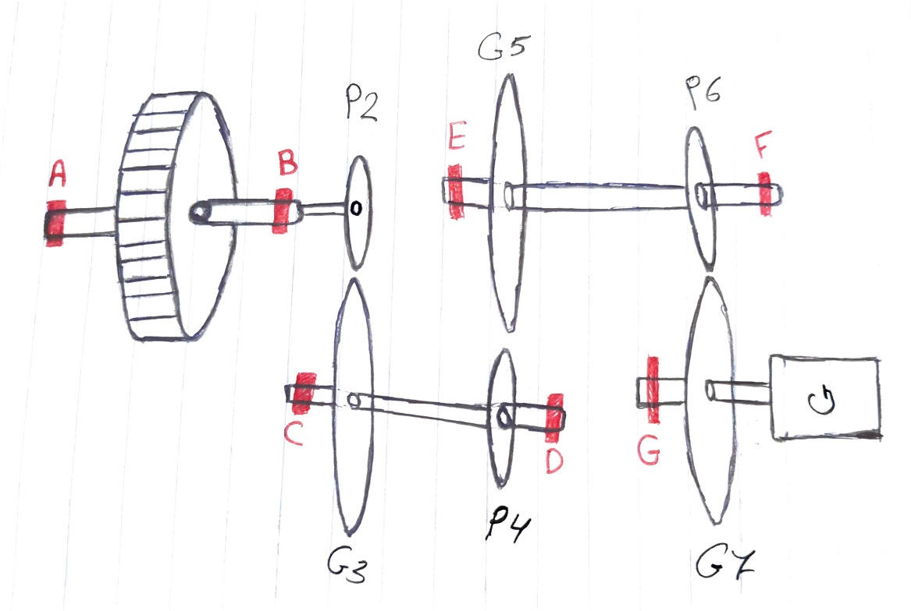

Figure Bearings positions

Further calculations require the forces on the water wheel that is placed between bearings A & B, the water wheel consists of diagonal plates that move due to the flow of water on these diagonal plates, hence, as an estimation, the wheel is dealt with as a spur gear with a pressure angle of 30 degrees. The tangential force was calculated in a previous section, and is equal to 104N, as for the radial force, it is given by the following formula which is used for spur gears,

$${F_{r}}_{W}={F_{t}}_{W}×tan∅=104×tan30°=60 N$$

## Bearing Reactions

### Bearings A & B

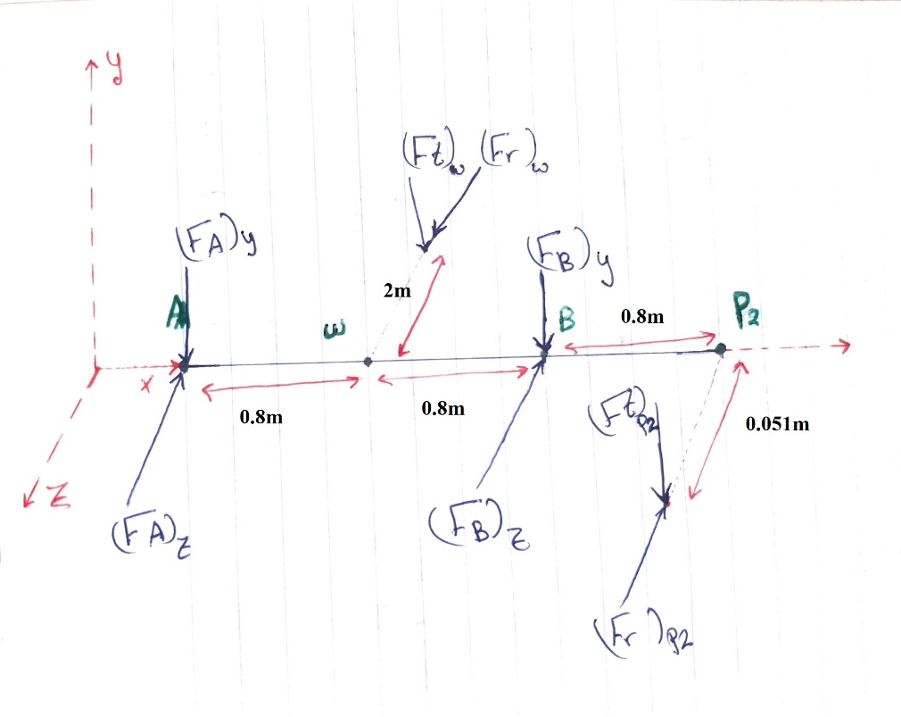

Figure Reactions on bearing A & B

To find the reactions on bearing B, the moment is taken at A.

$$Σ{M_{A}}_{Y}={F_{B}}_{Z}×D_{B}+{F_{r}}_{P2}×D_{P2}-{F_{r}}_{W}×D_{W}= 0$$

$${F_{B}}_{Z}=\frac{{F_{r}}_{W}×D_{W}-{F_{r}}_{P2}×D_{P2}}{D_{B}}$$

$${F_{B}}_{Z}=\frac{60×0.8-1484.4×2.4}{1.6}= -2196.6 N$$

$$Σ{M_{A}}_{Z}=-{F_{B}}_{Y}×D_{B}-{F_{t}}_{P2}×D_{P2}-{F_{t}}_{W}×D_{W}= 0$$

$${F_{B}}_{Y}=\frac{{{-F}_{t}}_{W}×D_{W}-{F_{t}}_{P2}×D_{P2}}{D_{B}}$$

$${F_{B}}_{Y}=\frac{-104×0.8-4078.4×2.4}{1.6}= -2195.2 N$$

$$F_{B}= \sqrt{{F_{B}^{2}}_{Z}+{F_{B}^{2}}_{Y}}= \sqrt{{\left(-2196.6\right)}^{2}+{\left(-2195.2\right)}^{2} }=3105.5 N$$

To find the reactions on A, we take the summation of forces on the shaft.

$$ΣF_{Z}=-{F_{A}}_{Z}+{F_{r}}_{W}-{F_{B}}_{Z}-{F_{r}}_{P2}=0$$

$$ΣF_{Z}=-{F_{A}}_{Z}+60-2196.6-1484.43$$

$${F_{A}}_{Z}= -3621.03 N$$

$$ΣF_{Y}=-{F_{A}}_{Y}-{F_{t}}_{W}-{F_{B}}_{Y}-{F_{t}}_{P2}=0$$

$$ΣF_{Y}=-{F_{A}}_{Y}-104+2195.2-4078.43=0$$

$${F_{A}}_{Y}= -1987.23 N$$

$$F_{A}= \sqrt{{F_{A}^{2}}_{Z}+{F_{A}^{2}}_{Y}}= \sqrt{{\left(-3621.03\right)}^{2}+{\left(-1987.23\right)}^{2} }=4130.5 N$$

### Bearing C & D

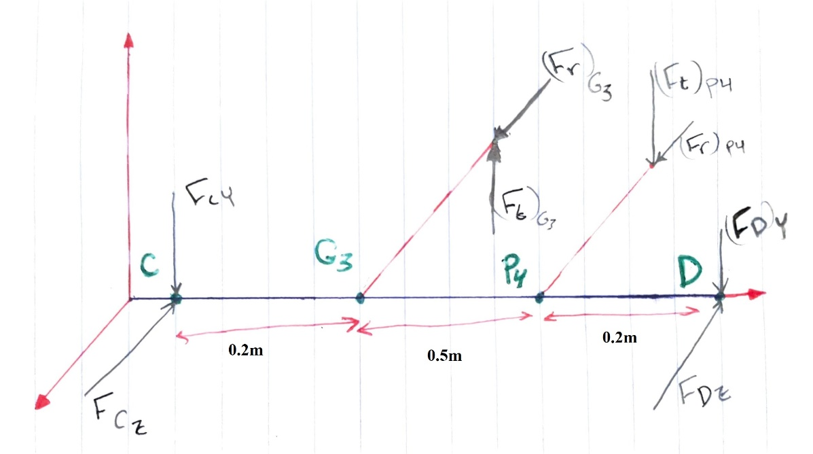

Figure Reactions on bearing C & D

To find the reactions on bearing D, the moment is taken at C.

$$Σ{M_{C}}_{Y}={F_{D}}_{Z}×D_{D}-{F_{r}}_{P4}×D_{P4}-{F_{r}}_{G3}×D_{G3}= 0$$

$${F_{D}}_{Z}=\frac{{F_{r}}_{G3}×D_{G3}+{F_{r}}_{P4}×D_{P4}}{D_{D}}$$

$${F_{D}}_{Z}=\frac{1484.43 ×0.2+212.06×0.7}{0.9}= 494.81 N$$

$$Σ{M_{C}}_{Z}={{-F}_{D}}_{Y}×D_{D}-{F_{t}}_{P4}×D_{P4}+{F_{t}}_{G3}×D_{G3}= 0$$

$${F_{D}}_{Y}=\frac{{F_{t}}_{G3}×D_{G3}-{F_{t}}_{P4}×D_{P4}}{D_{D}}$$

$${F_{D}}_{Y}=\frac{4078.43 ×0.2-582.63×0.7}{0.9}= 453.2 N$$

$$F_{D}= \sqrt{{F_{D}^{2}}_{Z}+{F_{D}^{2}}_{Y}}= \sqrt{{\left(494.81\right)}^{2}+{\left(453.2\right)}^{2} }=670.99 N$$

To find the reactions on A, we take the summation of forces on the shaft.

$$ΣF_{Z}=-{F_{C}}_{Z}+{F_{r}}_{G3}-{F_{D}}_{Z}+{F_{r}}_{P4}=0$$

$$ΣF_{Z}=-{F_{C}}_{Z}+1484.43-494.81+212.06$$

$${F_{C}}_{Z}= 1201.68 N$$

$$ΣF_{Y}=-{F_{C}}_{Y}+{F_{t}}_{G3}-{F_{D}}_{Y}-{F_{t}}_{P4}=0$$

$$ΣF_{Y}=-{F_{C}}_{Y}+4078.43-453.2-582.63=0$$

$${F_{C}}_{Y}= 3042.6 N$$

$$F_{C}= \sqrt{{F_{C}^{2}}_{Z}+{F_{C}^{2}}_{Y}}= \sqrt{{\left(1201.68\right)}^{2}+{\left(3042.6\right)}^{2} }=3271.31 N$$

### Bearings E & F

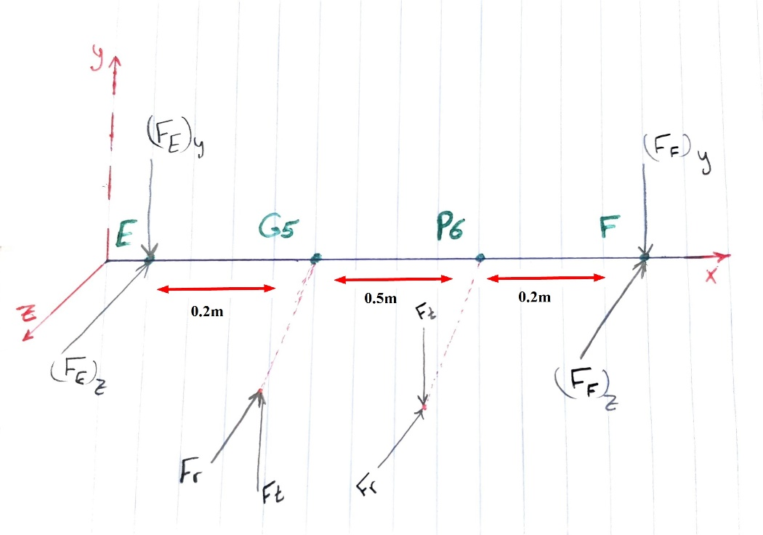

Figure Reactions on bearing E & F

To find the reactions on bearing E, the moment is taken at F.

$$Σ{M_{E}}_{Y}={F_{F}}_{Z}×D_{F}+{F_{r}}_{P6}×D_{P6}+{F_{r}}_{G5}×D_{G5}= 0$$

$${F_{F}}_{Z}=\frac{-{F_{r}}_{G5}×D_{G5}-{F_{r}}_{P6}×D_{P6}}{D_{F}}$$

$${F_{D}}_{Z}=\frac{-1484.4×0.2-212.1×0.7}{0.9}= -494.76 N$$

$$Σ{M_{E}}_{Z}={F_{F}}_{Y}×D_{F}-{F_{t}}_{P6}×D_{P6}-{F_{t}}_{G5}×D_{G5}= 0$$

$${F_{F}}_{Y}=\frac{{F_{t}}_{G5}×D_{G5}+{F_{t}}_{P6}×D_{P6}}{D_{F}}$$

$${F_{F}}_{Y}=\frac{582.63×0.2+88.44×0.7}{0.9}= 198.26 N$$

$$F_{F}= \sqrt{{F_{F}^{2}}_{Z}+{F_{F}^{2}}_{Y}}= \sqrt{{\left(-494.76\right)}^{2}+{\left(198.26\right)}^{2} }=533.01 N$$

To find the reactions on E, we take the summation of forces on the shaft.

$$ΣF_{Z}=-{F_{E}}_{Z}-{F_{r}}_{G5}-{F_{F}}_{Z}-{F_{r}}_{P6}=0$$

$$ΣF_{Z}=-{F_{E}}_{Z}+212.06-494.76-32.19$$

$${F_{C}}_{Z}= -314.89 N$$

$$ΣF_{Y}=-{F_{E}}_{Y}+{F_{t}}_{G5}-{F_{F}}_{Y}-{F_{t}}_{P6}=0$$

$$ΣF_{Y}=-{F_{E}}_{Y}+212.06-198.26-88.44=0$$

$${F_{E}}_{Y}= -74.64 N$$

$$F_{E}= \sqrt{{F_{E}^{2}}_{Z}+{F_{E}^{2}}_{Y}}= \sqrt{{\left(-314.89\right)}^{2}+{\left(-74.64\right)}^{2} }=323.62 N$$

### Bearing G

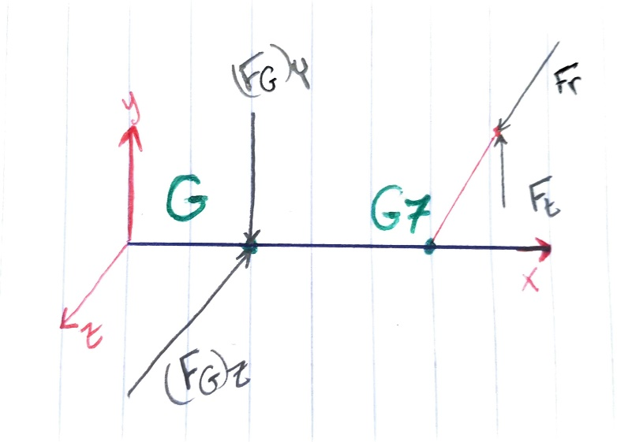

Figure Reactions on bearing G.

Assuming for resistance from the generator, the reactions on bearing G can be found from the summation of forces.

$$ΣF_{Z}=0={F_{r}}_{G7}-{F_{G}}_{Z}$$

$${F_{r}}_{G7}=F_{G_{Z}}=32.19 N$$

$$ΣF_{y}=0={F_{t}}_{G7}-{F_{G}}_{y}$$

$${F_{t}}_{G7}=F_{G_{y}}=88.44 N$$

$$F_{G}= \sqrt{{F_{G}^{2}}_{Z}+{F_{G}^{2}}_{Y}}= \sqrt{{\left(32.19\right)}^{2}+{88.44}^{2} }=94.11 N$$

## Bearing Selection

The bearings that will be selected are of the roller type, because there are no axial loads on any of the shafts. CR will be calculated, and the bearing will be chosen from table (11-3) such that C10 for the bearing is bigger than the calculated CR.

CR is given by the following formula,

$$C_{R}=K_{a}×F_{r}×{\left(\frac{L_{D}×n_{D}}{K_{r}×L_{r}×n_{r}}\right)}^{\frac{1}{a}}$$

Such that for all bearings,

* Ka was taken to be 1.3 for commercial bearings as stated in table (11-5).
* Kr equals 0.219 for manufacturer 2 at a reliability of 99%.
* The rated revolutions equal 106 revolutions for manufacturer 2.
* LD equals 8760 hours (The total hours in a year).
* The constant ‘a’ equals 10/3 for roller bearings.

### For bearing A

$$C_{R}=1.3×4130.5×{\left(\frac{8760×5}{0.219×{10}^{6}}\right)}^{\frac{3}{10}}=3.3133 KN$$

Then the suitable bearing is,

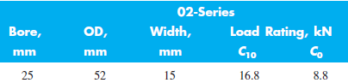

Figure Bearing A

### For bearing B

$$C_{R}=1.3×4105.5×{\left(\frac{8760×5}{0.219×{10}^{6}}\right)}^{\frac{3}{10}}=3.2932 KN$$

Then the suitable bearing is,



Figure Bearing B

### For bearing C

$$C_{R}=1.3×3271.31×{\left(\frac{8760×35}{0.219×{10}^{6}}\right)}^{\frac{3}{10}}=4.7044 KN$$

Then the suitable bearing is,



Figure Bearing C.

### For bearing D

$$C_{R}=1.3×670.99×{\left(\frac{8760×35}{0.219×{10}^{6}}\right)}^{\frac{3}{10}}=1.7299 KN$$

Then the suitable bearing is,



Figure Bearing D

### For bearing E

$$C_{R}=1.3×323.62×{\left(\frac{8760×245}{0.219×{10}^{6}}\right)}^{\frac{3}{10}}=0.83435 KN$$

Then the suitable bearing is,



Figure Bearing E

### For bearing F

$$C_{R}=1.3×533.01×{\left(\frac{8760×245}{0.219×{10}^{6}}\right)}^{\frac{3}{10}}=1.3742 KN$$

Then the suitable bearing is,



Figure Bearing F.

### For bearing G

$$C_{R}=1.3×94.11×{\left(\frac{8760×2501.85}{0.219×{10}^{6}}\right)}^{\frac{3}{10}}=0.418 KN$$

Then the suitable bearing is,



Figure Bearing G.