

Faculty of Engineering and Technology

Electrical and Computer Engineering

Department

(ENEE3103) Electronics Laboratory

Experiment #7

**Passive Filter**

Name : Tayma yasin

ID # : 1142391

Partners name :

Aya salameh : 1190418

Ahmad shoka    : 1173018

Instructor: Nasser Ismail

TA: Eng.Bilal Ismail

Section: 1

Date: 15 /12/ 2021

**Abstract:**

the experiment covered the design and analysis of the first order passive filters. Since the oscilloscope shows signals varying with time and doesn’t give the frequency response , the method throughout the experiment was by ‘taking different frequencies from function generator to see how the different filter circuits behave and affect the output voltage ‘, the expected results were verified which are ;for low pass filter circuits , as the frequency increased from low level , the output voltage was not changing(decreasing) significantly but after the frequency has jumped the cut off frequency , attenuation was clearly noticed on the value of output voltage till reaching a value near zero at far frequencies as will be shown in procedure and analysis. The opposite thing happened in the case of the high pass filter circuits. The band pass filter behaved like a combination of high pass-low pass filters which allowed the frequencies taken near the resonant frequency to pass, other signals with lower or higher frequency components than cut off ones were noticeably attenuated.

**Theory:**

**Low-Pass first order Filter:**

The series RC circuit shown in Figure 7.1 behaves as a low-pass filter. Note that the circuit's output is defined as the output across the Resistive load. We use three frequency regions to develop the behavior of the series RC circuit in

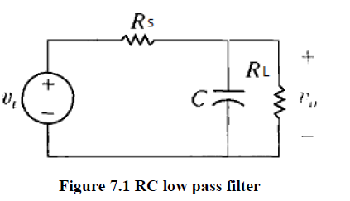

Figure 7.1 **RC low pass filter**

1. Zero frequency: The impedance of the capacitor is infinite, and the capacitor acts as an open circuit and therefore,

Vo= RLRL+RS Vs

2. As the frequency increases, the impedance of the parallel combination of C and RL decreases, causing the output voltage to get smaller.

3. At infinite frequency: The impedance of the capacitor is zero, and the capacitor acts as a short circuit. The output voltage is thus zero.

A low pass first-order transfer function is of the form H(S)= K wcS+wc

**High-Pass first order Filters:**

A series RC circuit is shown in Figure 7.2. In contrast to its low-pass the output voltage here is defined across the resistive load, not the capacitor. Because of this, the effect of the changing capacitive impedance is different than it was in the low-pass configuration

At w = 0, the capacitor behaves like an open circuit, so there is no current flowing in the resistor and Vo = 0.

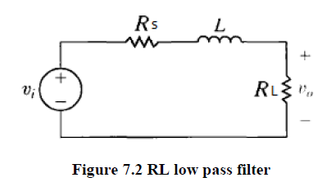

**RLC Bandpass Filter:**

Figure 7.5 depicts a series RLC circuit. We want to consider the effect of changing the source frequency on the magnitude of the output voltage. As before, changes to the source frequency result in changes to the impedance of the capacitor and the inductor. The qualitative analysis is somewhat more complicated, because the circuit has both an inductor and a capacitor.

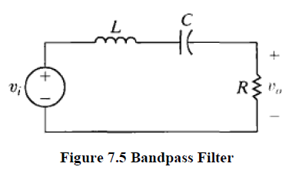

**Band reject Filters:**

As figure 7.7

We turn now to the last of the four filter categories—the band reject filter. This filter passes source voltages outside the band between the two cutoff frequencies to the output (the pass band) and attenuates source voltage before they reach the output at frequencies between the two cutoff frequencies (the stop band). Band pass filters and band reject filters thus perform complementary functions in the frequency domain. Band reject filters are characterized by the same parameters as band pass filters: the two cutoff frequencies, the center frequency, the bandwidth, and the quality factor. Again, only two of these five parameters can be specified independently

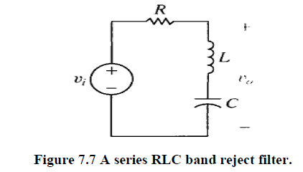

**Procedure:**

**Part A: First-order RC High Pass Filter**

Connect the circuit of Figure 1:

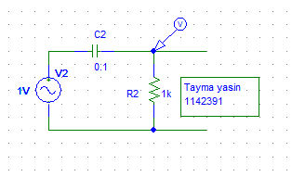

Figure1

Change the frequency according to Table 1, measure VO using DMMand record results in the same table,a sinusoidal input voltage at 1 VRMS. .

|  |  |  |  |  |  |  |  |  |  |  |
| --- | --- | --- | --- | --- | --- | --- | --- | --- | --- | --- |
| F(KHz) | 0.03 | 0.1 | 0.3 | 0.6 | 0.9 | fc  1.48K | 3 | 10 | 20 | 30 |
| VO[$V_{RMS}$] | 0.021 | 0.67 | 0.197 | 0.38 | 0.514 | $$V_{max/\sqrt{2}}$$ 0.703 | 0.863 | 0.993 | 0.997 | $$V_{max}$$ 0.995 |
| 20 $log\left(\frac{vo}{vi}\right)[dB]$ | -33.5 | -3.4 | -14.1 | -8.4 | -5.7 | -3.1 | -1.3 | -0.06 | -0.03 | -0.04 |

Table1

Question 1: In your report use data in Table 1 to plot {(20log VO) vs. (f)} using excel (use decade scale x-axis), discuss the plot’s behavior comparing experimental value of (fC) to its theoretical value.

$$fc=\frac{1}{2*π*R*C}=\frac{1}{2*π*1000*0.1*{10}^{-6}}=1.59KHz$$

The cut off frequency is calculated by using the formula ‘fc’ which is shown above on table 1, High Pass filter allows the frequencies which are higher than the cut off frequency ‘fc’ and blocks the lower frequency signals.

experimental value close to the theoretical value.

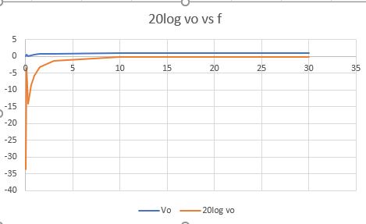

Figure2(The experimental frequency response Plot using excel)

**Part B: First-order RC Loaded Low Pass Filter**

Connect the circuit of Figure 3 :

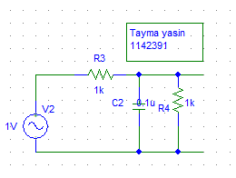

Figure3

change frequency according to Table 2 staying in the range (30 Hz-200 kHz), and record results in the same table.

|  |  |  |  |  |  |  |  |  |  |  |
| --- | --- | --- | --- | --- | --- | --- | --- | --- | --- | --- |
| F(KHz) | 0.03 | 0.3 | 2 | fc  3.1K | 5 | 7.5 | 12 | 30 | 100 | 200 |
| VO[$V_{RMS}$] | $$V_{max}$$ 0.503 | 0.500 | 0.416 | $$V_{max/\sqrt{2}}$$ 0.35 | 0.255 | 0.189 | 0.128 | 0.055 | 0.002 | 0.002 |
| 20 $log\left(\frac{vo}{vi}\right)[dB]$ | -5.9 | -6.0 | -7.6 | -9.1 | -11.8 | -14.4 | -17.8 | -25.2 | -30.4 | -53.9 |

Table2

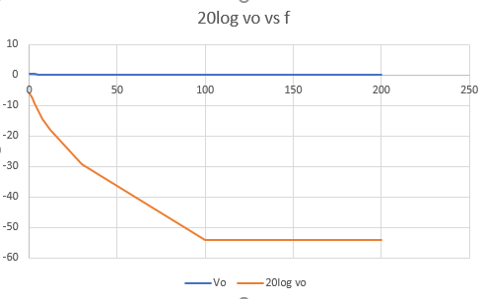

Figure4(The experimental frequency response Plot using excel)

Question 2: Repeat same procedure in question 1 for data in Table2 and discuss the effect of loading the filter on VO and fC.

The impedance of the capacitor is infinite, and the capacitor acts as an open circuit and therefore

Then

$$vo=\frac{RL}{RL+RC}vs$$

As the frequency increases, the impedance of the parallel combination of C and RL decreases, causing the output voltage to get smaller.

After this cut-off frequency point the response of the circuit decreases to zero at a slope of -20dB

$$\frac{1}{R}=\frac{1}{RC}+\frac{1}{Rl}=\frac{1000*1000}{1000+1000}=500Ω$$

$$fc=\frac{1}{2*π*R*C}=\frac{1}{2*π*500*0.1*{10}^{-6}}=3.18KHz$$

experimental value close to the theoretical value.

**Part C: Parallel RLC Band Pass Filter**

Connect the circuit of Figure 5 :

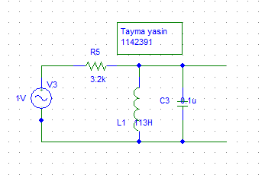

Figure5

R=3.2KΩ

Table 3

|  |  |  |  |  |  |  |  |  |  |  |  |
| --- | --- | --- | --- | --- | --- | --- | --- | --- | --- | --- | --- |
| VO[$V_{RMS}$] | 0.03 | 0.15 | 0.3 | 0.5 | $$V_{max/\sqrt{2}}$$ 0.68 | $$V_{max}$$ 0.97 | $$V_{max/\sqrt{2}}$$ 0.68 | 0.5 | 0.3 | 0.15 | 0.03 |
| F(KHZ) | 138.9Hz | 597.1Hz | 905.6Hz | 1.11K | Fc1  1.239K | Fc0  1.4K | Fc2  1.7K | 1.86K | 2.3K | 3.5K | 12.48 |
| 20 $log\left(\frac{vo}{vi}\right)[dB]$ | 30.4 | 16.4 | 10.4 | 6.0 | 3.3 | 0.26 | 3.3 | 6.0 | 10.4 | 16.4 | 30.4 |

Question 3**:** In your report use data in Table 3 to plot {(20log VO) vs. (f)} using excel (use log scale for x-axis). From the plot calculate the bandwidth (β) and discuss the plot’s behavior comparing experimental values of (f0), (fC1 and fC2), and (β) to their theoretical value.

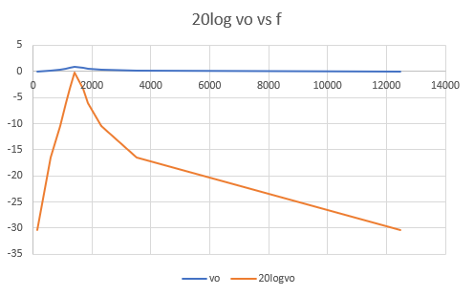

Figure5(The experimental frequency response Plot using excel)

$$fo=\frac{1}{2*π\sqrt{LC}}=\frac{1}{2*π*\sqrt{113*10*{10}^{-9}}}=1.49K$$

$$fc1=\frac{-\frac{R}{2L}+\sqrt{\left({\left(\frac{R}{2L}\right)}^{2}+\frac{1}{LC}\right)}}{2*π}=1.4K$$

$$fc2=\frac{\frac{R}{2L}+\sqrt{\left({\left(\frac{R}{2L}\right)}^{2}+\frac{1}{LC}\right)}}{2*π}=1.88K$$

$$β=\frac{R}{l}=28.3$$

|  |  |  |  |  |  |  |  |  |  |  |  |
| --- | --- | --- | --- | --- | --- | --- | --- | --- | --- | --- | --- |
| VO[$V_{RMS}$] | 0.03 | 0.15 | 0.3 | 0.5 | $$V_{max/\sqrt{2}}$$ 0.703 | $$V_{max}$$ 0.995 | $$V_{max/\sqrt{2}}$$ 0.703 | 0.5 | 0.3 | 0.15 | 0.03 |
| F(KHZ) | 71.4Hz | 342.7Hz | 617Hz | 877K | Fc1  1.07 K | Fc0  1.44K | Fc2  1.95K | 2.43K | 3.3K | 6.39K | 22.3K |
| 20 $log\left(\frac{vo}{vi}\right)[dB]$ | -30.4 | -16.4 | -10.4 | -6.0 | -3.0 | -0.04 | -3.0 | -6.0 | -10.4 | -16.4 | -30.4 |

R=1.6KΩ

Question 4:Repeat same procedure in question 3 for data in Table 7.4 and discuss the effect of changing R on the values of (f0), (fC1 and fC2), and (β) as compared to previous question.

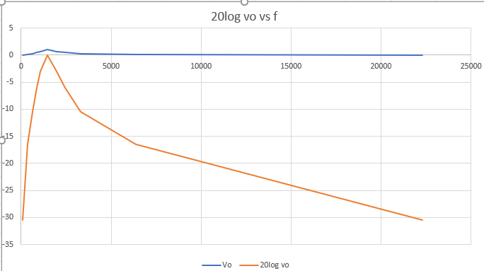

Figure6(The experimental frequency response Plot using excel)

$$fo=\frac{1}{2*π\sqrt{LC}}=\frac{1}{2*π*\sqrt{113*10*{10}^{-9}}}=1.49K$$

$$fc1=\frac{-\frac{R}{2L}+\sqrt{\left({\left(\frac{R}{2L}\right)}^{2}+\frac{1}{LC}\right)}}{2*π}=1.10K$$

$$fc2=\frac{\frac{R}{2L}+\sqrt{\left({\left(\frac{R}{2L}\right)}^{2}+\frac{1}{LC}\right)}}{2*π}=1.98$$

$$β=\frac{R}{l}=14.1$$

The bandwith increase when the resetaince changed

**Part D: Series RLC Band Reject Filter**

Connect the circuit of Figure 9 :

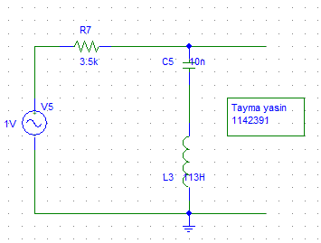

Figure 9

Connect the DMMacross VO, then change the frequency in steps so that VO is equal to the values listed in Table 5, record the corresponding values of frequency in Table 5 ,with a sinusoidal input voltage at 1 VRMS.

To determine center frequency (f0) experimentally, change frequency until VO is around VMin, at this point (f) is the center frequency (f0),cutoff frequencies (fC1 and fC2) change the frequency until VO is around (Vmax/√2), there will be two points, record values in Table 5.

R=3.5Ω

|  |  |  |  |  |  |  |  |  |  |  |  |
| --- | --- | --- | --- | --- | --- | --- | --- | --- | --- | --- | --- |
| VO[$V_{RMS}$] | $$V_{max}$$ 0.981 | $$V_{max/\sqrt{2}}$$ 0.68 | 0.5 | 0.3 | 0.15 | $$V_{min}$$ 0.006 | 0.15 | 0.3 | 0.5 | $$V_{max/\sqrt{2}}$$ 0.69 | $$V_{max}$$ 0.988 |
| F(KHZ) | 12 | Fc1  410 | 608 | 870 | 1.13K | Fc0  1.46K | 1.90K | 2.47K | 3.5K | Fc2  5.12K | 24.18K |
| 20 $log\left(\frac{vo}{vi}\right)[dB]$ | -0.16 | -3.35 | -6.02 | -10.4 | -16.4 | -44.4 | -16.4 | -10.4 | -6.02 | -3.22 | -0.1 |

Question 5**:** plot {(20log VO) vs. (f)} using excel (use log scale for x-axis). From the plot calculate the bandwidth (β) and discuss the plot’s behavior comparing experimental values of (f0), (fC1 and fC2), and (β) to their theoretical value.

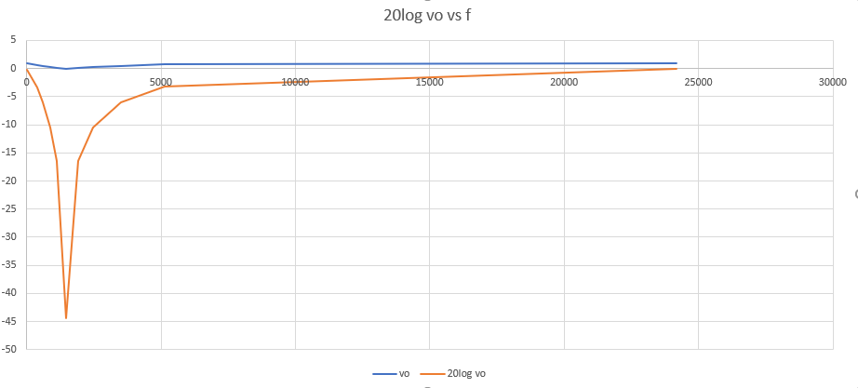

Figure10(The experimental frequency response Plot using excel)

When R=3.5KΩ

$$fo=\frac{1}{2*π\sqrt{LC}}=\frac{1}{2*π*\sqrt{113*10*{10}^{-9}}}=1.49K$$

$$fc1=\frac{-\frac{R}{2L}+\sqrt{\left({\left(\frac{R}{2L}\right)}^{2}+\frac{1}{LC}\right)}}{2*π}=420HZ$$

$$fc2=\frac{\frac{R}{2L}+\sqrt{\left({\left(\frac{R}{2L}\right)}^{2}+\frac{1}{LC}\right)}}{2*π}=4.9K$$

$$β=\frac{R}{l}=30.9$$

R=7.1KΩ

|  |  |  |  |  |  |  |  |  |  |  |  |
| --- | --- | --- | --- | --- | --- | --- | --- | --- | --- | --- | --- |
| VO[$V_{RMS}$] | $$V_{max}$$ 0.993 | $$V_{max/\sqrt{2}}$$ 0.702 | 0.5 | 0.3 | 0.15 | $$V_{min}$$ 0.010 | 0.15 | 0.3 | 0.5 | $$V_{max/\sqrt{2}}$$ 0.708 | $$V_{max}$$ 0.991 |
| F(KHZ) | 11 | Fc1  207.4 | 343 | 562.3 | 886 | Fc0  1.46K | 2.4K | 3.6K | 5.9K | 8.8K | 21.7K |
| 20 $log\left(\frac{vo}{vi}\right)[dB]$ | -0.06 | -3.07 | -6.02 | -10.4 | -16.4 | -40 | -16.4 | -10.4 | -6.02 | -3.09 | -0.07 |

Question 6:discuss the effect of changing R on the values of (f0), (fC1 and fC2), and (β) as compared to previous question.

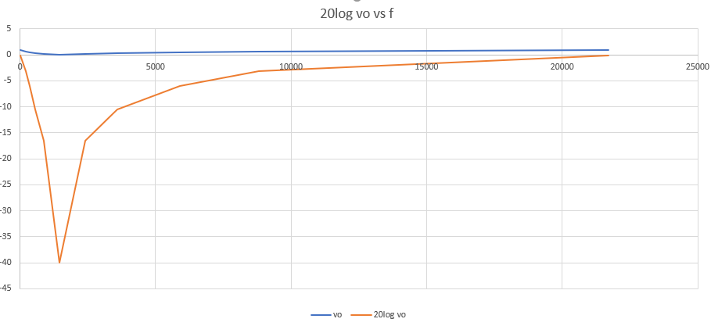

Figure10(The experimental frequency response Plot using excel)

When R=7.1KΩ

$$fo=\frac{1}{2*π\sqrt{LC}}=\frac{1}{2*π*\sqrt{113*10*{10}^{-9}}}=1.49K$$

$$fc1=\frac{-\frac{R}{2L}+\sqrt{\left({\left(\frac{R}{2L}\right)}^{2}+\frac{1}{LC}\right)}}{2*π}=186HZ$$

$$fc2=\frac{\frac{R}{2L}+\sqrt{\left({\left(\frac{R}{2L}\right)}^{2}+\frac{1}{LC}\right)}}{2*π}=11.8K$$

$$β=\frac{R}{l}=62.8$$

The bandwith increase when the resetaince changed

**Conclusion:**

In this experiment, different circuits that select some frequencies and attenuate others were tested. Such circuits are widely used in applications since they can be used to eliminate harmonics or undesired frequencies and pass other useful ones.

First of these is ; low pass filter, values of voltages obtained for frequencies less than the half power frequency were passed normally and changes in voltages  in this region were small. By contrast; for frequencies exceeding fc signals’ magnitudes were largely attenuated. Second type is high pass filters, and they behaved opposite the low pass filters. Third, Band pass filters were tested by measuring voltages for frequencies around resonance frequency which represents a special frequency since maximum value for current occurs and there was almost no phase shift at fo this phenomena happens at minimum impedance and zero phase shift for series circuits, and at maximum impedance or the voltage and current are in phase for parallel circuits. Finally, some deviations occurred between experimental and simulation results as appeared analysis section, this may have been caused by the resistance of wires, components uncertainty and tolerances, and inaccuracy in measurement devices.

**Appendix:**



