**Birzeit University**

**Mechanical & Mechatronics Engineering Department**

**Fluid Mechanics-ME335**

**Suggested problems Chapter 3**

**Instructors: Dr. Afif Hasan Summer 2018/2019**

1. The pipe flow in Fig. P3.12 fills a cylindrical tank as shown. At time t = 0, the water depth in the tank is 30 cm. Estimate the time required to fill the remainder of the tank.

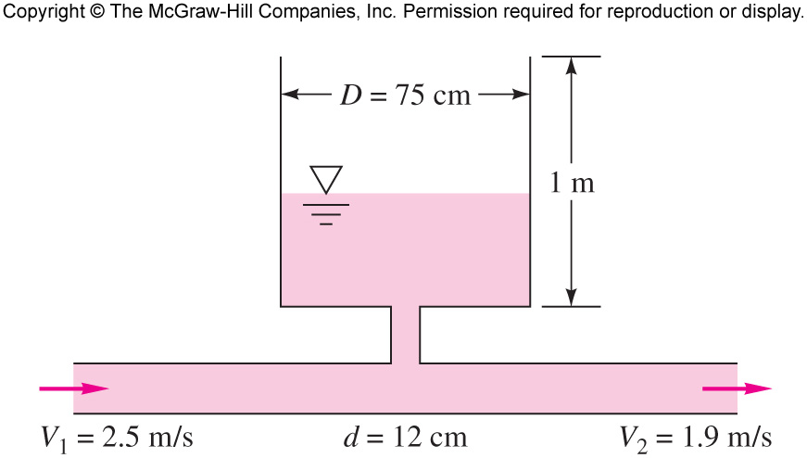

1. The open tank in the figure contains water at 20 OC. For incompressible flow, (a) derive an analytic expression for **dh/dt** in terms of (Q1, Q2, Q3). (b) **If h is constant**, determine V2 for the given data if V1 = 3 m/s and Q3 = 0.01 m3/s.

. 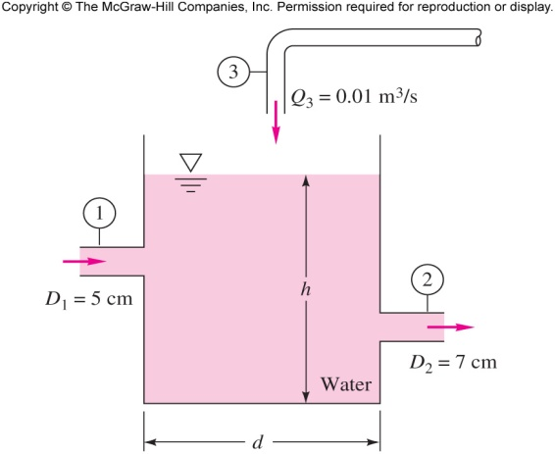

1. Water at 20°C flows through the piping junction in the figure, entering section 1 at 20 gal/min. The average velocity at section 2 is 2.5 m/s. A portion of the flow is diverted through the showerhead, which contains 100 holes of 1-mm diameter. Assuming uniform shower flow, estimate the exit velocity from the showerhead jets. (1 gal = 3,785 liters).

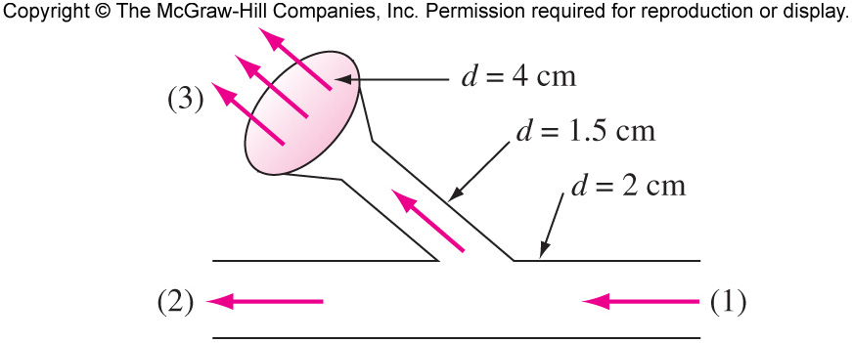

1. A liquid of density ρ flows through the sudden contraction in Fig. P3.42 and exits to the atmosphere. Assume uniform conditions (p1, V1, D1) at section 1 and (p2, V2, D2) at section 2. Find an expression for the force F exerted by the fluid on the contraction.

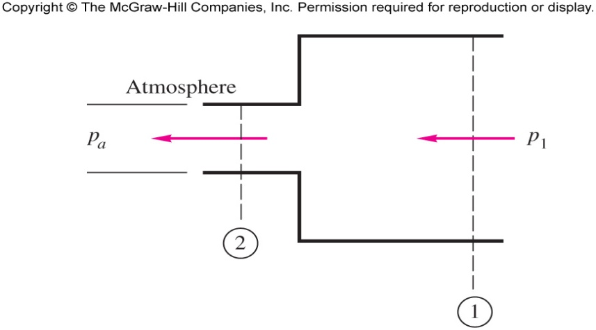

1. A liquid jet of density r and area A strikes a block and splits into two jets, as shown in the figure. All three jets have the same velocity V. The upper jet exits at angle θ and area αA, the lower jet turns down at 90° and area (1-α)A. (a) Derive a formula for the forces (Fx, Fy) required to support the block against momentum changes. (b)Show that Fy = 0 only if α ≥ 0.5. (c) Find the values of α and θ for which both F x and Fy are zero.

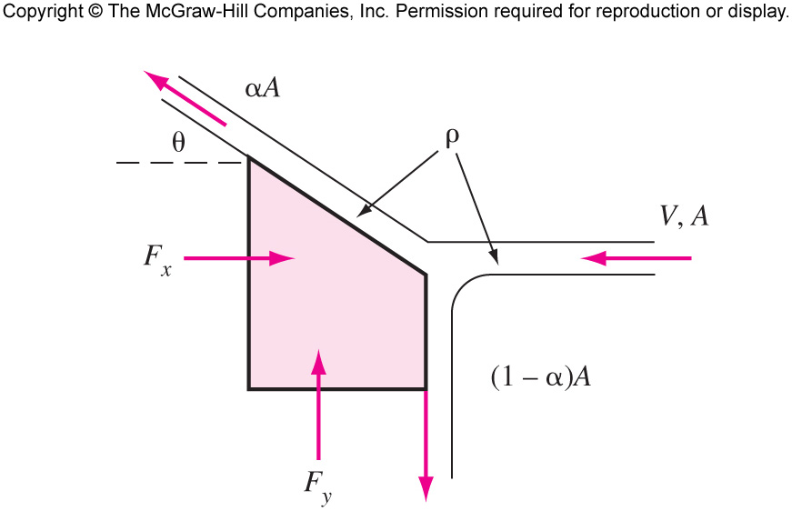

1. Water at 20 0C, in the pressurized tank of Fig. P3.117, flows out and creates a vertical jet as shown. Assuming steady frictionless flow, determine the height H to which the jet rises.

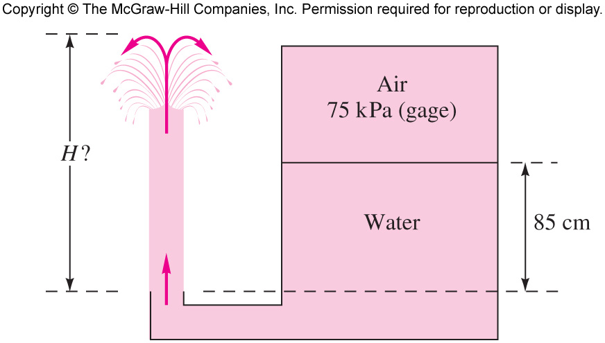

7.

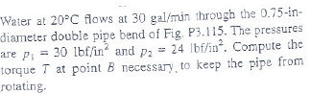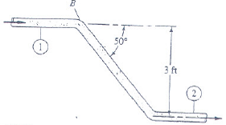

8.

