Clutches and Brakes

Clutches and brakes depend on friction in order to function.

Design objectives of brake and clutch design:
- Maximize friction
- Keep it uniform over a wide range of operation
- Minimize wear.

Clutch:
The function of a clutch is to permits smooth, gradual connection and disconnection of two members with common axis of rotation.

Brake:

Acts the same as the clutch but one member is fixed.

Types of clutches and brakes:

- Friction type
- Magnetic
- Eddy current
- Hydrodynamic (fluid coupling)

In this course, we will consider only friction type brakes and clutch

Friction Type Clutches and Brakes:

These types of brakes must satisfy the following requirement
- The friction torque must be produced by acceptable force.
- The energy produced must be dissipated without producing high temperature.
- Reduce friction wear to give acceptable life.

Drum Brakes

Drum brakes are of two types:
- External Shoe that contracts to bear against an outer drum surface.
- Internal Shoe that expands to contact the inner drum surface.

Short- Shoe Drum Brake:

The shoe contact only a small segment of drum periphery
➔ Short-Shoe Analysis: assume that the friction and normal force act at the center of contact.

A Free- Body diagram for clockwise drum rotation:

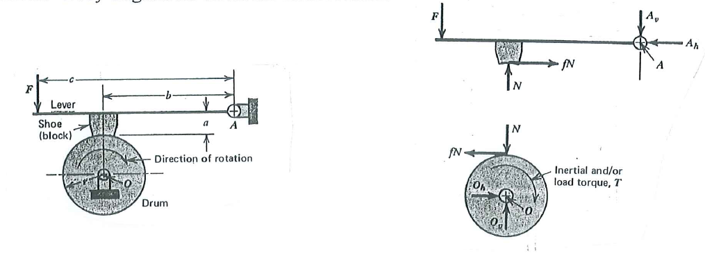

Taking moment about pivot A for the shoe and lever:
$\sum{M_{A}}=0$ $⇒ \text{Fc}+\text{fNa}−\text{bN}=0$ (1)
Taking moment about O of the drum:
$\sum{M_{O}}=0$ $⇒ T=\text{fNr}$ (2)
Solving (1) for N and substituting in (2):
$$⇒ N=\frac{\text{Fc}}{\left(b−\text{fa}\right)}$$

$$⇒ T=\frac{\text{fFcr}}{\left(b−\text{fa}\right)}$$

T = friction torque[ Inertial or load torque required for equilibrium]

Self-Energizing and Self-de-Energizing Brakes:

A brake is considered self- energizing if the moment friction force (fNa) assists the applied force (F) in applying the brake (reduce the force F).
Self-energizing is produced for cw rotation of the drum.
Self-de-energizing brake: if the moment of friction force opposes the application of the brake (increase the force F required for brakeing).
Self-de-energizing is produced for ccw rotation of the drum.

Friction force opposes direction of rotation F
$T=\frac{\text{fFcr}}{\left(b+\text{fa}\right)}$ fN

ccw

Note:

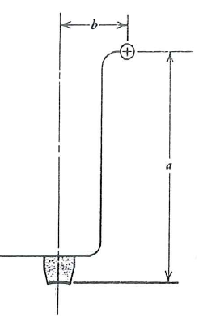
T (self-energizing) > T (self-de-energizing)

Self Locking Brake:

For cw rotation: $T=\frac{\text{fFcr}}{\left(b−\text{fa}\right)}$

If : (b-fa)≤ 0 ➔ no torque required to produce the brake (self-locking)

Self -Locking brake ➔ b≤ fa

For example: For cw rotation if f= 0.3
Self locking ➔ b ≤ 0.3a
➔ Self locking: F =0 (no force is required to produce the brake)

Long Shoe Drum Brake:

Long –Shoe: contact arc θ ≥ 45°.
- Internal Shoe
- External Shoe

Internal Shoe Drum Brake:

It is normally used for automotive rear wheel .
Function:
Both shoes pivot about pin and are forced against the inner surface of the drum by a hydraulic piston at the ends. The spring is used to retract the shoes to the original position

(a) (b)

To determine the pressure p of lining on the drum caused by applying the force F on the left shoe which is deformed (as shown by dashed line)
δ = Radial deflection

$δ=δ^{'}\text{cos}θ=γ\text{AG}\text{cos}α$ γ= small angle of shoe rotation.
$δ=r\text{sin}θ=γr\text{sin}θ$ $\text{AG}\text{cos}α=\text{AN}=r\text{sin}θ$
p ∝ δ ∝ sinθ p= kδ , p= pressure on the drum, k= stiffness constant of lining.

p_{max} ➔ θ =θ _{max}

$⇒ \frac{p}{\text{sin}θ}=\frac{p_{\text{max}}}{\text{sin}θ_{\text{max}}}$ (1)
$$(\text{sin}θ)_{\text{max}}=1\text{.}\text{0 when }θ_{\text{max}}={\text{90}}^{∘} ⇒\text{ at }(θ=\text{90}) p=p_{\text{max}}⇒\text{ max wear}$$

➔ Good design: max thickness of friction material at point of max. pressure.

It is required to find the friction torque and the reactions at the hinge of the shoe.

Drum rotating cw:

Taking an infinitesimal area (dA)then integrating over the whole contact area

$\text{dA}=\text{brd}θ$ where: b = face width of friction material

$\text{dN}=\text{pbrd}θ$ (2)
From (1):
$p=\frac{p_{\text{max}}}{\text{sin}θ_{\text{max}}}\text{sin}θ$ (3)
Substituting (3) in (1):
$$⇒ \text{dN}=p_{\text{max}}\frac{\text{br}\text{sin}θ dθ}{\text{sin}θ_{\text{max}}}$$
To find the actuating force F:

1- Frictional moment about A:
$$M_{f}=\int{\text{fdN}(r−a\text{cos}θ)}=\frac{{\text{fbrp}}_{\text{max}}}{\text{sin}θ_{\text{max}}}\int_{θ1}^{θ2}{\text{sin}θ(r−a\text{cos}θ)dθ}$$
- Normal force Moment about A:

$$M_{N}=\int{\text{dN}\left(a\text{sin}θ\right)}=\frac{{\text{brap}}_{\text{max}}}{\text{sin}θ_{\text{max}}}\int_{θ1}^{θ2}{{\left(\text{sin}θ\right)}^{2}dθ}$$
- Summing moment about A

$\sum{M_{A}}=\text{Fc}−M_{N}+M_{f}=0$ $⇒ F=\frac{M_{N}−M_{f}}{c}$ ➔ (self-energizing)
If $M_{N}=M_{f} ⇒\text{ F}=\text{0 }$ ➔ (Self-locking) No actuating force is required .

In Automotive application, brake must be strongly self – energizing while staying away from self-locking.

$$⇒ M_{N}≥M_{f}\text{ recommended value: }M_{N}=(1\text{.}\text{25}−1\text{.}5) M_{f}$$
Frictional Torque:

$$T=\int{{\text{dF}}_{f}r}=\int{\text{frdN}=\frac{{\text{fbr}}^{2}p_{\text{max}}}{\text{sin}θ_{\text{max}}}\int_{θ1}^{θ2}{\text{sin}θdθ}}=\frac{{\text{fbr}}^{2}p_{\text{max}}(\text{cos}θ_{1}−\text{cos}θ_{2})}{\text{sin}θ_{\text{max}}}$$

Reaction at hinge A:
$$\sum{F_{h}=0 ⇒ R_{x}=\frac{{\text{brp}}_{\text{max}}}{\text{sin}θ_{\text{max}}}}(A−\text{fB})−F_{x}$$
$$\sum{F_{v}=0 ⇒ R_{y}=\frac{{\text{brp}}_{\text{max}}}{\text{sin}θ_{\text{max}}}}(B+\text{fA})−F_{y}$$

Drum rotating ccw:

The friction force is opposite to the direction of rotation

$\sum{M_{A}}=\text{Fc}−M_{N}−M_{f}=0$ $⇒ F=\frac{M_{N}+M_{f}}{c}$ ➔ (Self-de-energizing)
$$R_{x}=\frac{{\text{brp}}_{\text{max}}}{\text{sin}θ_{\text{max}}}(A+\text{fB})−F_{x}$$

$$R_{y}=\frac{{\text{brp}}_{\text{max}}}{\text{sin}θ_{\text{max}}}(B−\text{fA})−F_{y}$$
where:

$$A=\int_{θ1}^{θ2}{\text{sin}θ}\text{cos}θdθ={\left(\frac{1}{2}\text{sin}θ\right)}_{θ1}^{θ2}$$
$$B=\int_{θ1}^{θ2}{{\text{sin}}^{2}θ}dθ={\left(\frac{θ}{2}−\frac{1}{4}\text{sin}θ\right)}_{θ1}^{θ2}$$
Note: the reference is always in the center of the drum. The positive x-axis is taken through the hinge. The positive y-axis is always in the direction of the shoe.

Internal Shoe Drum Brake:
- Normally used in automotive rear wheel
- Energizing and de-energizing characteristics are determined by:
- Noting the direction of friction force acting upon the shoe surface
- Determining if this force tends to bring the shoe into or out of contact of the drum
For the left figure shown below:
Left shoe: self – energizing
Right shoe: self-de-energizing
In automotive brakes ➔ self-energizing is desired ➔ decrease pedal force
But self-locking must be avoided

Improved Design:

The shoes are inverted and each one is actuated by a separate cylinder.
This arrangement will increase the self- energizing action
➔ Both shoes are self-energizing in forward car motion.
➔ This arrangement is used in automotive front wheels.
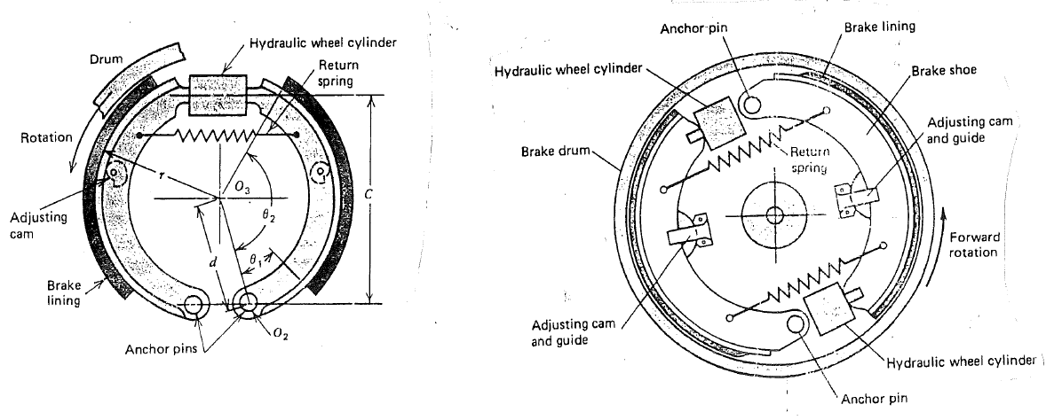

Long Shoe Drum Brake with External Shoe:

Consider the external brake shown in the figure. We have proved in previous sections that:
$p=\frac{p_{\text{max}}}{\text{sin}θ_{\text{max}}}\text{sin}θ$

- Drum rotating cw:

Summing moment about A:

$$\sum{M_{A}=}\text{Fc}−M_{N}−M_{f}=0$$

$⇒ F=\frac{M_{N}+M_{f}}{c}$ (Self-de-energizing)
Large force is required to balance these moments (friction moment does not assist the force to produce the brake).

Where M_{N} is the moment of normal force:

$$M_{N}=\int{\text{dN}\left(a\text{sin}θ\right)}=\frac{{\text{brap}}_{\text{max}}}{\text{sin}θ_{\text{max}}}\int_{θ1}^{θ2}{{\left(\text{sin}θ\right)}^{2}dθ}=\frac{{\text{brap}}_{\text{max}}}{4\text{sin}θ_{\text{max}}}\left[2\left(θ_{2}−θ_{1}\right)−\text{sin}2θ_{2}+\text{sin}2θ_{1}\right]$$
Moment of friction force:
$$M_{f}=\int{\text{fdN}(r−a\text{cos}θ)d}θ=\frac{{\text{fbrp}}_{\text{max}}}{\text{sin}θ_{\text{max}}}\int_{θ1}^{θ2}{\text{sin}θ(r−a\text{cos}θ)dθ}$$
Substituting the relation: $\text{sin}θ\text{cos}θ=12\text{sin}2θ$
$$M_{f}=\frac{{\text{fbrp}}_{\text{max}}}{\text{sin}θ_{\text{max}}}\left[r\left(\text{cos}θ_{1}−\text{cos}θ_{2}\right)+\frac{a}{4}\left(\text{cos}2θ_{2}−\text{cos}2θ_{1}\right)\right]$$
dN

cw

r
O fdN

Friction Torque:
$$T=\int{{\text{dF}}_{f}r}=\int{\text{frdN}=\frac{{\text{fbr}}^{2}p_{\text{max}}}{\text{sin}θ_{\text{max}}}\int_{θ1}^{θ2}{\text{sin}θdθ}}=\frac{{\text{fbr}}^{2}p_{\text{max}}(\text{cos}θ_{1}−\text{cos}θ_{2})}{\text{sin}θ_{\text{max}}}$$
Reaction forces at hinge A:

Reaction forces is obtained summing forces in horizontal and vertical direction:

$$\sum{F_{h}=0 ⇒ R_{x}=\frac{{\text{brp}}_{\text{max}}}{\text{sin}θ_{\text{max}}}}(A+\text{fB})−F_{x}$$

$$\sum{F_{v}=0 ⇒ R_{y}=\frac{{\text{brp}}_{\text{max}}}{\text{sin}θ_{\text{max}}}}(\text{fA}−B)+F_{y}$$
where:
$$A=\int_{θ1}^{θ2}{\text{sin}θ}\text{cos}θdθ={\left(\frac{1}{2}\text{sin}θ\right)}_{θ1}^{θ2}$$
$$B=\int_{θ1}^{θ2}{{\text{sin}}^{2}θ}dθ={\left(\frac{θ}{2}−\frac{1}{4}\text{sin}θ\right)}_{θ1}^{θ2}$$

2. Drum Rotating ccw:

Summing moment about A:
$$\sum{M_{A}}=\text{Fc}−M_{N}+M_{f}=0$$

$⇒ F=\frac{M_{N}−M_{f}}{c}$ (Self-energizing)
For ccw less force is desired to obtain the brake, the friction moment assists the force to produce the brake.

If $M_{f}≥ M_{N}$ ➔ self-energizing brake is self-locking
It is often desired to make brake self-energizing, while staying away from self-locking.

➔ In brake design: $f≥(\text{25}−\text{50}\text{\%})\text{ true value, }⇒ M_{f}≈ M_{N}$

Hinge Reactions:

$$\sum{F_{h}=0 ⇒ R_{x}=\frac{{\text{brp}}_{\text{max}}}{\text{sin}θ_{\text{max}}}}(A−\text{fB})−F_{x}$$

$$\sum{F_{v}=0 ⇒ R_{y}=\frac{{\text{brp}}_{\text{max}}}{\text{sin}θ_{\text{max}}}}(−\text{fA}−B)+F_{y}$$

Symmetrical External Shoe Drum Brake:

If the pivot P is located at the intersection of the resultant normal force (N) and frictional force (fN) ➔ the shoe will not rotate around P.
This is desirable to equalize wear.
In practice pivot P will move closer to the drum as wear occurs
➔ increase the tendency of the shoe to pivot around P.

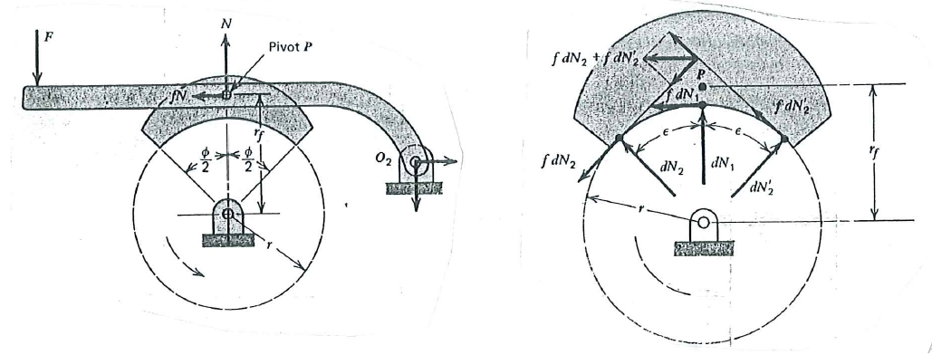

Integrating over the symmetrical shoe surface, the intersection point of the normal and friction forces r_{f} :
$$⇒ {\left(\int{M_{f}}\right)}_{\text{rf}}=0$$
$r_{f}=\frac{4r\text{sin}\left(φ2\right)}{φ+\text{sin}φ}$
where:
r_{f} : is measured from the drum center. Note that $r_{f}>r$
φ = total shoe angle.

With the pivot placed at this point, the moment about P is zero. The reactions at P are:

$$R_{x}=\text{fN}$$

$$R_{y}=N$$

Friction Torque:

The friction torque, which is equal to the brakeing torque is:

$$T={\text{fNr}}_{f}$$
where: $r_{f}>r$, because the resulting frictional force acting on any symmetrical shoe is located above the drum surface.

Example:

Double shoe drum brake with spring force F applied at distance c= 500 mm to both shoes. The brake is released by a solenoid. If f = 0.3 and P_{max} = 446 kPa, b=50 mm.
Determine an appropriate value of spring force, and the resulting brake torque and power absorption for 300 rpm drum rotation in either directions.
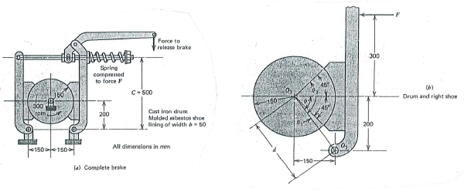

Solution:

- Right shoe:

φ= tan ^{–1}(200/150)= 53.13° ➔ θ₁ = 8.13° and θ₂ =98.13° .

- $a=\sqrt{{\text{200}}^{2}+{\text{150}}^{2}}=\text{250}$ mm.

- θ₂ > 90 deg., sin θ_{max} =1

- $$M_{N}=\frac{{\text{brap}}_{\text{max}}}{4\text{sin}θ_{\text{max}}}\left[2\left(θ_{2}−θ_{1}\right)−\text{sin}2θ_{2}+\text{sin}2θ_{1}\right]$$

$M_{N}=\frac{\left(\text{50}\right)\left(\text{150}\right)\left(\text{250}\right)p_{\text{max}}}{4×1}\left[2\left(\frac{π}{2}\right)−\text{sin}\text{196}\text{.}{\text{26}}^{∘}+\text{sin}\text{16}\text{.}{\text{26}}^{∘}\right]=−\text{1735}×{\text{10}}^{3}p_{\text{max}}$,
P_{max} in MPa
5- $M_{f}=\frac{{\text{fbrp}}_{\text{max}}}{\text{sin}θ_{\text{max}}}\left[r\left(\text{cos}θ_{1}−\text{cos}θ_{2}\right)+\frac{a}{4}\left(\text{cos}2θ_{2}−\text{cos}2θ_{1}\right)\right]$

$$M_{f}=\frac{{\text{fp}}_{\text{max}}(\text{50})(\text{150})}{1}\left[\text{150}\left(\text{cos}8\text{.}{\text{13}}^{∘}−\text{cos}\text{98}\text{.}{\text{13}}^{∘}\right)+\frac{\text{250}}{4}\left(\text{cos}\text{196}\text{.}{\text{26}}^{∘}−\text{cos}\text{16}\text{.}{\text{26}}^{∘}\right)\right]=\text{373}×{\text{10}}^{3}{\text{fp}}_{\text{max}}$$
- Brake Torque
$T=\frac{{\text{fbr}}^{2}p_{\text{max}}(\text{cos}θ_{1}−\text{cos}θ_{2})}{\text{sin}θ_{\text{max}}}=\frac{\left(\text{50}\right){\left(\text{150}\right)}^{2}{\text{fp}}_{\text{max}}(\text{cos}8\text{.}{\text{13}}^{∘}−\text{cos}\text{98}\text{.}{\text{13}}^{∘})}{1}=\text{1273}×{\text{10}}^{3}{\text{fp}}_{\text{max}}$ $\sum{M_{o1}=\text{Fc}+M_{f}−}M_{N}=0 ⇒ F=\frac{M_{N}−M_{f}}{c}$ (self-energizing)

- Fs= spring force = 1448 N

- For left shoe, the spring force will produce the brake pressure. Since, left shoe is self-de-energizing, P_{max} will be less than that for right shoe.

$$\sum{M_{o2}=\text{Fc}−M_{f}−}M_{N}=0 ⇒\text{ 1448}\left(\text{500}\right)\text{-1735}×{\text{10}}^{3}p_{\text{max}}−\text{373 }×{\text{10}}^{3}\left(0\text{.}3\right)p_{\text{max}}=0$$
p_{max}= 0.392 MPa

- Total braking torque

$T=T_{\text{RS}}+T_{\text{LS}}=\text{1273}×{\text{10}}^{3}\left(0\text{.}3\right)\left(0\text{.}\text{446}+0\text{.}\text{392}\right)=\text{320}$ N.m.

- Power = T×ω

$\text{Power}=T×ω=\text{320}×\text{300}\left(\frac{2π}{\text{60}}\right)=\text{9549}$ watt (applies for both directions of rotation)

Disk Clutch

Disk clutch operates dry or wet
- Dry clutch: Automotive clutch with manual transmission
- Wet clutch: multi disk clutches used in automotive automatic transmission. The oil serves as a coolant, multiple disks compensate for reduced coefficient of friction.

Estimating the axial clamping force and torque capacity is based on the two basic assumptions:
- Uniform pressure:
This assumption is valid for new, accurately manufactured clutches, with rigid outer disks.

The normal force acting on differential ring of radius r is
$$\text{dF}=\left(2π\text{rdr}\right)p$$
Axial Clamping Force:

$⇒ F=\int_{\text{ri}}^{\text{ro}}{2π\text{prdr}}=πp\left(r_{o}^{2}−r_{i}^{2}\right)$ (1)
Friction Torque:
$\text{dT}=\text{fdFr}=\left(2π\text{rdr}\right)\text{pfr}$ f : is assumed to be constant

Total torque:

$T=\int_{\text{ri}}^{\text{ro}}{2π{\text{pfr}}^{2}\text{dr}=23}π\text{pf}\left(r_{o}^{3}−r_{i}^{3}\right)$ (for one driving interface)

Multiple Clutch interfaces:

For N friction interfaces transmitting torque in parallel ➔ Total torque capacity:

$T=23π\text{pf}\left(r_{o}^{3}−r_{i}^{3}\right)N$ (2)
From eq. (1):
$p=\frac{F}{π\left(r_{o}^{2}−r_{i}^{2}\right)}$ (4)

Substituting (4) in (2):

$T=\frac{2\text{fF}\left(r_{o}^{3}−r_{i}^{3}\right)}{3\left(r_{o}^{2}−r_{i}^{2}\right)}N$ (5)

- Uniform Wear:

Wear rate ∝ Friction Work rate
Friction Work = Friction Force × Rubbing velocity
For constant f ➔ Wear ∝ pressure × Sliding velocity ➔ Wear ∝ p× v_{e}
For disk clutch:
➔ v_{e} ∝ r ➔ Wear ∝ p × r

➔ Uniform Wear results from uniform rate of friction work ➔ ${\text{pv}}_{e}=C$
- $$\text{pr}=C$$
➔ p_{max} at r_{min}

For disk clutch with: r_{o} = outside radius, r_{i} = inside radius

➔ p_{max} at r = r_{i}

$$\text{pr}=C=p_{\text{max}}r_{i}$$

$$⇒ F=\int_{\text{ri}}^{\text{ro}}{2πp_{\text{max}}r_{i}\text{dr}}=2πp_{\text{max}}r_{i}\left(r_{o}−r_{i}\right)$$
$T=\int_{\text{ri}}^{\text{ro}}{2πp_{\text{max}}r_{i}\text{frdrN}=}πp_{\text{max}}r_{i}f\left(r_{o}^{2}−r_{i}^{2}\right)N$ (6)

$$⇒ T=\text{fF}\left(\frac{r_{o}+r_{i}}{2}\right)N$$

Assumption of uniform wear gives lower clutch capacity than uniform pressure.

Clutch Design: Clutches are designed for uniform wear.

From eq. (6): Max. torque for a given outside radius is:

$$r_{i}=\sqrt{13}r_{o}=0\text{.}\text{58}r_{o}$$

Recommended Range: $r_{i}= 0\text{.}\text{45}r_{o} − 0\text{.}8r_{o}$

Disk Brake:

A brake is similar to clutch except that one of the shafts is replaced by a fixed member.
This type of brakes is unsatisfactory because of inadequate cooling.
For this reason, caliper disk brakes are commonly used.
Drum brake can be designed for self-energizing this has an advantage and disadvantage:
Advantage: reduced braking effort
Disadvantage: slight change of friction coefficient (as a result of temperature rise or moisture) will cause a large change in pedal force required for braking.
Disk brakes has no self-energization, hence is not sensitive to changes in friction coefficient.

Caliper disk brake have replaced front drum brakes due to:
- Greater cooling capacity
- High resistance to fade
- Drum brake tends to distort more with heat and large forces than disk brakes.

Cone Clutch and Brakes:

Cone clutch and brake can be considered as the general case of which disk brake is a special case, the cone angle α= 90°.
Cone clutch normally has one friction face ➔ N=1
The effect of the cone angle is to reduce the clamping force.
For the cone clutch shown on the figure:

$$\text{dA}=2π\text{rdr}\text{/sin}α$$

Normal force on dA:

$$\text{dN}=\text{pdA}=\left(2π\text{rdr}\right)p\text{/sin}α$$

Axial Clamping force:

$$\text{dF}=\text{dN}\text{sin}α=\left(2π\text{rdr}\right)p$$

Friction Torque:

$$\text{dT}=\text{dNfr}=2π\text{pf}r^{2}\text{dr}\text{/sin}α$$

- Uniform pressure:
$$F=\int_{\text{ri}}^{\text{ro}}{2π\text{prdr}}=πp\left(r_{o}^{2}−r_{i}^{2}\right)$$

$$T=23π\text{pf}\left(r_{o}^{3}−r_{i}^{3}\right)\text{sin}α$$

$$T=\frac{2\text{fF}\left(r_{o}^{3}−r_{i}^{3}\right)}{3\left(r_{o}^{2}−r_{i}^{2}\right)}\frac{1}{\text{sin}α}$$

- uniform Wear:

$$F=2πp_{\text{max}}r_{i}\left(r_{o}−r_{i}\right)$$

$$T=\frac{πp_{\text{max}}r_{i}f\left(r_{o}^{2}−r_{i}^{2}\right)}{\text{sin}α}$$

$$T=\text{fF}\left(\frac{r_{o}+r_{i}}{2}\right)/\text{sin}α$$
Note:
The smaller α ➔ the lower the clamping force ➔ the higher the friction torque.
If α < 8° ➔ the clutch tend to grab and become difficult to disengage.

➔ 8°<α< 15°

Optimum value: α=12°.

Band Brakes:

The band is made of steel, lined with a woven friction material
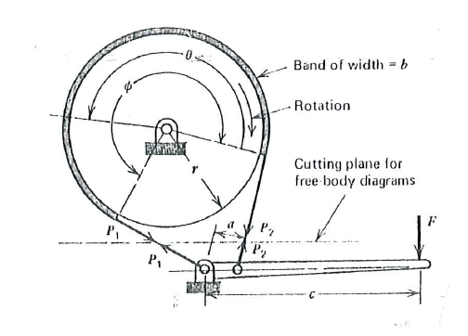

For cw drum rotation:

Friction force increases P₁ and decrease P₂ , ➔ $P_{1}>P_{2}$
Free-body diagram of Drum:

$$T=(P_{1}−P_{2})r$$
Free-body diagram of Lever:
$$F=\frac{{\text{aP}}_{2}}{c}$$
Forces acing on an element of the band:

For small angle dθ

$$\sum{F_{h}}=0$$

➔ $\text{dP}=\text{fdN}$ (1)
$$\sum{F_{h}}=0$$
➔ $\text{dN}=2\left(p\frac{dθ}{2}\right)=\text{Pd}θ$ (2)
Substituting (2) in (1):

➔ $\text{dP}=f\text{Pd}θ$

➔ $\frac{\text{dP}}{P}=fdθ$
Band force varies [P₁-P₂] between band contact angle θ =[0 - φ]

$\int_{P2}^{P1}{\frac{\text{dP}}{P}=f\int_{0}^{φ}{dθ}}$ ➔ $\text{ln}\frac{P_{1}}{P_{2}}=fφ$ ➔ $\frac{P_{1}}{P_{2}}=e^{fφ}$
But:
$\text{dN}=\text{pdA}=\text{pbrd}θ$ , where: p = pressure between drum and band.

$$\text{dN}=\text{Pd}θ$$

➔ $P=\text{pbr}$
➔ P ∝ p
p_{max} occurs at P_{max} = P₁

at θ = φ P= P_{max} = P₁

➔ at θ = φ $P_{1}=p_{\text{max}}\text{br}$

For cw rotation: Self-energizing

$F=\frac{{\text{aP}}_{2}}{c}$ , where P₂ < P₁ [friction force increases P₁ and decreases P₂]
For ccw rotation: Self-de-energizing

$F=\frac{{\text{aP}}_{2}}{c}$ , where P₁ < P₂ [friction force increases P₂ and decreases P₁]

Differential Band Brake:

To increase the self-energizing action the differential
$F=\frac{\left(P_{2}a−P_{1}s\right)}{c}$ , where P₁ < P₂ due to friction force
For self energizing: s < a (to insure that the lever will tighten the band at distance a more than at distance s).

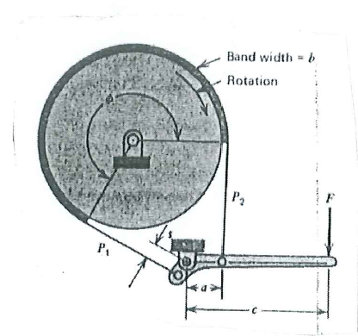

Energy Consideration in Brakes and Clutches:
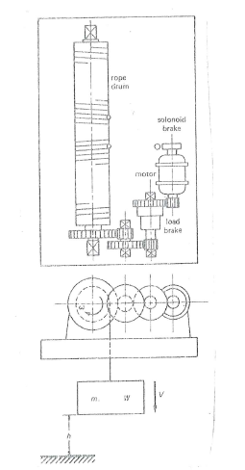

The hoist shown in the figure is required to lower a mass (m)

Assume that the brake is applied at time = t₁

At t₁
ω = ω₁ , V= V₁ , h = h₁

At t₂ the values are reduced

ω = ω₂ , V= V₂ , h = h₂

during time (t₂ – t₁)

Work done by brake = wk_{B}

Rolling friction, Bearing friction, air resistance = wk_{R}
Motor work = wk_{M}
wk_{M} = Work done by the machine in driving energy consuming device.
If the motor drives the machine during braking period ➔ wk_{M} = -ve

Total work done = Change in Energy

$${\text{wk}}_{B}+{\text{wk}}_{R}+{\text{wk}}_{M}=\sum{\frac{m}{2}}(V^{2_{1}}−V^{2_{2}})+\sum{\frac{I}{2}\left(ω_{1}^{2}−ω_{2}^{2}\right)}+\sum{W\left(h_{1}−h_{2}\right)}$$
the summation is made for different masses at their corresponding speeds and positions.

wk_{B} = mechanical energy transferred into heat at the brake .
$${\text{wk}}_{B}=\int_{ψ_{1}}^{ψ_{2}}{\text{Td}ψ =}T(ψ_{2}−ψ_{1})$$
ψ = angular displacement of the drum

For constant torque:

If T= const. ➔ linear deceleration = a= const.
- Angular deceleration = α = const.

Velocity displacement relation:

$$V_{2}=V_{1}−a(t_{2}−t_{1})$$
$$S_{2}=S_{1}+V_{1}(t_{2}−t_{1})−\frac{a}{2}{\left(t_{2}−t_{1}\right)}^{2}=S_{1}+\frac{V_{1}+V_{2}}{2}\left(t_{2}−t_{1}\right)$$
and angular velocity and displacement:

$$ω_{2}=ω_{1}−α(t_{2}−t_{1})$$

$$ψ_{2}=ψ_{1}+ω_{1}\left(t_{2}−t_{1}\right)−\frac{α}{2}{\left(t_{2}−t_{1}\right)}^{2}=ψ_{1}+\frac{ω_{1}+ω_{2}}{2}\left(t_{2}−t_{1}\right)$$

Clutch Work Energy Relationship:

In the clutching of two masses initially rotated in the same direction with different speeds, the higher speed mass supplies energy to lower speed mass.
In general: the work done by friction equal the net change in energy of the system.
Consider two masses with I and I′, rotating in the same direction with initial velocities ω> ω′

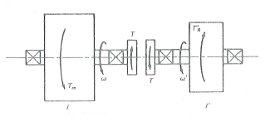

Assuming that clutch torque , T= const. during engagement

At time, t₁=0
ω> ω′
Left Shaft:
$$T=−I\frac{dω}{\text{dt}}$$
Right Shaft
$$T=I^{'}\frac{dω^{'}}{\text{dt}}$$
Integrating both equations:
$$ω=ω_{1}−\frac{T}{I}t$$
$ω^{'}=ω_{1}^{'}+\frac{T}{I^{'}}t$ (1)
A t=t₂ , relative motion ends (both shaft rotate at the same speed)

➔ ω₂ = ω′₂
$$ω_{1}−\frac{T}{I}t_{2}=ω_{1}^{'}+\frac{T}{I^{'}}t_{2}$$
$$t_{2}=\frac{ω_{1}−ω_{1}^{'}}{T}\frac{II^{'}}{I+I^{'}}$$
➔ the time required for engagement is proportional to velocity difference

t₂ = time required for clutch engagement
Subst. t₂ in eq. (1)

➔ Common velocity:
$$ω_{2}=ω_{2}^{'}=\frac{ω_{1}I+ω_{1}^{'}I^{'}}{I+I^{'}}$$
Displacement after time t₂:
$$ψ=\int_{0}^{t}{ω\text{dt}}=\int_{0}^{t}{\left(ω_{1}−\frac{T}{I}t\right)\text{dt}}=ω_{1}t−\frac{{\text{Tt}}^{2}}{2I}$$
$$ψ^{'}=\int_{0}^{t}{ω^{'}\text{dt}}=\int_{0}^{t}{\left(ω_{1}^{'}+\frac{T}{I}t\right)\text{dt}}=ω_{1}^{'}t+\frac{{\text{Tt}}^{2}}{2I^{'}}$$
The work done by the clutch after time t:

Work = Clutch Torque× Relative displacement
$$w_{K}=T(ψ−ψ^{'})=T\left(ω_{1}−ω_{1}^{'}\right)t−\frac{T^{2}\left(I+I^{'}\right)}{2II^{'}}t^{2}$$
Clutch work at completion of engagement, t = t₂
$$w_{\text{KC}}=\frac{II^{'}}{2\left(I+I^{'}\right)}{\left(ω_{1}−ω_{1}^{'}\right)}^{2}$$
w_{kc} = energy dissipated by the clutch or brake.
➔ energy dissipated is proportional to velocity difference squared.

S. I. units:
wkc = E = Joule

U. S. units:
wkc = E = lb.in., wkc = E = (lb.in./9336)= Btu.

Energy Absorption and Cooling:

Heat transfer equation of clutch or brake:

$$H=\text{CA}ΔT=\text{CA}(T_{s}−T_{a})$$
H = time rate of heat dissipation (Watt or hp)
C = overall heat transfer coefficient per unit area (W/m² °C, hp/in.² °F)
A = exposed heat –dissipating area (m² , in²)
T_{s} = average temperature of heat-dissipating surfaces (°C, °F)
T_{a} = Air temperature
Or
$$E=\text{mC}ΔT=\text{mC}(T_{s}−T_{a})$$
E = heat dissipation ( Joule or lb.in)
C = specific heat (J/m² °C, lb.in/in.² °F)
m = mass of brake or clutch (lb_{m}, Kg), (Btu = 9336 lb.in)
For steel and Cast Iron: C = 0.12 Btu/(lb_{m}. °F) = 500 J/(Kg. °C)
The rate of heat generation per unit area of friction interface is equal to the product of Clamping pressure, coefficient of friction and rubbing velocity
H= f pV
An emperical values for pV is obtained by brake manufacturer and is given below:

Operating Conditions | PV
Operating Conditions | (psi) (ft/min) | (KPa)(m/s)
Continuous poor heat dissp. | 30,000 | 1050
Occasional, poor heat dissp. | 60,000 | 2100
Continuous good heat dissp. | 85,000 | 3000

The ability of brake and clutch to absorb energy without reaching destructive temperatures can be increased by:
- Increasing exposed surface area
- Increasing air flow by minimizing air flow restrictions, and maximizing air pumping action of rotating parts.
- Increasing the mass and specific heat of contact parts.

Example:
An inertial load is to bring to rest in 10 sec. by a braking torque 2800 lb.in. The initial speed is 1600 rpm, and the heat dissipating surface weight 40 lb. Find the temperature rise.

Solution:
$ω_{1}=\frac{2πn}{\text{60}}=\frac{2π\text{1600}}{\text{60}}=\text{168}$ rad/s
ω₂ = 0
but: $t_{2}=\frac{ω_{1}−ω_{1}^{'}}{T}\frac{II^{'}}{I+I^{'}}$ = 10 sec
$\frac{II^{'}}{I+I^{'}}=\frac{{\text{Tt}}_{2}}{ω_{1}−ω_{1}^{'}}=\frac{\text{2800}(\text{10})}{\text{168}}=\text{166}\text{.}7$ lb.s². in.
$w_{\text{KC}}=\frac{II^{'}}{2\left(I+I^{'}\right)}{\left(ω_{1}−ω_{1}^{'}\right)}^{2}=\frac{\text{166}\text{.}7{\left(\text{168}\right)}^{2}}{2}$=2.35(10⁶) lb.in.
$$H=\text{mC}ΔT$$
H= 2.35(10⁶)/9336 = 252 Btu
ΔT= 252/[0.12(40)]=52.5 °F

Friction Material:

One of the mating material is normally metal (cast iron or steel) it must have:
- Good friction characteristics ( which is relatively stable over temp. range)
- Good thermal conductivity
- Good resistance to wear and thermal fatigue
- mooth surface finish to minimize wear of the mating friction material.
The friction material must have the following requirements:
- High dynamic coefficient of friction that is relatively stable over a usable temp range and not sensitive to moisture, dirt and oil
- Static coefficient of friction exceeds the dynamic value by as little as possible to avoid slip-stick chatter and noise.
- High resistance to abrasive and adhesive wear
- Good thermal conductivity
- Good temperature stability or resistance to fade (reduction in friction coefficient at elevated temp.)

Types of friction material:
- Molded: most common and least costly. Used for heavy duty application and drum brakes. Molded asbestos contains asbestos fiber and friction modifiers
- Woven: more flexible (suitable for band brake)
Asbestos lining is used for heavy machinery, perform better when contaminants as mud, grease, and dirt presents.
- Sintered: made of mixture of copper and iron particles with friction modifiers. Used in clutch and brakes for heavy duty applications.
Tables (16-1,2) list properties of typical friction materials
Example:

The figure shows a band brake used with a punch press. The brake is to be engaged when the crank is 120° past bottom dead center and bring the crank to rest at top dead center. The crank assembly has I= 12 N.m s² and rotating at 40 rpm when the brake is engaged. Max. allowed pressure p= 0.18 MPa, f = 0.35.
- Determine the required band width.
- Determine the required force, F
- Would any combination of direction of rotation or coefficient of friction make brake self-locking.

Solution:

(a) Work done by the brake = Change in K.E. of the system
$ΔK\text{.}E\text{.}=\frac{1}{2}I\left(ω_{1}^{2}−ω_{2}^{2}\right)=\frac{1}{2}(\text{12})(\frac{\text{40}×2π}{\text{60}})^{2}=\text{105}\text{.}\text{275}$ J
Brake done by brake = Torque ×angular displacement

$$w_{\text{kB}}=T(ψ_{2}−ψ_{1})$$
$(ψ_{2}−ψ_{1})=\text{180}−\text{120}={\text{60}}^{∘}=1\text{.}\text{047}$ rad Top dead center

$$ΔK\text{.}E\text{.}=T(ψ_{2}−ψ_{1})$$

$T=\frac{ΔK\text{.}E}{(ψ_{2}−ψ_{1})}=\frac{\text{105}\text{.}\text{275}}{1\text{.}\text{047}}=\text{100}\text{.}\text{56}$ N.m 120
Free body of the drum: bottom dead center

$T=(P_{1}−P_{2})r$
➔ $(P_{1}−P_{2})=\frac{T}{r}=\frac{\text{100}\text{.}\text{56}}{0\text{.}\text{12}}=\text{837}\text{.}\text{92}$ N (1)
But:
$\frac{P_{1}}{P_{2}}=e^{fφ}$
φ= 258°, f = 0.35 ➔ $\frac{P_{1}}{P_{2}}=e^{\left(0\text{.}\text{35}×\left(\frac{\text{258}×π}{\text{180}}\right)\right)}=4\text{.}\text{835}$ (2)
From (1) and (2):
P₁ = 218.41 N, P₂ = 1056.16 N
$P_{1}=p_{\text{max}}\text{br}$ $b=\frac{P_{1}}{p_{\text{max}}r}=\frac{\text{1056}\text{.}\text{16}}{\left(0\text{.}\text{18}×{\text{10}}^{6}\right)0\text{.}\text{12}}=\text{49}$ mm
(b) Free body of the lever

$\sum{M_{o}=F(\text{370}+\text{55})−P_{2}(\text{72})−P_{1}(\text{55})=0}$ ➔ F = 173.7 N
