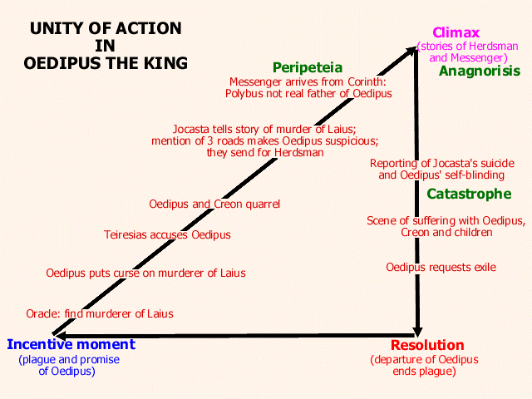
Unity of Action: Each of the incidents in this play is part of a tightly constructed cause-and-effect chain. The plague in Thebes prompts Oedipus to send Creon to consult the oracle of Delphi; the oracle’s reply that the murderer of Laius must be banished from Thebes prompts Oedipus pronounce a solemn curse on the murderer and to send for Teiresias. Teriesias states that Oedipus is the murderer, but since the king knows himself to be innocent (or thinks he knows), he accuses Creon of plotting with Teiresias against him. The quarrel of Oedipus and Creon brings Jocasta from the house; seeking to calm down her husband and prove that oracles cannot be trusted, she tells again of how Laius died. When she mentions that he was killed “at a place where three roads meet,” Oedipus suddenly begins to suspect that he may indeed have killed the king without knowing who he was. To settle the matter, they send for the Herdsman who is the only survivor of that attack. Meanwhile a messenger arrives from Corinth to inform Oedipus that his supposed father, King Polybus of Corinth, has died. When Oedipus rejoices that he did not kill his father as the oracle had prophesied but is still worried that he may marry his mother, the Messenger, seeking to relieve him of this fear, innocently tells him that Polybus and Merope were not his real parents.
The arrival of the Messenger is the only action in the play that is not directly caused by a previous action. However, this is a perfect example of Aristotle's contention that if coincidences cannot be avoided, they should have “an air of design,” for this messenger seems brought by fate, since he is the missing link in Oedipus’ story, the very man who received Oedipus as a baby from the Herdsman. Thus, when the Herdsman arrives and they tell their respective stories, the whole truth emerges. This is the climax, or turning point, of the plot—the truth about Oedipus leads directly to the suicide of Jocasta and Oedipus’ self-blinding and request to be exiled. The departure of Oedipus from Thebes will lift the plague, thus resolving the problem that started off the chain of events and concluding the plot.
This plot is also a perfect example of the exclusion of the irrational and the skillful handling of traditional elements of the myth on which the play is based. Sophocles does not dramatize any of the admittedly irrational parts of the myth (e.g., why did Laius and Jocasta not kill the baby outright? If Oedipus was afraid of marrying his mother, why did he marry a woman old enough to be his mother? etc.). Instead, in a brilliant move, he constructs the play as an investigation of the past. The tremendous sense of inevitability and fate in this play stems from the fact that all the irrational things have already been done; they are unalterable. Once Oedipus begins to investigate the murder of Laius, the whole truth about the past is bound to emerge; as he himself says, “O, O, O, they will all come, / all come out clearly!” (episode 4)

Complex Plot: The peripeteia of the play is the Messenger's reversal of intention; in seeking to help Oedipus by telling him that Polybus and Merope were not his real parents, he instead creates the opposite effect, providing the crucial piece of information that will reveal that Oedipus has indeed killed his father and married his mother. As Aristotle recommends, this is directly connected to the anagnorisis, for the Messenger and Herdsman piece together the whole story of Oedipus, enabling him to “recognize” his true identity, to gain the essential knowledge he has lacked. The peripeteia and anagnorisis directly cause Oedipus’ catastrophe, or change of fortune from good to bad, and lead to the emotional “scenes of suffering” with Creon and his children. In a sense, each of Oedipus’ actions can be considered a reversal of intention, and each gives him a little more knowledge of the dreadful truth that will lead to his downfall.
Role of the Hamartia: The play offers a perfect illustration of the nature of the hamartia as “mistake” or error rather than flaw. Oedipus directly causes his own downfall not because he is evil, or proud, or weak, but simply because he does not know who he is. If he really wanted to avoid the oracle, leaving Corinth was a mistake, killing an unknown older aristocrat was a mistake, and marrying an older queen was a mistake. Seeking to uncover the past, cursing the murderer of Laius, sending for the Herdsman—each of the actions that he pursued so vigorously and for such good reasons led to his doom. Oedipus is not morally guilty, but he is radically ignorant, and Sophocles does not present him as a unique case but rather as a paradigm of the human condition, as “a man like ourselves.” In the words of the Chorus:

What man, what man on earth wins more
of happiness than a seeming
and after that turning away?
Oedipus, you are my pattern of this,
Oedipus, you and your fate! (stasimon 5)

