**Handout on Sophocles’ *Oedipus Rex***

**NOTE BEFORE READING:**

**Please read this handout thoroughly and make sure that the information in it are clear enough.**

**______________________________________________________________________________**

1. **SOME TERMS EXPLAINED: (These are aside from the terms you already have explained in the book including the elements of drama, tragedy, and the theatre generally speaking)**

**APOLLO:** A god, son of Zeus and Leto and brother of Artemis. He is associated with music, poetic inspiration, archery, prophecy, medicine, pastoral life, and in later poetry with the sun; the sanctuary at Delphi was dedicated to him

**ORACLE OF DELPHI**: Delphi was where a priestess supposedly delivered messages from Apollo to those who sought advice; the messages were usually obscure or ambiguous.

**TRAGEDY:** A serious play in which the chief character, by some peculiarity of psychology, passes through a series of misfortunes leading to a final, devastating [catastrophe](http://web.cn.edu/kwheeler/lit_terms_C.html#catastrophe_anchor). According to Aristotle, [*catharsis*](http://web.cn.edu/kwheeler/lit_terms_C.html#catharsis_anchor) is the marking feature and ultimate end of any tragedy. He writes in his [*Poetics*](http://web.cn.edu/kwheeler/documents/Aristotle_Tragedy.pdf) (c. 350 BCE): "Tragedy is an imitation of an action that is serious, complete, and of a certain magnitude; . . . through pity [*eleos*] and fear [*phobos*] effecting the proper purgation [*catharsis*] of these emotions" (Book 6.2). Traditionally, a tragedy is divided into five acts. The first act introduces the characters in a state of happiness, or at the height of their power, influence, or fame. The second act typically introduces a problem or dilemma, which reaches a point of crisis in the third act, but which can still be successfully averted. In the fourth act, the main characters fail to avert or avoid the impending crisis or [catastrophe](http://web.cn.edu/kwheeler/lit_terms_C.html#catastrophe_anchor), and this disaster occurs. The fifth act traditionally reveals the grim consequences of that failure. (*web.cn.edu*)

**TRAGIC HERO**:The main character in a Greek or Roman tragedy. The tragic hero is typically an admirable character who appears as the focus in a tragic play, but one who is undone by a *hamartia*--a tragic mistake, misconception, or flaw. That hamartia leads to the downfall of the main character (and sometimes all he or she holds dear). In many cases, the tragic flaw results from the character's hubris, but for a tragedy to work, the audience must sympathize for the main character. Accordingly, in many of the best tragedies, the tragic flaw grows out of some trait we find admirable.

**THETHREE UNITIES:** In the 1500s and 1600s, critics of drama expanded Aristotle's ideas in the *Poetics* to create the rule of the "three unities." A good play, according to this doctrine, must have three traits. The first is unity of action (realistic events following a single plotline and a limited number of characters encompassed by a sense of reality). The second is unity of time, meaning that the events should be limited to the two or three hours it takes to view the play, or at most to a single day of twelve or twenty-four hours compressed into those two or three hours. The third is unity of space, meaning the play must take place in a single setting or location.

**SOPHOCLES**  (born *c.* 496 bc, Colonus, near Athens [Greece]—died 406, Athens): with [Aeschylus](http://www.britannica.com/EBchecked/topic/7413/Aeschylus) and [Euripides](http://www.britannica.com/EBchecked/topic/195618/Euripides), is one of classical Athens’ three great tragic playwrights. The best known of his 123 dramas is [*Oedipus the King*](http://www.britannica.com/EBchecked/topic/554733/Sophocles/30143/Antigone). (*Encyclopedia Britannica*)

**SPHINX**: A winged monster of Thebes, having a woman's head and a lion's body. It propounded a riddle about the three ages of man, killing those who failed to solve it, until Oedipus was successful, whereupon the Sphinx committed suicide.

**ZEUS**  In ancient Greek religion, he was the chief deity of the pantheon, a sky and weather god who was identical with the Roman god [Jupiter](http://www.britannica.com/EBchecked/topic/308395/Jupiter). His name clearly comes from that of the sky god [Dyaus](http://www.britannica.com/EBchecked/topic/174962/Dyaus) of the ancient Hindu [Rigveda](http://www.britannica.com/EBchecked/topic/503627/Rigveda). Zeus was regarded as the sender of thunder and lightning, rain, and winds, and his traditional weapon was the thunderbolt. He was called the father (i.e., the ruler and protector) of both gods and men.

1. **THE STORYLINE OF *OEDIPUS REX***

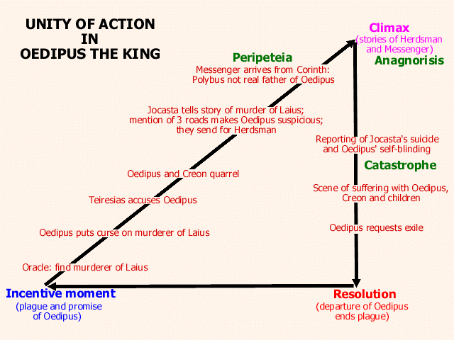

1. **THE FIVE ELEMENTS OF TRAGEDY ACCORDING TO ARISTOTLE**

Aristotle was one of the greatest philosophers of Ancient Greece. He defined tragedy as

“the imitation of a n action that is serious and also, as having magnitude, complete in itself; in appropriate and pleasurable language. . . in a dramatic rather than narrative form; with incidents arousing pity and fear, wherewith to accomplish a catharsis of these emotions.”

1. **“the imitation of an action that is *serious* and also, as having *magnitude*, *complete in itself”***

This means that a good tragedy deals with one issue that is very “serious.” You can’t have a tragedy about something trivial like breaking a fingernail. “Magnitude” here means great importance. The issue has to be serious and very, very important. That’s why a lot of tragedies deal with someone’s death. “Complete in itself” means that the play must stick to the one issue; otherwise, the audience will get lost in the plot.

1. ***“in appropriate and pleasurable language”***

Ancient Greek tragedy had a chorus whose role was to comment on the action of the play. The chorus sometimes sang their part. Aristotle said that the language should be easy to listen to. It should have rhythm and also good harmony for the lines that were sung.

1. **“in a dramatic rather than narrative form;”**

To narrate a story is simply to tell the story, like telling a friend what happened over the weekend. In a play, the story must be dramatized or acted out.

1. **“with incidents arousing pity and fear,”**

In a tragedy, the events or episodes in the play should lead the audience to feel very sorry for the main character--the tragic hero. The audience should also feel afraid for the he ro as he moves toward a destructive end.

1. **“wherewith to accomplish a *catharsis* of these emotions.”**

As the play moves along, the events should build up the emotions of pity and fear. A catharsis is a purging, or cleansing of the emotions --a release o f tension. In a tragedy, this is often a moment o f revelation when the tragic hero “falls flat on his face,” and the audience can finally “explode.”

1. **DISCUSSION QUESTIONS**:

* Discuss the concepts of guilt/justice as applied to the characters Oedipus, Jocasta, Laius, Creon, Tiresias, and the shepherd. How does each contribute to the play’s inevitably tragic outcome? What is his/her outcome? Has each received what they deserved?
* Using Aristotle’s (5) “rules” for tragedy, explain how Oedipus Rex fits perfectly into each one of the rules. Use specific examples.
* List the positive characteristics of Oedipus and the flaws within him that bring about his downfall.
* List the characteristics (good or bad) of Jocasta (as wife and mother) and of Creon (as friend and leader).
* Through Oedipus Rex Sophocles presents the idea that suffering brings about wisdom and that this suffering teaches the sufferer humility and exposes the limitations of the individual. Using this central theme as a point of reference, discuss what Sophocles says about:
* the gods role in human affairs
* the brevity of fame and fortune
* the “best” way to live one’s life
* the results of human imperfection
* Critics have found many universal applications of the Oedipus story. Write three (3) separate the statements (universal message/insight) that modern readers can learn from Oedipus (besides not to kill dad & marry mom)? Remember to state your theme in one complete and complex declarative sentence.