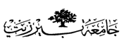

Organic –Chem. 221 Lab

Instructor name: Dr. Adi Qamhieh Exp. date: 7.5.2018

Experiment title

Chromatography Of Natural Colors

Student Name
Muhammad Ibrahim Musleh
Student No
1162595
Partner Name
Fairouz Zayed
Partner No
1160750

Experiment No
10

Submission date: 21.5.2018

