Birzeit university– faculty of engineering and technology

Department of mechanical engineering

Fluid Mechanic Laboratory

ENME312

Section 1

**Experiment No.9**

**“Pressure loss in ductwork and friction loss in pipes”**

Instructors:

Dr. Adel Dweik

Eng. Alanoud Muadi

Group 5:

Majd Raddad 1201196

Qais Samara 1202956

Mohammad Abu Ayyash 1182690

**Prepared by: Majd Raddad- 1201196**

Date of performance: 1/04/2024

Date of performance: 8/04/2024

Table of contents

Abstract 1

Objectives 1

Sample calculation: 2

Part a: 2

Part b: 5

Results 8

Part A 8

Part B 9

Discussion of results 10

Conclusion 11

References 11

Appendices 12

# Abstract

For a fluid flow system made up of several components, pipes, and fittings. Studying these systems' characteristics is essential especially when calculating the expected losses and trying to tolerate these systems to achieve the smallest loss.

The first experiment aims to investigate pressure loss in ductwork during high-speed fan operation. Since duct work is mainly used in heating and cooling systems, it needs to be made with an efficient design.

The equivalent length of a straight pipe, which is the length of a pipe with the same diameter as the fitting and which would result in the same pressure drop as the fitting, is one of the most important components of the ductwork system. It was observed that the duct's straight pipes, which are free of obstructions, experienced the least pressure drop, while the section with the screen installed experienced the greatest pressure drop and it was concluded that pressure losses are higher when fluid passes through fittings such as valves, bends (elbows), and expansions.

The second part of the experiment aims to investigate the impact of friction on pressure loss under high flow rate conditions. It was observed that flow in pipes is related to a value such as Reynolds number and type of flow (laminar and turbulent flow). For this part, the amount of water was fixed at 500ml through a scaled cup that was used to fill in the water while changing the head. The temperature of the water and the time it took for the water to fill the scaled cup were also measured. Moreover, Reynolds number, flow rate, and velocity were determined along with the friction factor experimentally, which was compared to the theoretical value obtained using the following equation:

$f=0.0756{Re}^{-0.25}$ OR from Moody chart.

# Objectives

* Study viscous flow in ducts and piping systems.
* Measurement of the total head loss between each station along the duct.
* Measuring friction head loss over laminar and turbulent ranges.

# Sample calculation:

## Part a:

* To calculate the pressure loss in each section of the system:

$∆P_{Loss}=f\frac{L_{eq}}{D}\left(\frac{1}{2}ρV^{2}\right)=K\left(\frac{1}{2}ρV^{2}\right)$ (1)

Where:

$∆P_{loss}:$ Static pressure loss [Pa]

$D$: Diameter of the pipe which equals **0.0984** m.

$L_{eq}:$ The equivalent length [m].

$ρ$*:* Air density which equals **1.2** kg/m3.

: Air velocity [m/s].

$f:$ Friction coefficient [-].

K: Pressure loss factor.

To calculate the flow rate in venturi and orifice, based on continuity equation:

For the **Venturi meter**:

$Q_{v}=163.3 \sqrt{h_{v}}$ (2)

= 278.1 m3/h.

Where:

ℎ𝑣: Air head for the venturi [mbar].

For the **Orifice meter**:

|  |  |  |
| --- | --- | --- |
|  | $$Q_{o}=123.7 \sqrt{h_{o}}$$ $Q_{o}=123.7 \sqrt{5.3}$ ${ Q}_{o}=$ 284.78 m3/h. | (3) |

Where:

$h_{o}:$ Air head for the orifice [mbar].

To calculate the velocity for both venturi and orifice:

$V_{venturi}$ = $\frac{Qv}{A}$ m/s (4)

$V_{venturi}$ = $\frac{278.1}{0.0076*3600}$

$V_{venturi}$ = 10.16 m/s.

${ V}_{orifice}$ = $\frac{Qo}{A}$ m/s (5)

$V_{orifice}$ = $\frac{284.78}{0.0076*3600}$

${ V}_{orifice}= 10.41$ m/s.

Where:

𝑉: is the velocity in venturi and orifice.

A: is the area of the cross section and diameter is 0.0984 meters.

To calculate the fluid main velocity:

$V_{Main}=\frac{V_{v}+V_{o}}{2}$ (6)

$V_{Main}=\frac{10.16+10.41}{2}$ = 10.29 m/s.

Where:

$V_{o}:$ Air velocity measured by the Orifice meter [m/s].

$V_{v}:$ Air velocity measured by the Venturi meter [m/s].

To calculate friction loss factor:

Section 3-5 was taken:

1 mm H2O = 9.80665 pa, (∆P in pascal = 1 mm H2O * 9.80665)

$K= \frac{2 ∆P}{ƿV_{main}^{2}}$ (7)

$K= \frac{2*0.2157}{1.2*{10.29}^{2}}$ = 0.0034

Where:

K: pressure loss factor.

To calculate the equivalent length of the system:

$Leq= \frac{K*D}{f}$ (8)

$Leq= \frac{0.0034*0.098*100}{0.025}$ = 1.33

$Leq=$**1.33 m.**

The total equivalent length of the system = 5.68 m

Where:

Leq: equivalent length of each section in m.

## Part b:

For Run **No. 2:**

To find flow rate:

m3/s (9)

**0.0000091 m3/s.**

Where:

Q: flow rate in m3/s.

V: volume in m3.

T: time in second.

To calculate the velocity:

$v= \frac{Q}{A}$ m/s (10)

$v= \frac{0.0000091}{0.00000706}$ = 1.288

$v$**= 1.288 m/s**

Where:

V: velocity of flow in m/s.

A: cross- sectional area (0.00000706 m2).

To find the hydraulic gradient:

$i$ = $\frac{32μu}{ρgD^{2}}$ (11)

$i$ = $\frac{32*1.288*0.001}{1000*9.81* {0.03}^{2}}$

$i$ = 0.46834

Where:

u: velocity m/s

g: gravity 9.81m/ s2.

d=0.03m

p: water density (1000)kg/ m3.

To find Reynold number:

$Re=\frac{ρuD}{μ}=uD/ν$ (12)

$Re=\frac{1000*1.288*0.003}{0.001}$ = 3844.88

Where:

Re: Reynold number.

u: velocity in m/s.

$μ$: viscosity.

To find the friction factor:

$f= \frac{2i*g*D}{4u^{2}}$ (13)

$f= \frac{2*0.46834*9.81*0.003}{4{*1.288}^{2}}$ = 0.00416

Where:

f: friction factor.

i: gradient.

To find theoretical friction factor:

$f theo. =0.079 {Re}^{-0.25}$ (14)

$f theo. =0.079* {3844.88}^{-0.25}$ = 0.009601

# Results

## Part A

Table(1): Data & calculation

## Part B

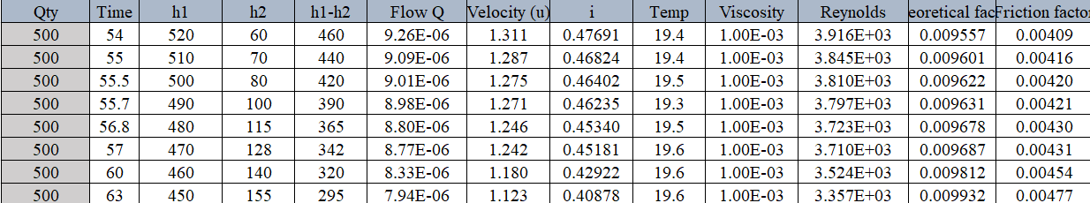Table (2): Data & Calculation

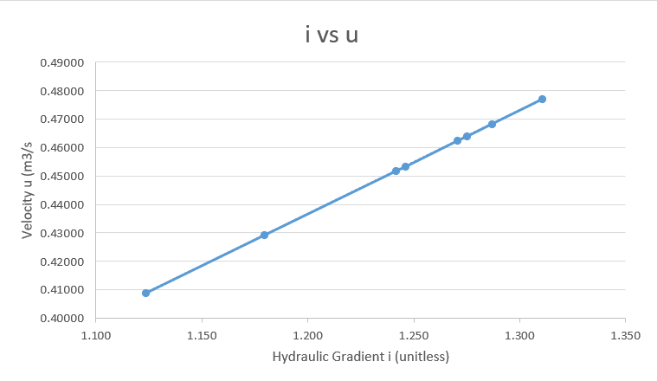

Figure(1): Relationship between hydraulic gradient and Velocity

# Discussion of results

For the first part of the experiment, the objectives included examining a ductwork simulation to comprehend the principle of pressure drop across the system and familiarizing with key variables like the pressure loss coefficient (K) and equivalent length (Le). These goals were met by determining the parameters and conducting the necessary analyses.

Based on Table (1), sections that are straight and do not have flow meters or bends show no variation in pressure, meaning that there is no significant pressure loss. On the other hand, there is a noticeable decrease in pressure in areas that include elbows, orifice meters, venturi meters, and screens. The length of the section, the radius of the elbow, and the discharge coefficient of the flow meter in use are some of the variables that affect this variation in pressure levels. Of these, straight duct sections are linked to the least amount of pressure loss, while the screen and orifice meter are the main causes of the highest-pressure losses. The ductwork contained a venturi-meter and an orifice, the orifice-meter suffer larger pressure loss when compared to a venturi meter due to the sudden change in the cross-section in the orifice compared to the smooth transition for a venturi-meter.

In the second part of the experiment, the objectives were centred around observing the flow dynamics within a pipe, by introducing concepts like friction losses, distinctions between laminar and turbulent flow, Reynolds number, hydraulic gradient, and the impact of viscosity, among others. These aims were realized through the computation of these specified parameters and gaining an understanding of their significance concerning the flow behaviour inside the pipe.

Table 2 presents the results of the calculations for the flow, velocity, head, hydraulic gradient, viscosity, Reynolds number, friction flow, and theoretical friction factor. The first observation is that, for all experimented conditions, the Reynolds number and the flow have an inversely direct proportional relationship, indicating that, at higher discharge rates, the flow becomes turbulent as the Reynolds number increases. The same is true for the velocity, which is directly proportional to the flow.

Figure (1) shows the relation between the hydraulic gradient vs velocity, which indicates a linear direct proportional relationship with a slope equal to 0.3639.

# Conclusion

There are two sections to the experiment. the first experiment was Studying losses in ductwork, which is used to move fluid from one place to another. The second section examined the loss of friction in a pipe under various flow conditions.

For part A, the findings indicated that the variation in pressure, or pressure loss, within the ductwork or pipe is attributed to the presence of internal obstacles and conditions. Specifically, in sections where obstacles were absent, such as in straight ducts, the pressure loss was nearly negligible. Conversely, the more abrupt and sharp the obstacle encountered, the greater the pressure loss observed. A variety of obstacles were tested, including sharp corners, rounded angles, venturi meters, orifices, and more, to study their effects on pressure loss. Losses are dependent on other factors such as the cross-sectional area, length of the pipes, changes in speed due to any sudden changes in the pipes and on the type of fluid (viscosity).

For part (B) of the experiment was conducted to study the best way through which the fluid passes that causes the least possible number of losses, along with studying these losses under laminar or turbulent flow. This was based on the Reynold number which ranges from 2300 for laminar to 2900 for turbulent, the experiment shows a higher Reynolds number that shows that it was all under turbulent flow.

It is expected that errors will be made during the experiment. These could be caused by a lack of speed when setting the timer to submerge the container in the water, taking inaccurate temperature readings, misreading the experiment gauges, or dropping to complete the necessary computations.

# References

* Fluid mechanics laboratory manual (2022, march).
* White, F. M. (1999, January 1). Fluid Mechanics.

# Appendices



