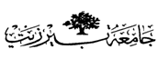

Organic –Chem. 221 Lab

Instructor name: Adi Qamhieh Exp. date: 26.2.2018

Student Name: Muhammad Ibrahim Musleh
Student No: 1162595
Partner Name: Fairouz Zayed
Partner No: 1160750

Experiment No: 2

Experiment title: Distillation-Fractional Distillation

Submission date: 5.3.2018
Abstract:- (including objectives, chemical reactions, methods used and main results)
The purpose of this experiment is to compare the efficiency of simple distillation and Fractional distillation for separation and purification of a mixture of Water and Acetone. We mix water (50ml) and acetone (50ml) then separate them by two methods mention above. The main result is to understand the difference between Simple and Fractional distillation.

Chemicals:-
1-Water (H₂O)
2-Acetone(CH₃COCH₃)
3- Boiling chips

Glassware:-
1-Thermometer.
2-Thermometer Adapter.
3-Distillation head.
4-Condenser.
5-Distillation flask.
6-Fractional distillation column.
7-Graduated cylinder.

Experimental Procedure:-(Brief and in clear items and use the passive voice form)

Step | #
The setup of fractional distillation was prepared. | 1
A 50ml of water and acetone was added and mixed in distillation flask then an amount of boiling chips were added. | 2
The mixture is heated by Bunsen burner ,then the temperature is read every 5 ml of the distillate. | 3
The distillation flask had not to dryness of it would broke. (This creates a potential risk of explosion) | 4
Sketch | 5

Data:-
Fill in the chart below with appropriate structures, and physical properties of reagents needed to complete the reaction. In addition calculate the moles and mass or volume of the reagents. Experimental results are to be filled in during completion of the experiment.

- Simple Distillation:-

T | 60 | 61.2 | 62.2 | 64 | 65.7 | 67.8 | 70 | 72.4 | 78.2 | 86 | 92 | 95 | 95.2 | 95.9 | 96 | 96 | 96.1
V | 5 | 10 | 15 | 20 | 25 | 30 | 35 | 40 | 45 | 50 | 55 | 60 | 65 | 70 | 75 | 80 | 85
T:Teperature(Cº) V:Volume(ml)

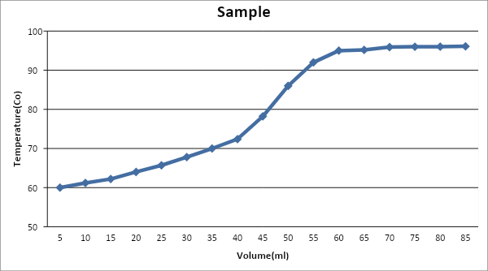

2- Fractional Distillation:-

T | 54 | 55 | 56 | 57 | 58 | 58.7 | 59 | 61 | 62 | 85 | 92 | 92.5 | 92.5 | 92.5 | 92.5 | 92.5 | 92.7
V | 5 | 10 | 15 | 20 | 25 | 30 | 35 | 40 | 45 | 50 | 55 | 60 | 65 | 70 | 75 | 80 | 85
T:Teperature(Cº) V:Volume(ml)

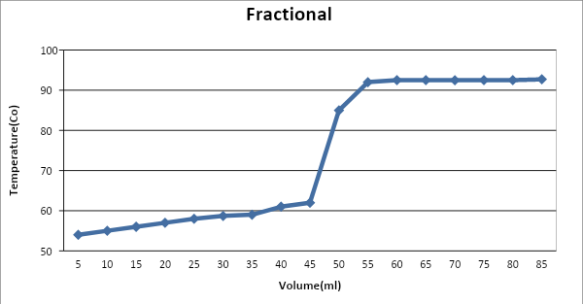

Results:-

As we see from two charts above we conclude that there is a noticeable difference between Simple and Fractional Distillation. Simple distillation is a continuous method that separate water and acetone. On the other hand, Fractional distillation has a noticeable step between separate of water and acetone.

Discussion & Comments:-

Provide a summary of the experiment including observations, analysis of all data and results, and methods to correct errors or optimize the experiment.

It appears that the fractional distillation was more efficient than the simple distillation. The simple distillation graphed basically as a straight line, but the graph of the fractional distillation actually somewhat shows the rise where mostly Acetone is being condensed and then the rise and second plateau where mostly Water is being condensed. This cannot be really seen in the graph of simple distillation. This may be due in part that the simple distillation was heated too fast. I know that for the fractional distillation it seemed like we heated it at a very steady rate, but the simple distillation was harder to control.
In simple distillation, two substances were collected would not be very pure and separation was not complete. After collected the acetone(Distillate) the temperature should rise sharply in order to boil water.
Both simple and fractional distillation assemble each other in the first and the end but a difference is observed in the middle region-Jump region-.

Questions:-

Q1. (1) : With the fractionating column(fractional distillation) is used, the results were more precise, water was not begun to vaporize until the all acetone was vaporized. However, without used of fractionating column(simple distillation), the vapor of acetone and water were overlap(Water vaporized with Acetone). This is the reason why fractional distillation gives accurate results. The graph of fractionating column between acetone and water was more sharp than simple distillation.

Q2. (3) Yes, because boiling point of liquid equal to temperature of vapor, also pure substance has special temperature so it will remain constant throughout distillation.

Q3. (5) : The observed temperature will be less than the actual value, because the bulb would not be direct to vapor stream.

Good Luck

