=

Faculty of Engineering and Technology

Electrical and Computer Engineering Department

ENEE2110

ELECTRIC CIRCUITS LAB

Experiment.5 Prelab

**FIRST ORDER CIRCUITS**

**Prepared by:**

Nermin Aqra 1212126

**Supervised by:**

Dr. Jaser Sa'ed

**Teacher assistance:**

Eng.Mohammad AL-Ba ttat

March2025

**Part A: Step response of First-order RC circuit**

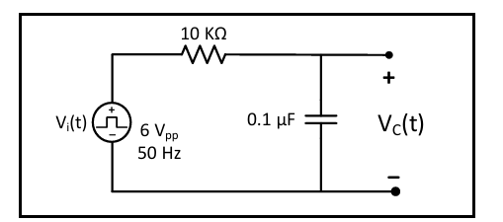

**Figure 1:5.5**

1. Calculate VC (t) using the general solution formula, show calculation of time constant (τ).

$V_{c}\left(0^{+}\right)=0 initial voltage$

$$V_{c}\left(∞\right)=6 final voltage$$

$$τ=R×C$$

$$τ=10000×0.1uF$$

$$τ=0.001s$$

$$V_{c}\left(t\right)=V_{c}\left(∞\right)+\left[V_{c}\left(0^{+}\right)-V_{c}(∞)\right]e^{{-t}/T}$$

$$V_{c}\left(t\right)=6+\left[0-6\right]e^{\frac{-t}{0.001}}$$

$$V_{c}\left(t\right)=6-6e^{-1000t}$$

1. Use PSPICE to do transient analysis of the circuit. Show VC(t) and use cursors to measure time constant (𝛕).

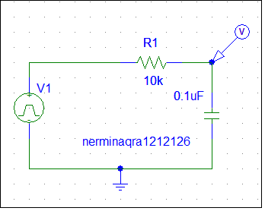

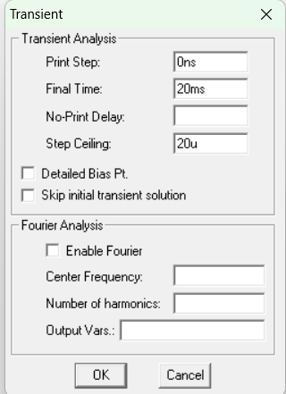 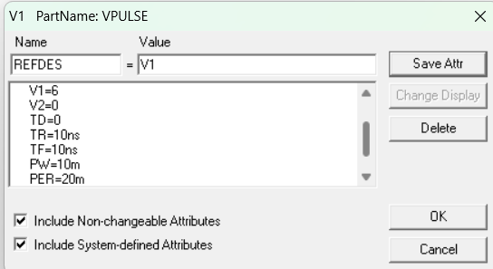



Charging cycle $V_{o}×0.63=3.78$

$$τ=11-10=1ms$$

Discharging $V_{o}×0.37=2.22$

1. For the same circuit show VR(t) using a differential voltage marker, and use cursors to measure time constant (𝛕).

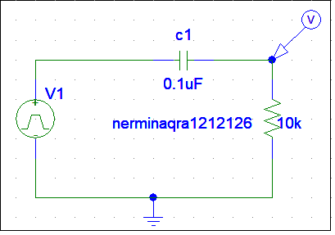



Discharging cycle $V_{o}×0.37=2.22$

$$τ≈1ms$$

**Part B: Step response of First-order RL circuit**

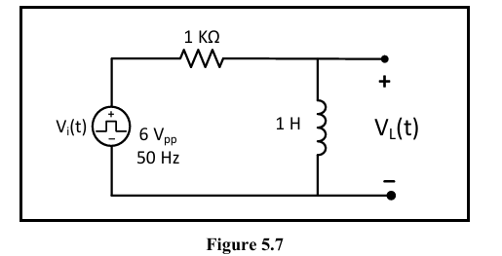

1. Calculate VL (t) using the general solution formula, show calculation of time constant (τ).

2. Use PSPICE to do transient analysis of the circuit. Show VL(t) and use cursors to measure time constant (𝛕).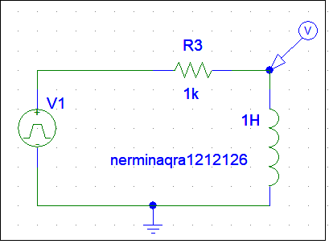



Discharging cycle $V_{o}×0.37=2.22$

$τ≈11.007-10 ≈1ms$

1. For the same circuit show VR(t) using a differential voltage marker, and use cursors to measure time constant (𝛕).

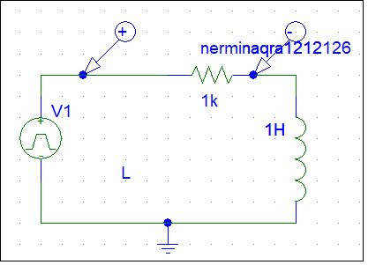



Charging $V_{o}×0.63=3.78$

$$τ=1ms$$

Discharging $V_{o}×0.37=2.22$