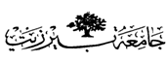

Organic –Chem. 221 Lab

Instructor name: Dr. Adi Qamhieh Exp. date: 23.4.2018

Experiment title

The Aldol Condensation

Student Name
Muhammad Ibrahim Musleh
Student No
1162595
Partner Name
Fairouz Zayed
Partner No
1160750

Experiment No
9

Submission date: 21.5.2018

