

BERZIET UNIVERSITY FACULTY OF ENGINEERING AND TECHNOLOGY DEPARTMENT OF ELECTRICAL AND COMPUTER ENGINEERING

ENEE 2102 Circuits Laboratory

Experiment.6 Prelab

**First Order Circuits**

Prepared by:

Omar nazal 1200629

Supervised by:

Dr. Jaser Sa'ed

Teacher assistance:

Shadi banhoura

April 2022

**Part A: Step response of First-order RC circuit**

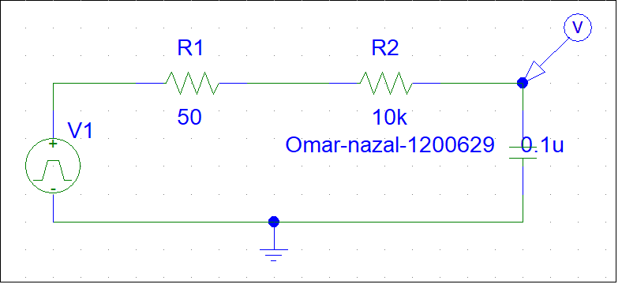



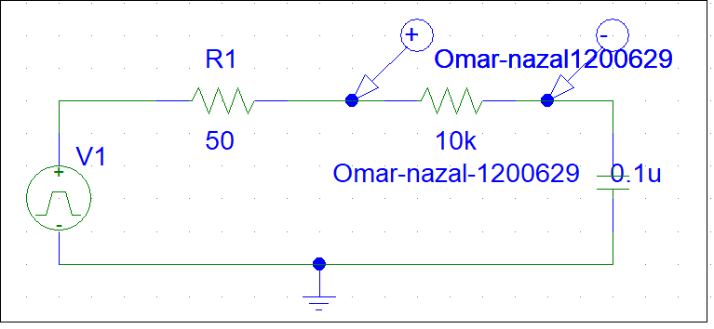



**Part B: Step response of First-order RL circuit**

