Chapter 02 Transaction Processing in the AIS

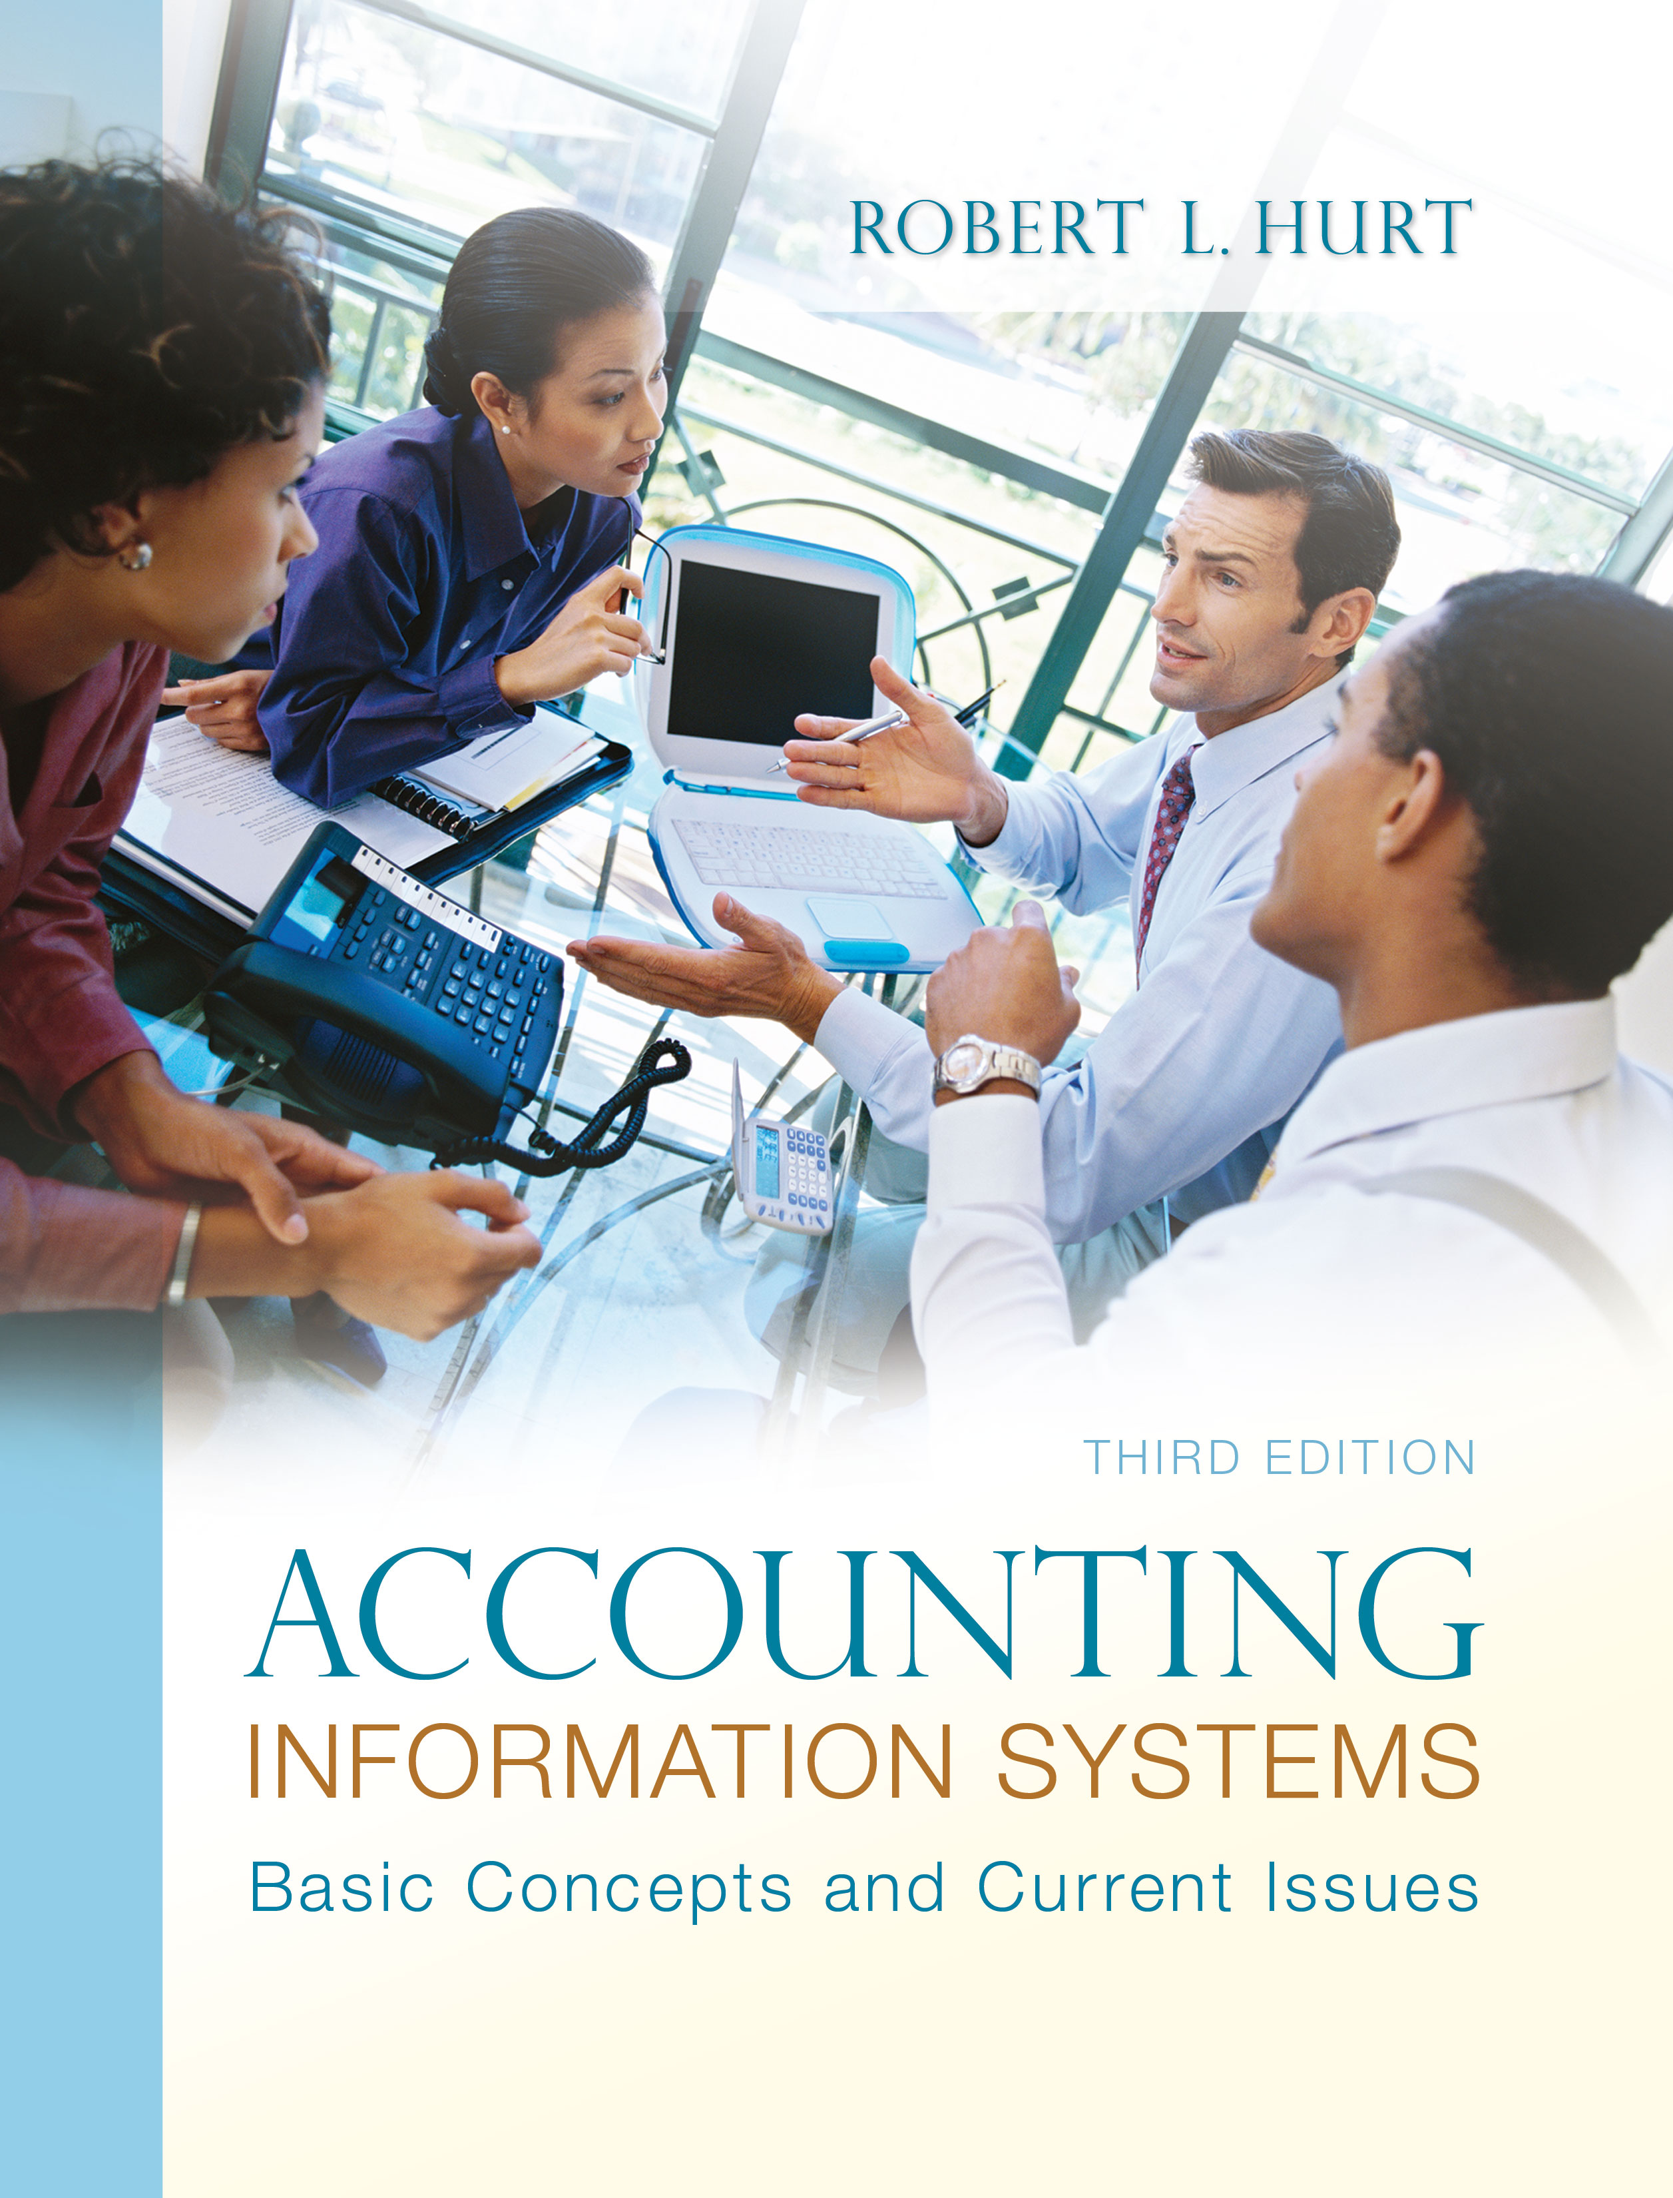
1. Reading review questions

a. In your own words, explain the similarities and differences between accounting and bookkeeping. Bookkeeping is the subset of accounting activities specifically concerned with recording transactions in the AIS, leading eventually to the production of the four general purpose financial statements. Although both accounting and bookkeeping require some elements of critical thinking, accounting probably requires more. In addition, the essential elements of bookkeeping can be mastered in a much shorter time than the entire body of knowledge in accounting.

b. What systems do accountants use to create and modify a chart of accounts? In general, most charts of accounts follow a block or hierarchical coding system. In block coding, similar items are coded similarly; for example, all current assets might have account numbers that start with “1.” Hierarchical coding is good for more complex charts of accounts, and is a specialized form of block coding. In hierarchical coding, groups of digits have meaning. Such a system might be used in a business that has multiple product lines and / or multiple geographic locations.

c. What internal controls are common in the accounting cycle? Internal controls useful in completing the accounting cycle include: sequentially numbered documents, adequate supervision, training & education and separation of duties. In addition, the requirement that journal entries maintain the equality of debits and credits is also an internal control.

d. How is human judgment involved in the accounting cycle? Human judgment is required to recognize recordable transactions. To the extent that the accounting cycle involves estimates (as with depreciation and bad debts), human judgment is also important.

e. How has information technology been employed in the accounting cycle? Information technology is an important component of most modern accounting information systems; however, the technology is not the system. Common IT tools employed in the accounting cycle include: general ledger software, spreadsheets, relational databases and enterprise resource planning systems. Auditors can also use IT to sample transactions.

f. List and discuss the six common types of adjusting entries found in most accounting information systems. Accrued revenues occur when an organization provides goods or services in one accounting period, but does not bill clients in that same period. Accrued expenses, on the other hand, occur when an organization incurs an expense, but does not pay cash until a subsequent period. Prepaid expenses are assets purchased in one period that are used up over multiple accounting periods, while deferred revenues involve the receipt of cash in one period for work that will be performed in a subsequent period. Depreciation and bad debt adjustments both involve estimates.

g. Explain the purpose and structure of each general-purpose financial statement. AIS outputs associated with the accounting cycle include four general-purpose financial statements. The income statement, which includes revenues and expenses, reports the results of business activity on the accrual basis for a specified period of time. The statement of shareholders’ equity tracks the changes in both paid-in capital and retained earnings, also for a period of time. The balance sheet embodies the accounting equation (assets = liabilities + equity), and reports financial position at a specified point in time. The statement of cash flows comprises three sections (operating, investing and financing), and reports the changes in cash for a specified period of time.

h. In a manner specified by your instructor (e.g., individually or with a group, as a written paper or as an oral presentation), prepare an original response to one or more of the questions for this chapter’s “AIS in the Business World.” I was very fortunate to have three assistants available to prepare responses to the AIS in the Business World vignettes for the third edition; I’ve posted their responses on my AIS blog: www.bobhurtais.blogspot.com.

2. Multiple choice review questions. Answers to all of these questions appear at the end of the textbook itself.

3. Reading review problem

a. Is transaction processing more closely related to accounting or bookkeeping? Explain your response. Transaction processing is more closely related to bookkeeping. It follows a strict set of rules and is not subject to much interpretation.

b. What does it mean to say RKR's chart of accounts is "block coded?" What other coding systems are available, and when might they be most appropriately used? Block coding a chart of accounts means that account numbers are assigned based on the elements of financial statements; for example, current assets might be denoted by account numbers in the 100s, while plant assets might have account numbers in the 200s. Hierarchical coding systems are a specialized form of block coding, in which numbers are grouped together; each group individually is block coded. Mnemonic codes help users remember the meaning of the code, such as with state abbreviations. Sequential coding is often used for source documents such as checks and purchase orders; in that system, items are numbered sequentially.

c. How should RKR maintain strong internal control over its transaction processing activities? RKR can maintain strong internal control over its transaction processing activities by enforcing separation of duties (the person who does recordkeeping should have neither physical custody of assets or authorization for use of assets. Adequate supervision and training can also be effectively employed to maintain internal control over transaction processing.

d. Suggest three to five transactions RKR would need to record on a routine basis. Indicate which accounts would be debited and credited for each transaction. Purchase of inventory on account: debit inventory, credit accounts payable. Payment of employee salaries: debit wages expense, credit cash and various liability accounts for withholding. Sale of meals for cash: debit cash and cost of goods sold, credit sales and inventory.
.

4. Making choices and exercising judgment
The point of these exercises, which appear in every chapter throughout the third edition, is to encourage students to think critically and “outside the box.” Thus, I am not providing solutions to them, as doing so would likely discourage the purpose of these exercises.

5. Field exercises
Answers to these exercises will vary significantly; thus, like the previous set, I am not preparing published solutions for them.

6. Journal entries

7. Adjusting entries.

8. Financial statements.

9. Coding systems
a. mnemonic
b. sequential
c. sequential
d. hierarchical
e. sequential
f. hierarchical
g. block
h. block
i. block
j. block

10. Terminology
1. F
2. D
3. C
4. B
5. I
6. G
7. A
8. H
9. E
10. J

11. Multiple choice questions
1. B
2. A
3. C
4. B
5. D

12. Statement evaluation
a. never true
b. sometimes true. The adjusting entry for an accrued liability is an example.
c. always true
d. sometimes true. The complexity of the chart of accounts will help determine which system to use.
e. never true
f. sometimes true. The statement describes an accrued revenue adjustment; the term “accrual” could also be used for an accrued expense.
g. never true
h. always true
i. sometimes true. Block coding facilitates closing entries, but not all automated AIS use block coding.
j. always true

13. International Financial Reporting Standards
a. Compare and contrast the IFRS framework with the FASB Conceptual Framework discussed in Chapter 1. List three similarities and three differences between the two. Similarities include (but are not limited to): Both frameworks were developed by a standards board (FASB and IASB). The structure of the two frameworks is similar. They both include some common elements, such as objectives of financial statements/ financial reporting and elements of financial statements. On the other hand, the frameworks differ in the following ways: The qualitative characteristics are different between the two frameworks. The IFRS framework identifies five elements of financial statements; the FASB framework, eight. The IFRS framework includes a section titled “Concepts of Capital and Capital Maintenance,” but the FASB framework does not.
b. Choose two countries that have adopted IFRS. If an organization had operations in both countries, how would you communicate that fact in their chart of accounts? A list of countries that have adopted IFRS is available at http://www.iasplus.com/country/useias.htm. To communicate multi-national operations via a chart of accounts, you could use a hierarchical code that includes a mnemonic abbreviation for the country. For example, if Cash is account #101, DEN101 could denote Cash in the Denmark branch and AUS101 could denote Cash in the Australian branch. Other systems are definitely possible as well.

