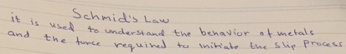

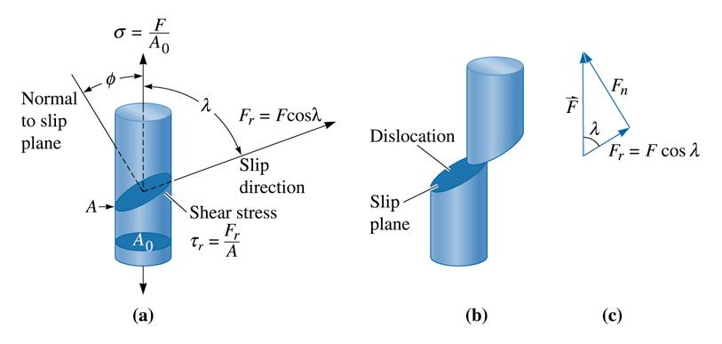

(c)2003 Brooks/Cole, a division of Thomson Learning, Inc. Thomson Learning™ is a trademark used herein under license.

