Department of Mechanical and Mechatronics Engineering
Statistical & Measurements – ENMC 3351
Dr. Simon Al-Araj Dr. Ahmed Abu Hanieh
Project and presentaions

Deadline: 01/06/2022

Project: Water flowmeter with digital readout

Design and manufacture a digital water flowmeter to measure the flow rate of water:

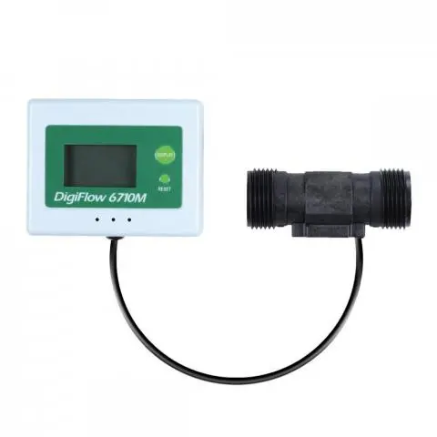

- Design and manufacture the mechanical and electrical setup in university workshops.
- Use Arduino or any other system to acquire data from the system and programme it to display results on a digital screen.
- Design an experiment on the set-up.
- Plot measurements of the output with time and compare with existing device.
- Repeat measurement and calculate the error.
- Write a formal report.

Requirements and timetable:

- Design & Technical drawings 20+21/04/2022
- Practical prototype (Workshops) 04+05/05/2022
- Experiment design and data analysis 18+19/05/2022
- Formal Report 01+02/06/2022
- Project discussion 01+02/06/2022

Presentations

The student groups are distributed as follows, the same group will work on the project and the presentation as a team work. Each group will prepare information about the sensors and measurement techniques of one of the following quantities and present it in the class using Power point presentation for 15 minutes:

Section 1:

- Presentation = Displacement, level and distance 20/4
Group = Mohammed Khatib + Jehad Shehadeh + Huthayfeh Afaneh
- Presentation = Velocity, speed and encoders 20/4
Group = Momen Shtayeh + Tasneem Badwan + Omar Shuaibi
- Presentation = Acceleration and vibration 27/4
Group = Ahmed Jbara + Ibrahim Dar AlMasri + Abdullah Zeidan
- Presentation = Pressure 27/4
Group = Osama Abu Latifa + Wesam Dajani + Afnan Wadi
- Presentation = Temperature 11/5
Group = Sama Hanoun + Lana Ansawi + Aisheh Ladadweh
- Presentation = Force, torques and strain 11/5
Group = Rawhi Mansour + Alaa Aqel + Ali Darawsheh
- Presentation = Capacitive, inductive and proximity sensors 18/5
Group = Ahmad Shokeh + Suleiman Samara

Section 2:

- Presentation = Displacement, level and distance 21/4
Group = Anas Ayhour + Eyad Abdeen + Abdullah Bueirat
- Presentation = Velocity, speed and encoders 21/4
Group = Shuaib Alkhateeb + Adham Sadeh + Mohammed Hasarmeh
- Presentation = Acceleration and vibration 28/4
Group = Salsabeel Anati + Shahd Hasouneh + Diana Khaled
- Presentation = Pressure 28/4
Group = Diaa + Mahmoud Ladadweh
- Presentation = Temperature 12/5
Group = Tala Hasan + Abd Alhakeem Bawatneh + Mariam Latifeh
- Presentation = Force, torques and strain 12/5
Group = Rita Ladadweh + Hadi Alshweiki + Tariq Alshalaldeh

